180° POWER-OFF ACCURACY APPROACH AND LANDING (ASEL)

Objective:
To instill in the student the judgment and procedures necessary for accurately flying the airplane, without power, to a safe landing. To further develop judgment in estimating distances and glide ratios.

Before Flight:
- Review appropriate aircraft performance information

Maneuver Elements:
- Clear the area
- Choose forced landing area (runway)
- Configure aircraft: landing checklist (CCGUMPS, no flaps), insure gear extended, approx. 1000’ AGL downwind for landing
- Select outside references (e.g. aim point markers)
- Throttle to idle abeam touchdown
- Establish and maintain best glide speed or 1.4 VSO
- Select aim point ahead of touchdown point (compensate for ground effect)
- Position and adjust base leg as necessary and compensate for wind
- Flaps or forward slip as necessary for landing on touchdown point
- Land at touchdown point beyond and within 200’
- How to measure? Runway edge lights are spaced 50’

Aircraft Setup:

Flaps as required, gear down, propeller Full
Downwind: (C172RG: 18” Hg, 2700 RPM)
1.4 VSO: (C172RG: 75 KIAS 0º Flaps)

Things to Avoid (Common Errors)
- Downwind leg too far from runway/landing area
- Overextension of downwind leg resulting from tailwind
- Inadequate compensation for wind drift on base leg
- Skidding turns in an effort to increase gliding distance
- Failure to lower landing gear in retractable gear airplanes
- Attempting to “stretch” the glide during undershoot
- Premature flap extension/landing gear extension
- Use of throttle to increase the glide instead of merely clearing the engine
- Forcing the airplane onto the runway to avoid overshooting the touchdown point

Diagrams:
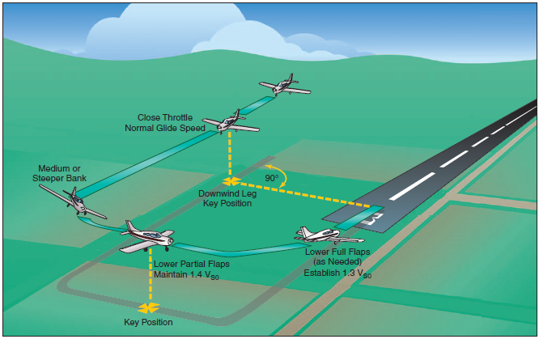

References:
Airplane Flying Handbook - Chapter 8-23

Completion Standards:
The lesson is complete when the student demonstrates knowledge through a written or oral exam and is able to perform a 180° power-off approach to the satisfaction of the instructor and in accordance with the current Practical Test Standards for the student’s stage of training.

