AEROMEDICAL FACTORS

Objective:
To familiarize the student with factors affecting the human body in flight and the necessary precautions to insure safety.

Content:
- Medical Certificates (14 CFR Part 67)
- Physiological and Psychological factors affecting performance ◦Hypoxia
  - Hyperventilation
  - Carbon Monoxide poisoning
  - Motion Sickness
  - Dehydration and Heatstroke
  - Alcohol and drugs
  - Stress
  - Fatigue
  - IMSAFE
  - Middle ear and sinus problems during climbs and descents
  - Scuba Diving
  - Empty Field Myopia
  - Night Flying
- Illusory factors affecting performance
  - Vestibular
    - The leans
    - Coriolis illusion
    - Graveyard spiral
    - Somatogravic illusion
    - Inversion illusion
    - Elevator illusion
    - False horizon
  - Visual
    - False horizon
    - Autokinesis
    - Runway width illusions
    - Runway and terrain slopes illusions
    - Featureless terrain illusion
    - Water refraction
    - Haze
    - Fog
    - Ground lighting illusions
  - Postural

Completion Standards:
The lesson is complete when the instructor determines that the student has adequate knowledge of aeromedical factors and ways to prevent aeromedical-related accidents by giving an oral or written exam.

Instructor Notes:
- Obtaining an Appropriate Medical Certificate
  - Issued after a routine medical examination which by administered only by FAA-designated doctors called Aviation Medical Examiners (AME)
  - FAA Directory of AMEs
    - FSDOs
    - FSSs
    - FAA Offices
  - Medical Certificate with a Possible Medical Deficiency
    - Even with a medical deficiency, a medical certificate can be issued
      - Operating limitations may be imposed, depending on the nature of the deficiency
      - Obtain assistance from an AME and the local FSDO
        - The assistance is only available on request
  - Regulation
    - Once a medical is obtained, it is self-regulating
      - EX: Broken wrist, can you still fly? It’s the pilot’s judgment
  - A medical is not required when:
    - Exercising the privileges of a flight instructor certificate if the person is not acting as PIC or serving as a required flight crewmember
    - Exercising the privileges of a ground instructor certificate
    - When a military pilot of the US Armed Forces can show evidence of an up-to-date medical examination authorizing pilot flight status issued by the US Armed Forces and
      - The flight does not require higher than a 3rd class medical certificate
      - The flight conducted is a domestic flight within US airspace
  - Operations requiring a Medical OR U.S. Driver’s License
    - A person must hold and possess either a medical certificate or a U.S. driver’s license when:
      - Exercising the privileges of a student pilot certificate while seeking sport pilot privileges in a light-sport aircraft other than a glider or balloon
      - Exercising the privileges of a sport pilot certificate in a light sport aircraft other than a glider or a balloon
      - Exercising the privileges of a flight instructor certificate with a sport pilot rating while acting as PIC or serving as a required flight crewmember of a light-sport aircraft other than a glider or a balloon
      - Serving as an examiner and administering a practical test for the issuance of a sport pilot certificate in a light-sport aircraft other than a glider or a balloon
    - A person using a U.S. driver’s license must:
      - Comply with each restriction and limitation imposed by the driver’s license and any judicial or administrative order applying to the operation of a motor vehicle
      - Have been found eligible for at least a 3rd class medical certificate at the time of the most recent application (if the person has applied for a medical certificate)
      - Not have had the most recently issued medical certificate suspended or revoked or most recent Authorization for a Special Issuance of a Medical Certificate withdrawn
      - Not know or have reason to know of any medical condition that would make the person unable to operate a light-sport aircraft in a safe manner
  - Student Pilot Update
    - As of April 2016, the student pilot certificate is longer included on the medical
    - Student Pilot Certificate Application - FAR 61.85
      - Submit an application to a Flight Standards District Office, a designated pilot examiner, an airman certification representative associated with a pilot school, a flight instructor, or other person authorized by the Administrator
      - The FAA estimates it will take approximately 3 weeks to approve and return the new plastic student pilot certificates to applicants by mail
    - Here’s more info than you’ll ever need: https://www.federalregister.gov/articles/2016/01/12/2016-00199/student-pilot-applicationrequirements
  - BasicMed
    - Overview
      - Beginning May 1, 2017, pilots may take advantage of the regulatory relief in the new BasicMed rule and operate without an FAA medical certificate, or opt to continue to use their FAA medical certificate
      - Under BasicMed, a pilot will be required to complete a medical education course, undergo a medical examination every four years, and comply with aircraft and operating restrictions
      - FAA BasicMed Info: https://www.faa.gov/licenses_certificates/airmen_certification/basic_med/
      - FAA BasicMed FAQ: https://www.faa.gov/licenses_certificates/airmen_certification/basic_med/media/basicmed_faq.pdf
    - Pilot Requirements
      - Possess a U.S. driver's license
      - Have held a medical that was valid at any time after July 15, 2006.
      - Have not had the most recently held medical certificate revoked, suspended, or withdrawn.
      - Have not had the most recent application for medical certification completed and denied.
      - Have completed a medical education course described in FESSA within the past 24 calendar months
      - Have received a comprehensive medical examination from a State-licensed physician within the previous 48 months.
      - Be under the care and treatment of a physician for certain conditions
      - When applicable, have been found eligible for special issuance of a medical certificate for certain specified mental health, neurological, or cardiovascular conditions
      - Make certain health attestations and agree to a National Driver Register check
    - Aircraft Requirements
      - Any aircraft authorized under federal law to carry not more than 6 occupants
      - Has a maximum certificated takeoff weight of not more than 6,000 pounds
    - Basic Operating Requirements
      - Carries not more than 5 passengers
      - Operates under VFR or IFR, within the United States, at less than 18,000’ MSL, and not exceeding 250 knots
      - Flight not operated for compensation or hire

- Hypoxia
  - Hypoxia means “reduced oxygen” or “not enough oxygen”
    - The most concern is with getting enough oxygen to the brain, since it is particularly vulnerable to oxygen deprivation
    - Hypoxia can be caused by several factors including:
      - An insufficient supply of oxygen
      - Inadequate transportation of oxygen
      - Inability of the body tissues to use oxygen
  - Hypoxic Hypoxia
    - A result of insufficient oxygen available to the lungs
    - A blocked airway or drowning are obvious examples of how the lungs can be deprived of oxygen
      - The reduction in partial pressure of oxygen at high altitude is an appropriate example for pilots
    - Although the percentage of oxygen in the atmosphere is constant, its partial pressure decreases proportionately as atmospheric pressure decreases
      - As the airplane ascends during flight, the percentage of each gas remains the same, but there are fewer molecules available at the pressure required for them to pass between the membranes in the respiratory system
      - This decrease of oxygen molecules at sufficient pressure can lead to hypoxic hypoxia
  - Hypemic Hypoxia
    - Occurs when the blood is not able to take up and transport a sufficient amount of oxygen to the cells in the body
    - Hypemic means “not enough blood”
    - This type of hypoxia is a result of oxygen deficiency in the blood
    - Possible Causes:
      - Not enough blood volume
        - Due to severe bleeding
        - Due to blood donation
      - Certain blood diseases, such as anemia
      - Hemoglobin, the actual blood molecule that transports oxygen, is chemically unable to bind oxygen molecules
      - Carbon monoxide poisoning
    - Although the effects of blood loss are slight at ground level, there are risks when flying during this time
  - Stagnant Hypoxia
    - Stagnant means “not flowing” and stagnant hypoxia results when the oxygen rich blood in the lungs isn’t moving, for one reason or another, to the tissues that need it
    - An arm or leg going to sleep because the blood flow has accidentally been shut off is one form of stagnant hypoxia
    - This type of hypoxia can result from:
      - Shock
      - The heart failing to pump blood effectively
      - A constricted artery
    - During flight, stagnant can occur when pulling excessive positive G’s
    - Cold temperatures can also reduce circumstances and decrease the blood supplied to extremities
  - Histotoxic Hypoxia
    - The inability of the cells to effectively use oxygen
      - “Histo” refers to tissues or cells, and “Toxic” means poison
    - In this case, plenty of oxygen is being transported to the cells that need it, but they are unable to make use of it
    - Causes:
      - Alcohol and other drugs, such as narcotics and poison
        - Research shows that drinking one ounce of alcohol can equate to about an additional 2,000 ft of physiological altitude
  - Symptoms of Hypoxia
    - The first symptoms are euphoria and a carefree feeling. With increased oxygen starvation, the extremities become less responsive and flying becomes less coordinated.
    - As it worsens, the field of vision begins to narrow and instrument interpretation can become difficult
    - Common symptoms include:
      - Cyanosis (blue fingernails and lips)
      - Headache
      - Decreased reaction time
      - Impaired judgment
      - Euphoria
      - Visual Impairment
      - Drowsiness
      - Lightheaded or dizzy sensation
      - Tingling in fingers or toes
      - Numbness
      - Even with all of these symptoms, the effects of hypoxia can cause a pilot to have a false sense of security and be deceived into believing that everything is normal
  - Useful Consciousness
    - Describes the maximum time the pilot has to make rational, life saving decisions and carry them out at a given altitude without supplemental oxygen
    - As altitude increases above 10,000 feet, the symptoms of hypoxia increase in severity, and the time of useful consciousness rapidly decreases
Altitude (ft. MSL) | Time of Useful Consciousness
45,000 | 9 – 15 seconds
40,000 | 15 – 20 seconds
35,000 | 30 – 60 seconds
30,000 | 1 – 2 minutes
28, ,000 | 2 ½ – 3 minutes
25,000 | 3 – 5 minutes
22,000 | 5 – 10 minutes
20,000 | 30 minutes or more

  - Treatment
    - Flying at lower altitudes
      - Emergency Decent
    - Using supplemental oxygen
- Hyperventilation
  - Occurs when an individual is experiencing emotional stress, fright, or pain, and the breathing rate and depth increase, although carbon dioxide level in the blood is at a reduced level
    - The result is an excessive loss of carbon dioxide from the body, which can lead to unconsciousness due to the respiratory system’s overriding mechanism to regain control of breathing
  - Pilots encountering a stressful situation may unconsciously increase their breathing rate
    - If flying at higher altitudes, with or without oxygen, a pilot may have a tendency to breathe more rapidly than normal, which often leads to hyperventilation
  - Since many symptoms of hyperventilation are similar to those of hypoxia, it is important to correctly diagnose and treat the proper condition.
  - Common Symptoms:
    - Headache
    - Decreased reaction time
    - Impaired judgment
    - Euphoria
    - Visual Impairment
    - Drowsiness
    - Lightheaded or dizzy sensation
    - Tingling in fingers and toes
    - Numbness
    - Pale, clammy appearance
    - Muscle spasms
  - Treatment
    - Involves restoring the proper carbon dioxide level in the body
    - If using supplemental oxygen, check the equipment and flow rate to ensure the symptoms are not hypoxia related
    - Breathing normally is both the best prevention and the best cure for hyperventilation
    - Breathing into a paper bag or talking aloud helps to overcome hyperventilation
    - Recovery is usually rapid once the breathing rate is returned to normal
- Middle Ear and Sinus Problems
  - Middle Ear Problems
    - Explanation
      - The physiological explanation is a difference between the pressure of the air outside the body and the air inside the middle ear and nasal sinuses.
      - The middle ear is a small cavity located in the bone of the skull
        - Normally, the pressure differences between the middle ear and the outside world are equalized by a tube leading from inside each ear to the back of the throat on each side called the Eustachian tube
          - These tubes are usually closed, but open during chewing, yawning or swallowing to equalize pressure.
    - Symptoms
      - Can be an extremely painful condition
        - Can damage the eardrums
      - Temporary reduction in hearing sensitivity
    - Relation to flying
      - During a climb, middle ear air pressure may exceed the pressure of the air in the external ear canal, causing the ear drum to bulge outward
      - During a descent, the reverse happens: while the pressure of the air in the external ear canal increases, the middle ear cavity (which equalized with the lower pressure at altitude) is at lower pressure than the external ear canal.
        - Results in the higher outside pressure causing the ear drum to bulge inward
    - Treatment
      - Can be difficult to relieve due to the fact that the partial vacuum tends to constrict the walls of the Eustachian tube
      - Pinch the nostrils shut, close the lips and mouth, and blow slowly and gently in the mouth and nose
        - This forces air through the Eustachian tube into the middle ear
        - It may not be possible to equalize the pressure in the ears if a pilot has a cold, an ear infection, or sore throat
      - If experiencing minor congestion, nose drops or nasal sprays may reduce the chance of painful ear blockage
  - Sinus Problems
    - Explanation
      - Air pressure in the sinuses equalizes with the pressure in the cockpit through small openings that connect the sinuses to the nasal passages
      - An upper respiratory infection (cold or sinusitis) or a nasal allergic condition can produce enough congestion around an opening to slow equalization
    - Symptoms
      - Excruciating pain over the sinus area
      - A maxillary sinus block can also make the upper teeth ache
      - Bloody mucus may discharge from the nasal passages
    - Relation to flying
      - As the difference in pressure between the sinus and the cockpit increases, congestion may plug the opening
      - The “sinus block” occurs most frequently during descents
    - Treatment
      - Slow decent rates can reduce the associated pain
      - Can be avoided by not flying with an upper respiratory infection or nasal allergic condition
- Spatial Disorientation
  - Explanation
    - Orientation is the awareness of the position of the aircraft and of oneself in relation to a specific reference point
    - Disorientation is the lack of orientation
    - Spatial Disorientation specifically refers to the lack of orientation with regard to the position, attitude, or movement of the airplane in space.
    - The body uses three integrated systems working together to ascertain orientation and movement in space
      - Visual: The eye, by far the largest source of information
      - Postural: The sensation of position, movement, and tension perceived through nerves, muscles, and tendons.
      - Vestibular System: A very sensitive motion sensing system located in the inner ears. It reports head position, orientation, and movement in three-dimensional space
    - All of this info comes together in the brain, and most of the time, the three streams of information agree, giving a clear idea of where and how the body is moving
  - Relation to flight
    - Flying can sometimes cause these systems to supply conflicting information to the brain, which can lead to disorientation
    - Visual System (eyes)
      - Flight in VMC
        - During flight the eyes are the major meteorological source and usually prevail over false sensations from other systems
      - Flight in IMC
        - When visual cues are taken away, false sensations can cause a pilot to quickly become disoriented
    - Vestibular System (ears)
      - The vestibular system in the inner ear allows the pilot to sense movement and determine orientation in the surrounding environment
      - Two major parts concerned with orientation: Semicircular Canals and Otolith Organs
      - Semicircular Canals
        - Explanation
          - Detect angular acceleration
          - Three tubes at right angles to each other
            - Each on one of the three axes; pitch, roll, and yaw
          - Each canal is filled with a fluid, called Endolymph Fluid
          - In the center of the canal is the cupola, a gelatinous structure that rests upon sensory hairs located at the end of the vestibular nerves
        - How they work: in a turn
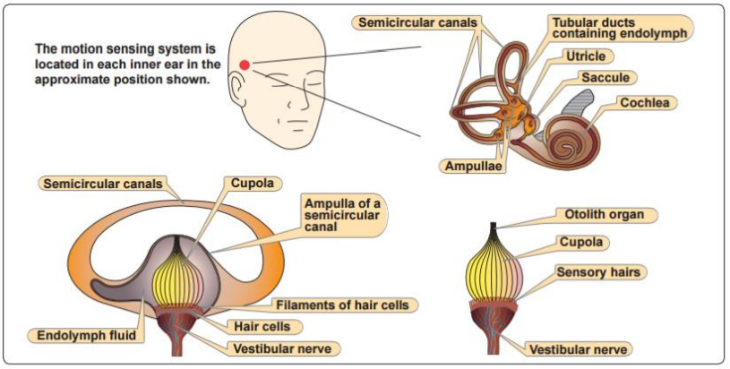
          - Turn Detection
            - In straight and level flight, with no acceleration, the hair cells are upright, and the brain does not sense a turn
            - Placing the aircraft into a turn puts the semicircular canal and its fluid into motion, with the fluid within the semicircular canal lagging behind the accelerated canal walls
              - This lag creates a relative movement of the fluid within the canal. The canal wall and the cupola move in the opposite direction from the motion of the fluid
            - The brain interprets the movement of the hairs to be a turn in the same direction as the canal wall
          - The ear only detects turns of a short duration
            - After approximately 20 seconds, the motion of the fluid in the canals catches up with the canal walls and the hairs are no longer bent
            - At the same speed, the hairs detect no relative movement and the sensation of turning ceases (it feels like straight and level flight)
              - With the hair cells upright, the brain receives the false impression that the turning has stopped
            - When the aircraft rolls back to straight-and-level flight, the fluid in the canal moves briefly in the opposite direction. This sends a signal to the brain that is falsely interpreted as a turn in the opposite direction
              - In an attempt to correct the falsely perceived turn, the pilot may reenter the original turn
            - This can be demonstrated: Establish a 30o bank turn, tell the student to close their eyes and let you know when the aircraft is flying straight. Maintain the turn, after about 20 seconds the student should feel as though the aircraft is out of the turn, have them open their eyes. Try it again, but this time once they believe the aircraft is straight, roll out of the bank. The student will feel like the aircraft is turning in the opposite direction.
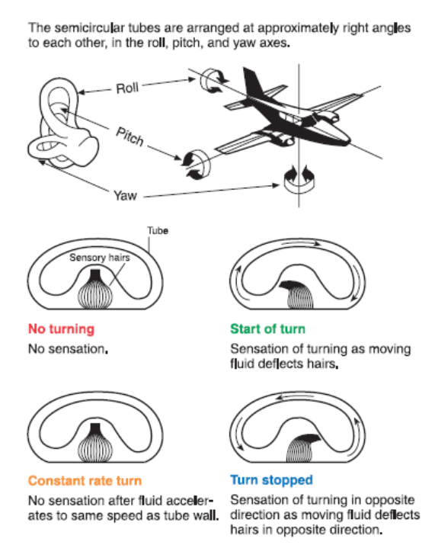
      - Otolith Organs
        - Explanation
          - Detect linear acceleration/gravity
          - A gelatinous membrane containing chalk like crystals covers the sensory hairs
          - When the pilot tilts his head, the weight of these crystals causes this membrane to shift due to gravity and the sensory hairs detect the shift
          - The brain orients this new position to what it perceives as vertical
        - Acceleration
          - Forward acceleration gives the illusion of the head tilting backward
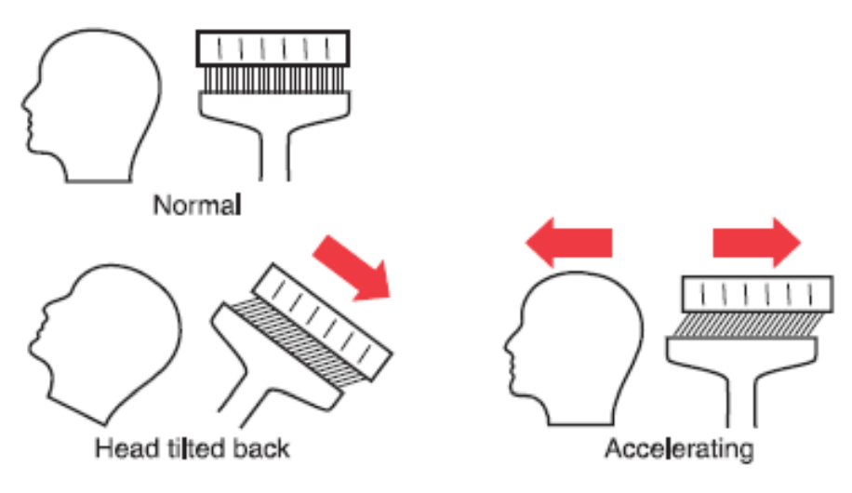
    - Postural System (nerves)
      - Nerves in the body’s skin, muscles, and joints constantly send signals to the brain, which signals the body’s relation to gravity
      - Acceleration will be felt as the pilot is pushed back into the seat
      - False Sensations
        - Forces created in turns can lead to false sensations of the true direction of gravity, and may give the pilot a false sense of which way is up
        - Uncoordinated turns, especially climbing turns, can cause misleading signals to be sent to the brain
        - Skids and slips give the sensation of banking or tilting
        - Turbulence can create motions that confuse the brain as well
        - Fatigue or illness can exacerbate these sensations and ultimately lead to subtle incapacitation
  - Countering the sensations
        - Recognize the problem, disregard the false sensations, and while relying totally on the flight instruments, use the eyes to determine the aircraft attitude
        - The pilot must have an understanding of the problem and the self-confidence to control the aircraft using only instrument indications
- Motion Sickness
  - Cause
    - Caused by the brain receiving conflicting messages about the state of the body
    - Anxiety and stress are also a cause
  - Symptoms
    - General discomfort
    - Nausea
    - Dizziness
    - Paleness
    - Sweating
    - Vomiting
  - Treatment
    - Open fresh air vents
    - Focus on objects outside the airplane
    - Avoid unnecessary head movement
    - Generally goes away after a few flight lessons
      - After more used to flying and stress/anxiety are reduced
- Carbon Monoxide Poisoning
  - How it Happens – In the Plane
    - Carbon Monoxide (CO) is a colorless, odorless gas produced by all internal combustion engines
    - Aircraft heater vents and defrost vents provide CO a passageway into the cabin, particularly if the engine exhaust system has a leak or is damaged
  - How it Happens – In the Body
    - CO attaches itself to the hemoglobin in the blood
      - It does this about 200 times easier than oxygen
    - CO prevents the hemoglobin from carrying oxygen to the cells
      - Resulting in Hypemic Hypoxia
    - It can take up to 48 hours for the body to dispose of CO
    - If the poison is severe enough it can result in death
  - Effects of CO
    - Headache
    - Blurred vision
    - Dizziness
    - Drowsiness
    - Loss of muscle power
  - Detecting and Correction
    - If a strong odor of exhaust gases is detected, assume the CO is present
      - However, CO may be present in dangerous amounts even if no exhaust odor is detected
    - If exhaust odor is noticed or any symptoms are experienced immediate corrective actions should be taken
      - Turn off the heater
      - Open fresh air vents and windows
      - Use supplemental oxygen, if available
- Stress and Fatigue
  - Stress
    - The body’s response to physical and psychological demands placed upon it
    - Body’s Reaction
      - Releasing chemical hormones (such as adrenaline)into the blood
      - Increasing metabolism to provide more energy to the muscles
      - The blood sugar, heart rate, respiration, blood pressure, and perspiration all increase
    - Stressors
      - Physical stress (noise or vibration)
      - Physiological stress (fatigue)
      - Psychological stress (difficult work or personal situations)
    - Categories of Stress
      - Acute Stress (short term)
        - Involves an immediate threat that is perceived as danger
        - The type of stress that triggers a “fight or flight” response in an individual
        - Normally, a healthy person can cope with acute stress and prevent stress overload
        - On-going acute stress can develop into chronic stress
      - Chronic Stress (long term)
        - A level of stress that presents an intolerable burden, exceeds the ability of an individual to cope, and causes individual performance to fall sharply
        - Causes
          - Unrelenting psychological pressures such as loneliness, financial worries and relationship or work problems
        - Pilots experiencing this level of stress are not safe and should not exercise their airman privileges
  - Fatigue
    - Effects
      - Degradation of attention and concentration
      - Impaired coordination
      - Decreased ability to communicate
    - Causes
      - Sleep loss
      - Exercise
      - Physical work
      - Stress and prolonged performance of cognitive work can result in mental fatigue
    - Categories
      - Acute Fatigue (short term)
        - Definition
          - Normal occurrence in everyday life
          - Tiredness felt after a period of strenuous effort, excitement, or lack of sleep
        - Skill Fatigue – A special type of acute fatigue
          - Effects on performance
          - Timing Disruption
            - Appearing to perform a task as usual, but the timing of each component is slightly off.
            - Makes a pattern of the operation less smooth as each component is performed as if it is separate instead of part of an integrated activity
          - Disruption of the perceptual field
            - Concentrating attention upon movements or objects in the center of vision and neglecting those in the periphery
            - May be accompanied by loss of accuracy and smoothness in control movements
        - Causes
          - Mild hypoxia
          - Physical stress
          - Psychological stress
          - Depletion of physical energy resulting from psychological stress
        - Prevention
          - Proper diet: Prevents the body from having to consume its own tissues as an energy source
          - Adequate rest and sleep: Maintains the body’s store of vital energy
      - Chronic Fatigue
        - Definition
          - Fatigue extending over a long period of time
          - Usually has psychological roots, although an underlying disease is sometimes responsible
        - Symptoms
          - Weakness
          - Tiredness
          - Palpitations of the heart
          - Breathlessness
          - Headaches
          - Irritability
          - Stomach or intestinal problems (More rare)
          - Generalized aches and pains throughout the body
          - Emotional Illness (when conditions become serious enough)
        - Prevention
          - Usually requires treatment by a physician
    - Prevention
      - If suffering from acute fatigue, stay on the ground
      - Fatigue in the cockpit cannot be overcome through training or experience
      - Getting adequate rest is the only way to prevent fatigue
        - Avoid flying without:
          - A full night’s rest
          - After working excessive hours
          - After an especially exhausting or stressful day
      - Suspected chronic fatigue should be treated by a physician
- Dehydration
  - Definition
    - Critical loss of water from the body
  - Effects
    - First noticeable effect is fatigue
      - In turn, makes top physical and mental performance difficult, if not impossible
  - How it affects flying
    - As a pilot, flying for long periods of time hot summer temperatures or at high altitudes increases the susceptibility of dehydration since the dry air at altitude tends to increase the rate of water loss from the body
    - If the fluid is not replaced, fatigue progresses to dizziness, weakness, nausea, tingling of the hands and feet, abdominal cramps, and extreme thirst
  - Prevention
    - Carry an ample supply of water to be used frequently on any long flight, whether thirsty or not
    - If the airplane has a canopy or roof window, wearing light colored, porous clothing and a hat will provide protection
    - Keep the cockpit well ventilated
- Alcohol and Other Drugs
  - DON’T drink and fly
    - Hangover can impair pilots
    - More susceptible to disorientation and hypoxia
    - FARS – 8 hrs ‘from bottle to throttle’
  - Medications
    - Can affect pilot performance
      - Side effects of medicines impair judgment, coordination, vision
    - Anything that depresses nervous system can make a pilot more susceptible to hypoxia
    - Do not fly while taking any medication, unless approved by the FAA
- Nitrogen and Scuba Diving
  - Provide the body with enough time to rid itself of excess nitrogen absorbed from diving
    - Otherwise decompression sickness can occur and create an in-flight emergency
      - Bubbles in the bloodstream
    - Wait at least 12 hrs after a dive which did not require a controlled ascent
      - Before flight altitudes up to 8,000’
    - Wait at least 24 hrs after a dive which has required a controlled ascent
    - For flights above 8,000’ wait at least 24 hrs
- IM SAFE
  - Your own preflight
    - Illness
    - Medical
    - Stress
    - Alcohol
    - Fatigue and Food
    - Emotion

