AIRCRAFT FLIGHT INSTRUMENTS AND NAVIGATION EQUIPMENT

Objective:
To familiarize the student with the various instruments, navigation, anti-ice/deicing, and weather detection equipment available so as to equip the student to better cope with instrument flight and navigation in the IFR environment.

Content:
- Flight instrument systems and their operating characteristics
  - Pitot-static system
  - Attitude indicator (attitude instrument, AI, artificial horizon, gyro horizon)
  - Heading indicator/horizontal situation indicator/remote magnetic indicator
  - Magnetic compass
  - Turn-and-slip indicator/turn coordinator
- Navigation equipment and their operating characteristics
  - VHF omnirange (VOR)
  - Distance measuring equipment (DME)
  - Instrument landing system (ILS)
  - Marker beacon receiver/indicators
  - Automatic direction finder (ADF)
  - Global positioning system (GPS)
- Anti-ice/deicing and weather detection equipment and their operating characteristics
  - Airframe
  - Propeller or rotor
  - Air intake
  - Fuel system
  - Pitot-static system
  - Radar/lightning detection system

References:
AIM, Instrument Flying Handbook, FAA-H-8083-15,
AC 90-94 Guidelines for Using GPS, GPS NOTAMs,
GPS PowerPoint Presentation (Washington FSDO),
Aircraft Icing (AOPA Safety Advisory)
AC20-113 Pilot Precautions and Procedures to be taken in Preventing Aircraft Reciprocating Engine Induction System and Fuel System Icing Problems,
AC91-51A Effect of Icing on Aircraft Control and Airplane Deice and Anti-Ice Systems,
AC91-74 Pilot Guide: Flight in Icing Conditions

Completion Standards:
The lesson is complete when the instructor determines that the student has a proper understanding of the aircraft instrumentation, navigation, anti-ice/deicing, and weather detection equipment through the use of oral or written examinations.
Instructor Notes:
- Flight instrument systems and their operating characteristics
  - Pitot-static system
    - Includes three basic pressure-operated instruments:
      - Sensitive altimeter
      - Airspeed indicator (ASI)
      - Vertical speed indicator (VSI)
    - All three pressure-operated instruments depend on accurate sampling of static (ambient) pressure at two or more locations outside the aircraft

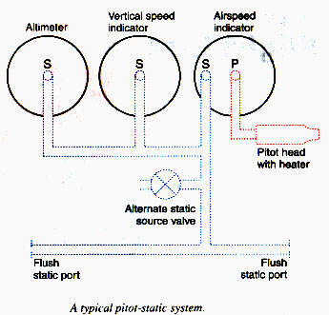

      - Static pressure is pressure of the air that is still, or not moving, measured perpendicular to the surface of the aircraft
      - Static ports may be on the side of an electrically heated pitot-static head

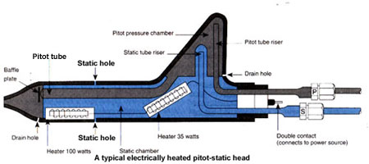

      - Static pressure may be measured through flush ports on the side of the fuselage
        - Ports are normally paired, one on each side of the aircraft
        - Area around ports may be heated to help prevent ice blockage
      - If static ports block, pilot may open the static system alternate source to provide static pressure from a source inside the aircraft
    - Pitot pressure (impact or ram air pressure) is used to measure airspeed
      - Measured through an open-eyed pitot tube pointed directly into the relative wind
      - Pitot tube connects only to ASI
    - Position error
      - Under some flight conditions, especially at higher angles of attack in landing configuration, disturbances in the air around the static port(s) may cause errors in pressure-operated instrument indications
      - The POH contains any position error corrections to apply to airspeed indications under specified conditions
    - Sensitive altimeter
      - The sensitive altimeter is an aneroid barometer that measures absolute pressure of ambient air and displays it in terms of height above a selected pressure level
      - Principle of operation
        - Sensitive element is a stack of evacuated, corrugated bronze aneroid capsules the thickness of which changes with air pressure
        - An adjustable barometric scale, visible in the Kollsman window, allows the pilot to set reference pressure from which altitude is measured (from 28.00 to 31.00 inches Hg)
          - A change in scale of 1 inch Hg changes altimeter reading by 1,000 feet
          - To read pressure altitude, set scale to 29.92 inches Hg
          - Set scale to local altimeter setting to indicate existing height above sea level
      - Altimeter errors
        - Preflight check for mechanical error: with barometric scale set to local altimeter setting, altimeter should indicate within 75 feet (maximum error) of airport elevation
        - Nonstandard temperature effects
          - Warmer than standard air: pressure levels are farther apart; altimeter indicates lower; aircraft will be higher (than in standard air)
          - Colder than standard air: pressure levels closer together; altimeter reads higher; aircraft is lower ("flying from high to low, look out below!")
          - Very cold air: altimeter error may be significant; increase minimum terrain clearance altitudes; notify ATC if flying higher than assigned altitude
          - ICAO Cold Temperature Error Table (AIM)
        - Nonstandard pressure effects
          - When flying into lower pressure, altimeter reads higher than true altitude and aircraft is lower than indicated ("flying from high to low, look out below!")
    - Encoding altimeter
      - A sensitive altimeter with an internal computer that measures pressure altitude (referenced from 29.92 inches Hg) and delivers data to Mode C transponder which transmits data to ATC ground controller
      - 14 CFR part 91.217 requires that the transponder transmitted altitude must be within 125 feet of the pressure altitude (29.92 in Hg) indicated by the altimeter that the pilot is using to maintain flight altitude
    - Absolute altimeter (radar or radio altimeter)
      - Measures time taken by transmitted signal to travel from aircraft to ground below and back (not a pressure-operated instrument)
      - Most have provisions for setting a minimum altitude at which a warning light or sound will be produced
    - Airspeed indicator (ASI)
      - ASI is a differential pressure gauge that measures dynamic pressure, the difference between static and total, or ram, pressure caused by movement of the aircraft through the air
      - Corrugated phospor-bronze aneroid, or diaphragm, receives ram pressure from the pitot tube, while the sealed instrument case receives static pressure
      - Indicated airspeed (IAS) is the uncorrected airspeed shown on the ASI dial
      - Calibrated airspeed (CAS) is IAS corrected for instrument and position errors; POH provides CAS for IAS with various flap and landing gear configurations
      - Equivalent air speed (EAS) is CAS corrected for compression of air in the pitot tube (same as CAS in standard atmosphere at sea level; less than CAS at higher altitudes and faster airspeeds)
      - True airspeed (TAS) is CAS corrected for nonstandard temperature and pressure
        - TAS = CAS in standard atmosphere at sea level
        - Some true airspeed indicators have temperature-compensated aneroid bellows
        - Others have a knob requiring pilot input to align outside air temperature (OAT) with pressure altitude so that TAS is then indicated
      - Mach number is the ratio of TAS to the speed of sound in the same atmospheric conditions; it may be indicated by a Machmeter
      - Maximum allowable airspeed indicator has an additional pointer indicating never-exceed speed which changes with altitude
      - Airspeed color codes:
        - White arc: flap-operating range (from flaps-down stall speed to maximum airspeed with flaps down)
        - Green arc: Normal operating range (from flaps-up stall speed to maximum airspeed in rough air)
        - Blue radial line: Best single-engine rate of climb speed
        - Yellow arc: Structural warning area (from maximum rough air speed to never-exceed speed)
        - Red radial line: Never-exceed speed
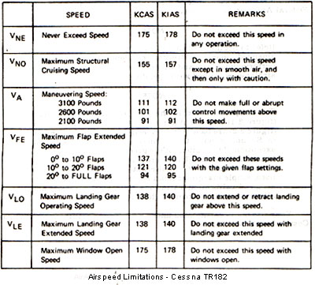

    - Vertical speed indicator (VSI) (vertical velocity indicator, VVI, formerly rate-of-climb indicator)
      - Rate-of-pressure-change instrument indicates deviation from a constant pressure level; indicates rate of climb or descent
      - Aneroid and instrument case both receive static pressure, but case is vented through a calibrated orifice (a hole of specific diameter used to delay pressure change)
      - VSI pointer lags a few seconds behind actual pressure change, but is more sensitive than an altimeter
      - An instantaneous VSI (IVSI) has two aircraft pitch-sensitive accelerometers that eliminate the lag time of the VSI

  - Attitude indicator (attitude instrument, AI, artificial horizon, gyro horizon)
    - Takes advantage of one of the principle properties of the gyroscope: rigidity in space
    - Operating mechanism: small brass wheel (gyroscope) with a vertical spin axis
      - Spun at high speed by either
        - Stream of air (via vacuum system), or
        - Electric motor
      - Mounted in a double gimbal with axes perpendicular to gyro spin axis allowing free motion in two planes around the gyro (pitch and roll)
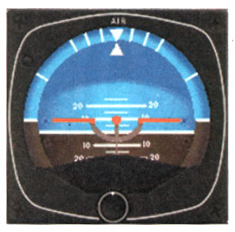
    - Horizon disk fixed to gimbals remains in same plane as gyro
      - Blue top half and brown bottom half represent sky and ground, respectively
      - Pitch marks indicate degree of up or down pitch
      - Bank index indicates bank angle
    - Symbolic aircraft is mounted on instrument case over horizon disk
      - Knob allows pilot to raise or lower aircraft symbol to compensate for pitch trim changes
      - Width of wings and center dot represent approximately 2 degrees of pitch change
    - Erection mechanism inside case applies a corrective force any time gyro tilts from the vertical
    - Older gyros tumbled at extremes of pitch (60 degrees) or roll (100 degrees), and so had a caging mechanism to lock gyro in vertical plane during such maneuvers
    - After engine start-up, it takes two or three to as long as five minutes for gyro self-erecting mechanism to be fully effective
    - Errors
      - Slight nose up or down during rapid acceleration or deceleration respectively
      - Possible small bank and pitch errors after 180 degree turn
      - Errors are small and correct themselves within a minute or so in SLF

  - Heading indicator/horizontal situation indicator/remote magnetic indicator
    - Heading indicator (HI, directional gyro, DG)
      - HI gyroscope
        - Double gimbal mounted
        - Horizontal spin axis, so senses rotation about aircraft vertical axis
        - Rigidity in space courses HI to maintain heading indication without the oscillation and other errors inherent in the magnetic compass
      - Not north-seeking (except slaved gyro indicator) so must be periodically set to the heading indicated by the magnetic compass
      - DGs usually air-driven by vacuum system; filtered air blows against buckets cut in periphery of gyro wheel
      - Bearing friction causes gyro precession, so check and reset HI to agree with magnetic compass about every 15 minutes
      - HI precession should be less than 3° in 15 minutes
      - HI gyro drives a vertical compass card dial (azimuth card)
      - Heading is indicated by nose of symbolic aircraft and lubber line on instrument glass
      - Spring-loaded knob on front may be pushed in and turned to rotate gyro and azimuth card to reset HI, then released to disengage from gimbals
      - Check and if necessary reset HI to agree with magnetic compass about every 15 minutes
    - Horizontal situation indicator (HSI)
      - HSI is a direction indicator that uses output from a flux valve to drive an azimuth card
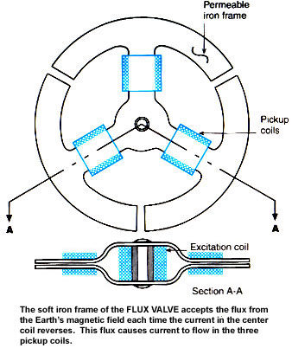
      - Combines magnetic compass with navigation signals and glide slope to indicate location relative to a chosen course
      - Heading indicated by lubber line
      - Desired course (VOR/LOC/RNAV) selected by rotating course select pointer (arrowhead) using course select knob
      - Aircraft symbol and course deviation bar display location relative to selected course
      - TO/FROM indicator is triangular-shaped pointer
      - Glide slope deviation pointers below aircraft symbol indicate aircraft above glide slope
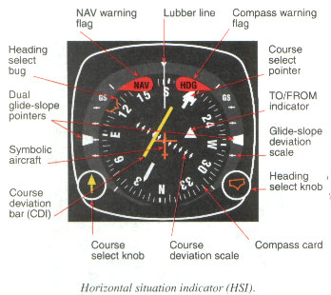
      - If, as in some HSIs, azimuth card is not a remote indicating compass, then it must be periodically checked and reset to agree with magnetic compass
    - Remote magnetic indicator
      - Remotely mounted magnetic slaving transmitter
        - Usually in wingtip to eliminate magnetic interference
        - Remote flux valve is the system direction-sensing device
        - Remote heading indicator unit torque motor is operated by amplified flux valve signal and precesses gyro to align it with signal
        - Connected electrically to panel-mounted pictorial navigation indicator (HSI)
      - Panel-mounted components in a typical system
        - HIS
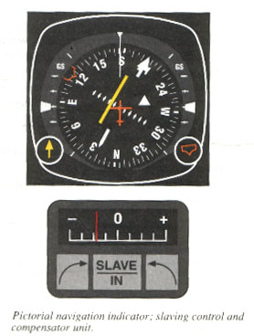
        - Slaving control and compensator unit
- Slaving meter indicates left (counterclockwise) or right compass card error
- Pushbutton selects slaved or free gyro modes
- In free gyro mode, adjust compass card by depressing appropriate heading drive button
        - Radio magnetic indicator (RMI)
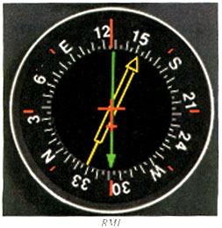
          - Compass card driven by flux valve
          - One pointer driven by automatic direction finder (ADF)
          - Another pointer driven by very-high-frequency omnidirectional range (VOR)

  - Magnetic compass
    - Operating principle
      - Earth is magnet whose lines of flux leave its surface at magnetic north pole and reenter at magnetic south pole
      - Most direction indicators make use of one of two important magnetic principles
        - Free magnets align with lines of flux (magnetic compass)
        - Electrical current is induced in conductor that cuts across lines of flux (flux gate compass)
    - Magnetic compass is required by 14 CFR part 91 for both VFR and IFR flight
    - Components
      - Two small magnets attached to a
      - Metal float that is sealed inside a
      - Bowl of clear fluid similar to kerosene
      - Graduated scale, the card, marked with cardinal direction letters, numbers every 30° between letters, and long and short marks representing 10° and 5° respectively
      - Lubber line reference indicating magnetic direction
      - Jewel-and-pivot type mounting of float and card assembly allows free rotation and tilting to about 18° bank
      - Compensator assembly allows aviation maintenance technician (AMT) to correct deviation error
    - Compass errors
      - Variation
        - Difference between true and magnetic directions is called variation
        - Isogonic lines connect points with the same variation and are numbered to indicate degrees of variation along each one

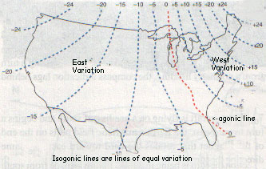

        - Along the agonic line, passing near Chicago, the variation is zero
        - East of agonic line is the west variation area (magnetic north pole is west of geographic north pole) where west variation is added to true course (TC) to obtain magnetic course (MC) to be flown:
MC = TC + West Variation
        - West of agonic line is the east variation area (magnetic north pole is east of geographic north pole) where east variation is subtracted from true course to obtain magnetic course:
MC = TC - East Variation
      - Deviation
        - Caused by local magnetic fields within the aircraft
        - Different on each heading
        - AMT minimizes by "swinging the compass" - adjusting compensating magnets as needed every 30° while aircraft is aligned with magnetic directions indicated on a compass rose on the surface
        - Deviation errors that cannot be eliminated by AMT are recorded on a compass correction card placed near the magnetic compass for use by pilot in flight
      - Compass course (CC)
        - Course to be maintained under the magnetic compass lubber line during cross country flight leg in order to fly appropriate true course over the ground
        - True course (TC) corrected for variation (V) and deviation (D) errors:
TC +/- V = MC
MC +/- D = CC
      - Dip errors
        - Northerly turning error
- Caused by pull of vertical component of Earth's magnetic field
- When turning east (or west) from a north heading, compass initially shows a turn in the opposite direction (compass lags)
- When turning east (or west) from a south heading, compass initially shows an exaggerated turn in the same direction (compass leads)
- NOSE ("North Opposite, South Exaggerates")
        - ii) Acceleration error
            - Acceleration in SLF on a heading of east or west causes magnetic compass to indicate a turn to the north
            - Deceleration in SLF on a heading of east or west causes magnetic compass to indicate a turn to the south
            - ANDS (Accelerate North, Decelerate South)
      - Oscillation error
        - Combination of all other errors results in compass swinging back and forth around heading being flown
        - Set gyroscopic HI to average compass heading between swings
    - Compass turns
      - With bank angle 15-18° (approximately standard rate turn), amount of lead or lag when turning to north or south varies with and is approximately equal to the current local latitude (e.g., 41° at KLPR)
      - Turn to north: lead for roll out = normal lead + latitude
Near KLPR lead to N = 5+41 = 46°, i.e.,
Start rollout at approximately 45° or 315°
      - Turn to south: lead for roll out = pass south heading by latitude - normal lead
Near KLPR lead to S = 41-5 = 36° past S, i.e.,
Start rollout at approximately 145° or 215°
      - Turn to east or west from north, led by approximately 10°
      - Turn to east of west from south, led by approximately 5°
      - Interpolate for other directions
      - Use smooth control technic and accurate pitch-and-bank control

  - Turn-and-slip indicator/turn coordinator
    - These rate instruments operate on the principle of gyroscopic precession
    - Turn-and-slip indicator (needle and ball, turn-and-bank indicator)
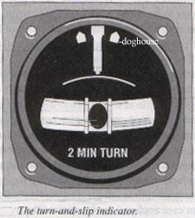
      - Inclinometer (slip-skid indicator)
        - Black glass ball sealed inside glass tube partially filled with clear liquid
        - Indicates quality of turns: relationship between bank angle and rate of yaw
      - Turn indicator
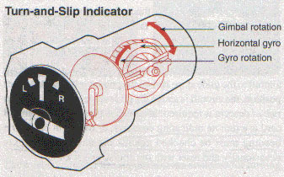
        - Gyro spin axis parallel to aircraft lateral axis and mounted in a single gimbal with rotation axis parallel to aircraft longitudinal axis
        - Needle pointing to doghouse indicates standard rate turn (3° per sec)
    - Turn coordinator
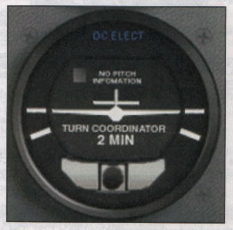
      - Inclinometer (slip-skid indicator, coordination ball)
        - Similar to that in the turn-and-slip indicator
        - Centered ball indicates coordinated turn
      - Turn indicator
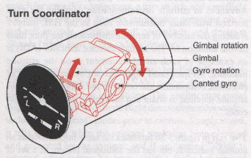
        - Gyro gimbal frame angled upward about 30° allowing it to sense both roll and yaw
        - Wing of symbolic airplane pointing to mark indicates standard rate turn

- Navigation equipment and their operating characteristics
  - VHF omnirange (VOR)
    - Description
      - The primary navigation aid (NAVAID) used by general aviation
      - Provides 360° azimuth information accurate to within 1°
      - If collocated with DME, then resultant VOR/DME provides both azimuth and distance information
      - If collocated with military tactical air navigation unit (TACAN), then resultant VORTAC provides both azimuth and distance information
      - Courses oriented from the VOR station are called radials
      - VOR information is not influenced by aircraft attitude or heading
      - Transmitted also:
          - Morse code identification signal
          - Voice communication
      - Classified by operational use and service volumes (A.I.M 1-1-8)
          - Standard high altitude VOR service volume
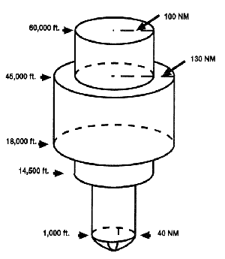
ii) Standard low altitude VOR service volume
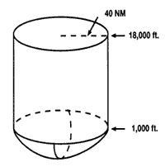
iii) Standard terminal VOR service volume
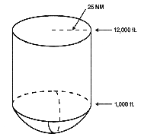
NOTE: Check NOTAMs or A/FD for accuracy problems of specific VORs
    - VOR components
      - Ground station
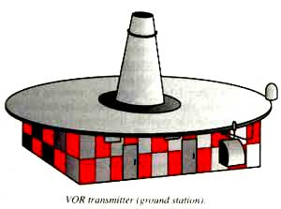
          - Automatic monitoring system
          - Identification
                - Morse code
                - Voice
          - VHF frequencies between 108.0 and 117.95 MHz (only even tenths between 108.0 and 112.0 to preclude conflict with ILS frequencies)
          - Accuracy of signal is generally within +/-1° (AIM)
      - Airborne equipment
          - Antenna
          - Receiver
          - Indicator instrument
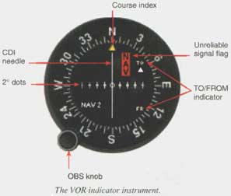
            - Omnibearing selector (OBS)
            - Course deviation indicator (CDI) needle
            - Ambiguity or TO/FROM indicator
            - Index
            - Flags or other weak signal indicator (OFF or blank TO/FROM indicator window)
            - May be part of HSI
      - VOR operational use
          - Orientation
          - Tune VOR to appropriate frequency
            - Audibly identify station
            - Rotate OBS to center CDI needle with FROM indication
            - Read azimuth (radial) at index
            - With a TO indication and centered CDI needle, index indicates magnetic bearing to the station
            - Above the station, in the cone of confusion, CDI needle deviates back and forth
            - Reverse sensing results if heading to the station with a FROM indication or from the station with a TO indication
            - A second VOR can allow simultaneous determination of location along a radial from the first VOR
      - Tracking TO and FROM the station
          - TO the station: Rotate the OBS until the CDI needle centers with a TO indication and fly course indicated, correcting for wind (left needle deflection indicates left crosswind)
          - FROM the station: Center CDI needle with FROM indication and fly course indicated, correcting for crosswind
      - Course interception
          - For initial orientation, turn to fly parallel to and in same direction as desired course
          - Determine difference between desired and current radials
          - Double the difference to determine intercept angle between 20° and 90°
          - Rotate OBS to set desired course at index
          - Turn to intercept heading
          - Fly until CDI centers
          - Turn and track desired course inbound or outbound
          - For example:
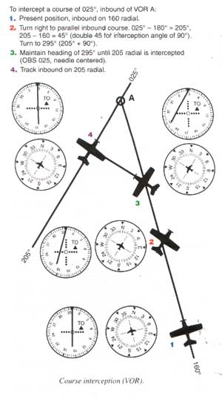
Course interception without initial turn to parallel:
                - Determine present radial you are on
                - Find difference between radial on and radial to intercept
                - Double this difference to find intercept angle between 20 and 90°
                - Turn to intercept new radial at this angle
      - VOR operational errors
          - Careless identification of station
          - Failure to check accuracy/sensitivity
          - Turning in wrong direction during orientation
          - Failure to check ambiguity indicator, resulting in reverse sensing and corrections in the wrong direction
          - Failure to initially parallel desired radial on a track interception problem
          - Overshooting or undershooting radial on interception
          - Over controlling corrections during tracking, especially close to the station
          - Misinterpretation of station passage (voice transmission may cause transient fluctuation of TO/FROM indicator)
          - Chasing the CDI needle resulting in homing instead of tracking
          - Certain propeller RPM settings may cause CDI fluctuation of up to 6° (correct with slight RPM change)
      - VOR receiver accuracy check
          - Sensitivity check: note number of degrees of change as OBS is rotated to move CDI from center to last dot on either side (should be less than 10-12° on either side)
          - 14 CFR Sec. 91.171 requires VOR accuracy check within 30 days prior to IFR flight
          - VOR test (VOT) facility or repair station accuracy check
            - Locations published in A/FD and IFR area and low altitude enroute charts
            - Repair station frequency normally 108.0
            - Identify with series of dots or continuous tone (contact FSS for specific VOR identification information)
            - Instrument should indicate 0° FROM (i.e., on the 0° radial) or 180° TO (reminder: "Cessna one-eighty-TO")
            - Airborne check may be permitted for specific areas/altitudes stated in the A/FD
          - Certified surface or airborne checkpoints
            - Specific radials at specific points on surface (or airborne)
            - Error should be no more than 4° (6° airborne) after applying compass card correction
            - Dual system VORs (independent except for antenna) may be checked against each other: bearings to station should not differ by more than 4°

  - Distance measuring equipment (DME)
    - Description
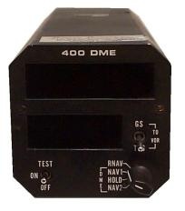
      - Aircraft DME transmits interrogating radio frequency (RF) pulses that trigger ground receiver equipment to transmit reply pulses back to the aircraft DME
      - Aircraft DME measures time between sending RF pulse to receiving reply and converts it to distance in nautical miles (NM) from the ground station
      - Some receivers provide groundspeed in knots, accurate only when tracking directly to or from the station
    - DME components
      - Ground station may be collocated with other navaids to provide course and distance information as VOR/DME, VORTAC, ILS/DME and LOC/DME
        - Frequency pairing plan provides for automatic selection of DME frequency when this collocated navaid is selected
        - DME frequencies are UHF between 962 MHz and 1213 MHz
        - Some aircraft DME must be separately tuned
      - Airborne equipment
        - Antenna and receiver
        - Pilot controlled receiver features
          - Channel frequency selector
          - On/Off/Volume switch
          - Mode switch (distance, groundspeed or time to station may be selected)
          - Hold function - holds current DME channel (useful for ILS approach when DME is nearby but not collocated)
          - Altitude - some DME correct for slant-range error
        - Operational use
          - DME allows accurate determination of distance of aircraft from ground DME station
          - Flying DME arcs
            - Flying track that is constant distance from station
            - General method
              - Track inbound (or outbound) on a radial to intercept the DME arc
              - Lead turn by 0.5 NM with GS < 150 knots
              - Turn approximately 90°
              - Monitor DME to time rollout to intercept arc
            - DME arc with wind
              - Wind-drift correction constantly changes throughout the arc
              - Important to maintain situational awareness
              - Maintaining arc is simplified by keeping slightly inside the curve
            - Flying DME arc using VOR
              - Center the CDI needle upon completion of 90° arc-interception turn, then
              - Note aircraft heading at left or right side of VOR
              - Adjust aircraft heading to compensate for wind or to correct for distance
              - Re-center CDI and note new primary heading indicated whenever the CDI has moved 2-4° from center
            - Flying DME arc using VOR and 10-10 method
      - Set OBS to radial 10° ahead (FROM)
      - When CDI centers, reset OBS to radial 10° ahead
      - Check DME (at each CDI center/OBS reset)
        - On arc => turn 10°
        - Inside => maintain heading
        - Outsite arc => turn 2 x 10 = 20°
            - Flying DME arc using RMI
              - If no wind, can theoretically fly precise arc by maintaining relative bearing of 90° or 270°
              - In actual practice, fly a series of short legs
              - With RMI bearing pointer on wingtip reference (90° or 270° position), maintain heading and allow bearing pointer to move 5° to 10° behind wingtip
              - Turn toward station until pointer points 5° to 10° ahead of wingtip
              - Continue these last two steps to maintain arc
              - If crosswind drifts aircraft away, turn in until bearing pointer points ahead of wingtip
              - If crosswind drifts aircraft closer, turn out until bearing pointer points behind wingtip
              - Change relative bearing 10° to 20° for each 0.5 NM deviation from arc
            - Intercepting lead radials
              - Lead radial is radial at which turn is started to transition from DME arc to inbound course
              - Lead may be < 5° at < 150 knots
              - With RMI, set course of radial to be intercepted and determine approximate lead
              - Intercepting localizer from DME arc is similar
              - If depicted lead radial provides 7° of lead, then half-standard-rate turn should be used initially
              - GPS substitution for DME (or ADF)
            - Operational DME errors
              - DME/DME fixes (from two DME stations) are more accurate than VOR and DME
              - DME signals are line-of-sight, so DME distance is slant-range distance
                - Slant-range error is greatest when aircraft is directly over ground station when DME will then display altitude in NM
                - Slant-range error is negligible if aircraft is > 1 mile form station for each 1,000 feet of altitude above station

  - Instrument landing system (ILS)
    - ILS is an electronic system that provides horizontal and vertical guidance to a specific runway, used to execute a precision instrument approach.
    - Three types based on equipment at airport and pilot experience level
      - Category I - approach height not less than 200 feet above touchdown
      - Category II
- Approach height not less than 100 feet above touchdown
- Requires special pilot certification
      - Category III
- No decision height
- Requires special pilot certification
    - Ground components
      - Localizer (LOC) equipment
        - Antenna array located beyond opposite end of runway that radiates a field pattern providing left/right guidance along the centerline of the runway (in both directions)
        - Transmits on odd tenths from 108.1 to 111.95 MHz out to 18 NM away from and 4,500 feet above the antenna site
        - LOC course width normally 5° (full-scale deflection when aircraft is 2.5° to either side of centerline)
        - Audibly identified by "I" plus three-letter designator and includes a voice feature for use by ATC
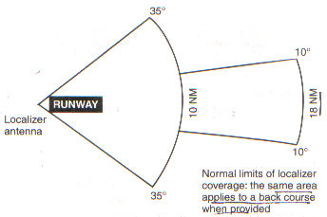
      - Glide slope (GS) equipment
        - Located in a building 750-1,250 feet from approach end of runway, 400-600 feet to one side of centerline
        - Projection angle normally adjusted to 2.5-3.5° above horizontal to intersect the middle marker (MM) at about 200 feet and the outer marker (OM) at about 1,400 feet above runway elevation
        - GS signal is radiated on front course only (NOT on back course)
        - GS normally 1.4° thick (about 1,500 feet at 10 NM from touchdown, narrowing to just a few feet at touchdown)
      - Marker beacons
        - Low-powered transmitters direct signal upward in a small fan-shaped pattern
        - Outer marker (OM) located 4-7 miles from airport near position where aircraft at appropriate altitude will intercept glide path
        - Middle marker (MM) located approximately 3,500 feet from landing threshold at position where glide-slope centerline is about 200 feet above touchdown zone elevation
        - Inner marker (IM) located at decision height on glide path for Category II approach
        - There may be a back-course marker to indicate the back-course FAF
      - Compass locator
        - Supplementary, optional component that may be employed to increase safety and utility
        - A low-powered NDB collocated with the OM and/or MM facilities
        - Outer marker locator ID code consists of the first two letters of the LOC 3-letter identifier
        - Middle marker locator ID code consists of the second two letters of the 3-letter LOC identifier
      - Approach lighting systems (ALS)
        - Provide directional, distance and glide path information for safe transition to runway threshold
        - Common ALS configurations
- Approach light system with sequenced flashing lights (ALSF)
- Simplified short approach light system with runway alignment indicator lights (SSALR)
- Medium intensity approach light system with runway alignment indicator lights (MALSR)
- Runway end identification lights (REIL)
- Medium intensity approach light system with sequenced flashing lights (and runway alignment) (MALSF)
- Omnidirectional approach light system (ODALS)
        - High-intensity flasher system ("the rabbit") lights flash in sequence towards the runway (2 times per second)
        - REIL are a pair of synchronized flashing lights one on each side of threshold facing approach area
        - Visual approach slope indicator (VASI) projects a visual glide path providing safe obstruction clearance within the approach zone
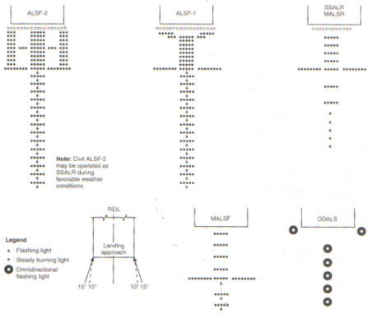
      - ILS airborne components include receivers and indicator instruments for the following
        - Localizer
          - Typically VOR receiver is also a localizer (LOC) receiver that switches to LOC automatically when sensing odd tenths between 108 and 112 MHz
          - Warning flag shows when unstable signal or receiver malfunction occurs
        - Glideslope (GS)
          - Usually tuned automatically with LOC
          - Cross-pointer indicator is both a LOC and GS indictor
          - GS needle is quite sensitive since glide path is relatively narrow (approximately 1.4° from full up to full down deflection)
          - GS warning flag shows if signal is unstable or receiver malfunctions
        - Marker beacons
          - OM - low-pitched tone, continuous dashes, two per second and purple or blue light
          - MM - intermediate tone, alternate dots and dashes, 95.- per minute and amber light
          - IM - high-pitched continuous dots, six per second and white light
          - BCM (back-course marker) - high-pitched pairs of dots, 72-75 pairs per minute and white light
          - Many units allow selection of 2 sensitivities
- Low gives sharpest indication of position and should be used during an approach
- High provides an earlier indication that aircraft is approaching the beacon
        - ILS function
          - Localizer needle
            - Indicates whether aircraft is right or left of localizer centerline, regardless of aircraft heading
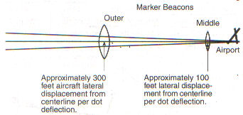
            - OBS has no effect on localizer needle; but it is recommended to set LOC inbound course under course index
            - Remains directional inbound on front course or out bound on back course
          - Flying inbound on back course or outbound on front course
            - Unless reverse sensing is in use, heading corrections to on-course are opposite to needle deflection ("Fly away from the needle." or "You ARE the needle.")
            - Do not use back course signals for approach unless procedure is published and authorized by ATC
          - Maintain LOC centerline with decreasingly small drift corrections, ideally no more than 2° inside the OM
          - Adjust pitch to maintain proper rate of descent and power to maintain proper airspeed along glide path from OM to MM making small corrections based on glideslope needle indications
        - ILS errors
          - LOC and GS signals
            - Reflection from surface vehicles and low-flying (<5,000 feet AGL) aircraft
            - False courses from GS facility at higher vertical angles (e.g. 9-12°) (avoid by flying approach at altitudes specified on approach chart)
          - Marker beacons
            - Inadequate receiver power supply (may utilize power from another source, e.g. ADF, which must be turned on)
            - "Test" position of switch usually tests only the light bulb, not the receiver
          - Operational errors
            - Failure to understand differences between VOR and ILS; that LOC CDI sensing is sharper and faster
            - Disorientation due to poor planning and failure to utilize all available equipment
            - Disorientation on LOC course due to i) above
            - Incorrect localizer interception angles. Helpful to turn on first indication of needle movement (when needle "comes alive"), and use ADF if there is a locator or NDB on inbound course
            - Chasing CDI needle and glide path needles (study the approach before the flight)
        - Simplified directional facility (SDF)
          - Similar to ILS, but course may be wider than standard ILS, resulting in less precision
          - SDF antenna may be offset from runway centerline so that inbound course is not aligned with runway centerline (difference is usually not more than 3°)
          - SDF signal course width is fixed at either 6° or 12°
          - Three-letter SDF identifier is transmitted on SDF frequency
        - Localizer type directional aid (LDA)
          - Accuracy and utility comparable to that of a localizer, but not part of a complete ILS
          - Course width is between 3 and 6°
          - Some LDAs have glideslopes
          - LDA course is not aligned with runway
            - If angle between LDA course and runway is not greater than 30°, then straight-in minimums may be published
            - Angle greater than 30°: only circling minimums are published
          - Identifier is "I" plus 3 letters

  - Marker beacon receiver/indicators
    - Ground elements
      - Low-powered VHF transmitter directs its signal upward in a small fan-shaped pattern
      - Outer marker (OM) located 4-7 miles from airport near position where aircraft at appropriate altitude will intercept glide path
      - Middle marker (MM) located approximately 3,500 feet from landing threshold at position where glide-slope centerline is about 200 feet above touchdown zone elevation
      - Inner marker (IM) located at decision height on glide path for Category II approach
      - There may be a back-course marker to indicate the back-course FAF
    - Airborne marker beacon receiver indicates, aurally and visually, when the aircraft is directly over the transmitter facility
      - OM - low-pitched tone, continuous dashes, two per second and purple or blue light
      - MM - intermediate tone, alternate dots and dashes, 95.- per minute and amber light
      - IM - high-pitched continuous dots, six per second and white light
      - BCM - (back-course marker) - high-pitched pairs of dots, 72-75 pairs per minute and white light
      - Many units allow selection of 2 sensitivities
        - Low gives sharpest indication of position and should be used during an approach
        - High provides an earlier indication that aircraft is approaching the beacon

  - Automatic direction finder (ADF)
    - Description
      - ADF determines and indicates the relative bearing (RB) from the aircraft to a non-directional beacon (NDB) on the ground
      - ADF needle points to the NDB, indicating the RB to the NDB station
      - Magnetic heading (MH) + relative bearing (RB) = magnetic bearing TO the station
MH + RB = MB TO station
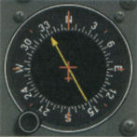
    - NDB components
      - NDB transmits in range of 190-535 kHz
      - Most ADF will also tune to AM radio frequencies (550-1650 kHz) but these do not continuously identify themselves and are more susceptible to sky wave propagation
      - NDB stations may transmit voice, e.g. the AWOS information
      - Before relying on ADF, identify the NDB station by its 2-letter (compass locators) or 3-letter Morse code identifier
    - ADF components
      - "Sense" antenna (non-directional) receives signals equally from all directions
      - "Loop" antenna (bidirectional) receives signals better from two directions
      - When sense and loop antenna information is processed together, directional ambiguity is resolved
    - Indicator instruments
      - Fixed-card ADF or relative bearing indicator (RBI) always indicates zero at top of instrument
      - Movable-card ADF allows pilot to rotate card to place aircraft's heading at top of instrument so needle head then indicates MB to the station (and tail indicates MB from the station)
      - Radio magnetic indicator (RMI) automatically rotates azimuth card to keep aircraft heading at top of instrument
        - Controlled by remote gyrocompass
        - Two needles can be used to indicate navigation information from both ADF and VOR receivers
    - Using the ADF
      - Tune and identify NDB
        - Tune ADF receiver to appropriate NDB station with function switch in "Receiver" or "Antenna" position
        - Identify by Morse code signal
        - Move function switch to ADF position
        - Check needle points to station before and after test function used to swing needle away
        - Set low but audible volume to continuously monitor station signal
      - Orientation
        - ADF needle points TO the NDB station
        - RB + MH = MB TO station
      - Station passage
        - Near station: small heading changes cause large needle deflections
        - Passing station: needle shows erratic left/right oscillations or moves steadily toward a wingtip position (RB = 90° or 270°)
        - Abeam station: needle points to 90° or 270° position
        - Station passage occurs when needle shows a wingtip position or settles near the 180° position
        - Time interval from near station to station passage varies with altitude (from a few seconds to 3 minutes at high altitudes)
      - Homing
        - Identify station Morse code signal
        - Fly aircraft on any heading required to maintain the 0° RB position of the ADF needle
        - Aircraft follows a circuitous path to station on downwind side of direct track
      - Tracking
        - Use heading that maintains desired track (constant MB) to or from the station
        - To track inbound to station:
- Turn to 0° RB heading
- Maintain heading until 2°-5° needle deflection (drift angle) is observed
- Turn in direction of needle deflection to intercept initial MB
- Intercept angle depends on rate of drift, aircraft speed, station proximity
- Standard intercept angle = 2 x drift angle
- Track is intercepted when needle deflection = intercept angle
- As track is intercepted, turn back in direction of needle until RB = estimated wind correction angle (WCA)
- If needle deflects off-course, re-intercept track and turn to new RB = new estimated WCA
        - To track outbound from station:
- Same principles as tracking inbound to station
- Wind correction made toward needle tip deflection
        - Intercepting bearings
          - Inbound bearing
- Turn to parallel desired inbound bearing
- Note whether station is left or right of nose, double number of degrees of needle deflection to determine interception angle
- Turn toward desired MB the number of degrees determined for the intercept angle
- Maintain interception heading until needle is deflected same number of degrees as interception angle minus an appropriate lead
- Turn and track inbound
          - Outbound bearing
- Same procedure as for inbound except substitute 180° needle position for zero position
        - Operational ADF errors
          - Improper tuning and station identification
          - Not identifying malfunction of RMI slaving system or ignoring warning flag
          - Homing instead of tracking (relying solely on ADF instead of correlating with heading)
          - Poor orientation due to failure to follow proper steps in orientation and tracking
          - Careless interception angles after rushing initial orientation procedure
          - Overshooting or undershooting MB often due to forgetting the course interception angle
          - Failure to maintain heading
          - Failure to understand ADF limitations
          - Over-correcting (chasing the ADF needle) due to failure to understand or recognize station approach
          - Failure to keep heading indicator set to agree with magnetic compass
        - GPS substitution for ADF (or DME)

  - Global positioning system (GPS)
    - Definition and description
      - GPS is a spaced-based positioning, velocity and time system
      - Department of Defense (DOD) developed and is responsible for monitoring the GPS satellite constellation to ensure proper operation
      - Provides aircraft position referenced to DOD World Geodetic System of 1984 (WGS-84)
      - Unaffected by weather
      - Meets civil requirements for use as primary means of navigation in oceanic and certain remote areas
      - Properly certified GPS equipment is approved for use as supplemental means of IFR navigation for
        - Domestic enroute operation
        - Terminal operations
        - Certain IAPs
    - GPS components
      - Space elements
        - Constellation of 24 Navstar satellites

        - Four satellites in each of 6 orbital planes about 11,000 miles above the earth
        - At least 5 satellites are in view at all times
        - GPS constellation broadcasts pseudorandom code timing signal and data message that aircraft equipment processes to obtain satellite position and status
        - Aircraft receiver/processor measures time each signal takes to arrive at receiver and, combining this with location data from each satellite, determines aircraft position
      - Control elements
        - Network of ground-based GPS monitoring and control stations
- Five monitoring stations
- Three ground antennas
- Master control station
        - Ensure accuracy of satellite positions and clocks
      - User elements
        - Aircraft antennas and receiver/processor (e.g. Garmin GNS 530) that provide position, velocity, and timing information
        - Requirements for GPS equipment used under IFR
- Meet standards in Technical Service Order (TSO) C-129
- Meet airworthiness installation standards Be "approved" for that type of IFR operation
- Be operated in accordance with the applicable POH/AFM or supplement
- Updatable GPS database that supports the appropriate operations
        - Equipment approved in accordance with TSO C-115a, VFR and hand-held systems
- Do not meet TSO C-129 requirements and are not authorized for IFR navigation
- May only be considered aids to situational awareness
    - Function of GPS
      - Operation based on concept of ranging and triangulation from a minimum of four satellites above the mask angle (lowest usable angle above horizon)
      - Each satellite transmits a specific course/acquisition (CA) code containing
        - Satellite's ephemeris (exact position in space)
        - GPS system time
        - Health and accuracy of the data
      - Pseudo-range (distance determined by time measurement) is derived by receiver/processor
      - Using pseudo-range and supplied position information from at least four satellites, GPS receiver/processor determines, by triangulation, a three-dimensional position (latitude, longitude, altitude) and time solution
      - Navigational values are computed by the GPS receiver/processor using the position/time solution above and its built-in database
      - Receiver autonomous integrity monitoring (RAIM)
        - Verifies integrity (usability) of GPS signals
        - Needs at least five satellites in view (or four plus a barometric altimeter to provide baro-aiding) to detect an integrity anomaly
        - Some receivers, with six satellites in view (or five plus baro-aiding) can isolate a corrupt signal and remove it from the navigation solution
        - Two types of RAIM messages
- Not enough satellites available (GNS 530: INTEG annunciation)
- Potential error detected (GNS 530: WARN annunciation)
        - Without RAIM, GPS accuracy is not ensured
        - Active monitoring of the required alternate means of navigation is not required if GPS receiver uses RAIM
        - Predicting loss of RAIM (other approved equipment must then be used)
GNS 530 RAIM Prediction
GPS RAIM Prediction applet
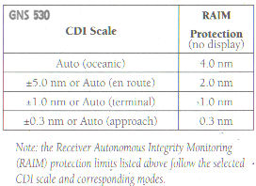
    - GPS substitution
      - IFR certified GPS system may substitute for ADF and DME when
        - Determining position over DME fix (including operations above FL 240)
        - Flying a DME arc (GNS 530)
        - Navigating TO/FROM NDB/compass locator
        - Determining position over NDB/compass locator
        - Determining position over fix defined by NDB/compass locator bearing crossing a VOR/LOC course
        - Holding over NDB/compass locator
      - Requirements for using GPS to substitute for ADF or DME
        - GPS meets airworthiness installation requirements and is operated in accordance with POH/AFM or supplement
        - At least en route RAIM or equivalent
        - Positions must be retrieved form current database
        - Be able to use alternate equipment when RAIM outages are predicted
        - CDI set to terminal sensitivity (usually 1-1¼ NM) in terminal area
        - If alternate airport is required
- A non-GPS approach must be available at alternate airport
- If the non-GPS approach requires DME or ADF, aircraft must be equipped with DME or ADF avionics
        - Charted ADF and/or DME requirements can be met using GPS, except for use as principal instrument approach navigation source
      - To determine position over DME fix
        - Verify satisfactory GPS system integrity
        - Select as active GPS waypoint (WP) from GPS database either
- Five-letter named fix, or
- Facility establishing DME fix
        - Aircraft is over selected 5-letter named fix when GPS indicates aircraft is at active WP
        - If facility establishing DME fix selected as WP, aircraft is over fix when on course and GPS distance from WP equals charted DME value
      - To fly DME arc (GNS 530)
        - Verify (satisfactory GPS system) integrity
        - As active GPS WP, select, from database, facility on which DME arc is based
        - Maintain position on arc by reference to GPS distance
      - To navigate TO or FROM an NDB/compass locator
        - Verify integrity
        - As active WP, select, from database, NDB/compass locator or collocated fix of the same name
        - Select and navigate on course to or from WP
      - To determine position over NDB/compass locator
        - Verify integrity
        - Select NDB/compass locator from database
        - Aircraft is over NDB/compass locator when GPS indicates aircraft is at the active WP
      - To determine position over fix when an NDB/compass locator bearing intersects a VOR/LOC course
        - Verify integrity
        - As active WP, select from database either 5-letter named fix or NDB/compass locator
        - Aircraft is over fix when GPS indicates at 5-letter named fix WP, or when GPS bearing to NDB/compass locator WP is the same as that charted for fix as aircraft is flying along prescribed track
      - To hold over NDB/compass locator
        - Verify integrity
        - Select NDB/compass locator from database as active WP
        - Select non-sequencing mode and appropriate course according to POH or supplement
        - Hold using GPS according to POH (GNS 530)
    - IFR flight using GPS
      - Install, check current database
      - Conduct operations in accordance with POH (GNS 530)
      - Study to become comfortable with operation of specific receiver installed in aircraft
      - Practice in VFR conditions first
      - Check GPS NOTAMs
      - Obtain GPS RAIM availability information
      - Check required underlying ground-based navigation facilities and related aircraft equipment operational
      - Enter flight plan into GPS receiver: departure WP, DP, enroute WPs, STAR, IAF, destination airport (GNS 530)
      - Select, activate flight plan
      - GPS provides course guidance between WPs, including desired direct track to WP and aircraft's actual track over ground
    - GPS instrument approaches (GNS 530)
      - Types
        - GPS overlay approaches have "or GPS" as part of the approach name
        - GPS stand-alone approaches are named "GPS..." or "RNAV (GPS)..."
      - Ground-based NAVAIDs and associated aircraft avionics are not required to be operational or monitored, but monitoring available backup navigation systems is always recommended
      - Practice GPS IAPs under VMC first until thoroughly proficient
      - Fly only those IAPs retrieved from current GPS database to assure compliance with published procedures and proper RAIM and CDI sensitivities
      - Follow manufacturers recommended procedures (GNS 530)
      - Fly full approach from initial approach WP (IAWP) or feeder fix unless specifically cleared otherwise
      - Load and arm (activate) IAP beyond 30 NM from airport so receiver will change from enroute CDI (+/- 5 NM) and RAIM (+/- 2 NM) sensitivity to terminal sensitivity (+/- 1 NM) when within 30 NM of airport
      - Follow manufacturers recommendations for holding pattern (GNS 530) and procedure turn (GNS 530) which may require pilot action to stop and later resume waypoint sequencing
      - Follow receiver operating manual procedures when receiving vectors to final (GNS 530)
      - Within 2 NM of final approach WP (FAWP), armed approach mode switches to active approach mode resulting in RAIM and CDI sensitivity changing to approach mode sensitivity, +/- 0.3 NM
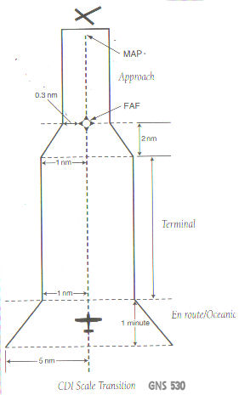
      - To help maintain position orientation during CDI sensitivity ramp down
        - Get established on final approach course beyond 2 NM from FAWP
        - Note cross track error (compare actual to desired/direct track)
      - If approach mode is not armed by 2 NM prior to FAWP
        - Approach mode will not become active at 2 NM from FAWP
        - GPS receiver will flag
        - Pilot should fly to MAWP and execute a missed approach (GNS 530)
      - Check approach mode active prior to FAWP
      - GPS missed approach
        - Follow manufacturers recommendations (GNS 530)
        - Requires pilot action to sequence past MAWP to missed approach procedure
        - No turns prior to MAWP
        - Additional pilot action required if first tack of missed approach is via a course rather than direct to next WP
      - Flying to alternate airport after missed approach
        - Avionics needed to receive all appropriate ground facilities for route to alternate must be installed and operational
        - Alternate airport must have an operational approach that is NOT based on GPS or LORAN C navigation; and aircraft must have the appropriate operational equipment to fly that approach
    - GPS errors
      - Whenever less than 24 satellites are operational, GPS navigational capabilities may be lost in certain areas
      - Loss of signal in valleys surrounded by high terrain
      - Loss of signal when aircraft's GPS antenna is "shadowed" by aircraft structure (e.g. when the aircraft is banked)
      - Signal interference
        - From certain receivers, transceivers, mobile radios, portable receivers; "harmonic interference" from some UHF transmissions
        - Isolate interference by moving or turning off suspected devices while monitoring GPS receiver's signal quality data page
      - Equipment characteristic and geometric factors can cause small errors (typically less than 100 feet)
      - Small position errors or momentary loss of signal
        - Small atomic clock inaccuracies
        - Receiver/processor error
        - Multipath (signals reflected from hard objects)
        - Ionospheric and tropospheric delays
        - Satellite data transmission error
      - Selective availability (SA)
        - Method by which DOD can create significant clock and ephemeris errors in the satellites
        - When SA active
- Horizontal accuracy is within
100 m 95% of time
300 m 99.99% of time
- Vertical accuracy is within
156 m 95% of time
500 m 99.99% of time
- Time accurate within
300 nsecs 95% of time
900 nsecs 99.99% of time
        - Do not rely on GPS altitude information (vertical error can be significant)

- Anti-ice/deicing and weather detection equipment and their operating characteristics
  - Airframe
    - Accumulation of ice on exterior surface of aircraft
    - Requires
      - Visible moisture (clouds, rain)
      - Freezing temperatures
    - Types
      - Rime
        - Small droplets that freeze immediately
        - Milky white, rough looking
        - Especially on leading edges of wings and struts
      - Clear
        - Relatively slow freezing of large droplets
        - Can spread over large surface, changing shape of airfoil
        - Clear, hard to see, most dangerous
      - Mixed
        - Mixture of clear and rime
        - Ice particles embedded in clear ice, very rough
OAT (°C) range | Icing type
-10 to 0 | Clear
-15 to -10 | Mixed
-20 to -15 | Rime

    - Effects
      - Control problems due to change in airfoil shape
      - Changed stall angle of attack and increased stall speed
      - Decreased lift
      - Increased drag
      - Blocked or limited control surfaces
      - Increased weight
      - Roll upset caused by airflow separation which induces self-deflection of ailerons
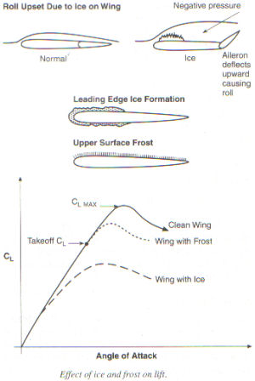
    - Inadvertent icing encounter
      - When operating in visible moisture, anticipate ice by monitoring OAT
      - Proper use of anti-icing/deicing equipment is critical. Refer to POH/AFM
      - Activate appropriate anti-icing/deicing when OAT is 5°C or less before entering visible moisture
      - Use flashlight to check for ice on night flights
      - Pilot actions once airframe ice accumulation begins
        - Move to altitude with significantly colder temperatures
        - Move to altitude where temperatures are above freezing
        - Fly to an area clear of visible moisture
        - Change heading and fly to area known to be free of ice (e.g., consider 180° turn)
        - Consider immediate landing at nearest suitable airport
    - Anti-icing/deicing equipment
      - Not designed for operation in icing conditions indefinitely
      - Intended simply to allow pilot more time to get out of the icing conditions
    - Cessna TR-182 and airframe icing
      - Flight into known icing conditions is prohibited
"Known icing does not mean a near-certainty of icing conditions, only that icing conditions are being reported or forecast.”
- NTSB
      - No standard airframe anti-ice/deice equipment
      - Windshield defrost air is supplied to outlet on top left side of antiglare shield. Activate by rotating DEFROST knob.
      - Inadvertent icing encounter in Cessna TR-182
        - Prop anti-ice ON
        - Pitot heat ON
        - Turn back or change altitude
        - Cabin heat full ON, windshield defrost ON
        - Increase RPM to minimize prop ice
        - Beware carb ice. Apply carb heat only as required. Lean mixture if carb heat used continuously
        - Plan landing nearest suitable airport or "off airport" site
        - Beware: ¼ inch or more on leading edge significantly increases stall speed
        - Leave flaps retracted UP
        - Open window, scrape ice if practical for landing visibility
        - Approach with forward slip if needed for visibility
        - Approach 85-95 KIAS
        - Land in level attitude

  - Propeller or rotor
    - Modified airfoil subject to icing induced loss of effectiveness
    - Cessna TR-182 propeller anti-ice system
      - Operated by rocker-type PROP A/ICE switch on upper left panel
      - Current is cycled by an anti-ice timer to electrically heated elements in anti-icing boots on leading edges of each prop blade
      - Check operation by monitoring PROP ANTI-ICE AMP ammeter on upper right panel
      - System protected by "push-to-reset" type 20-amp PROP A/ICE circuit breaker (3-blade prop)
      - Limitations - Intentional flight into know icing conditions prohibited
      - If unexpected icing
        - Check Master ON
        - PROP A/ICE switch ON
        - Prop anti-ice ammeter MONITOR in green arc, 14-18 amps (3-blade prop) continuously except pointer should "flick" momentarily every 20 seconds as timer switches element sets
        - Monitor that airplane ammeter maintains slight charge (if discharge indicated, limit use of other electrical equipment)
      - Malfunction
        - PROP A/ICE ammeter out of green arc or pointer fails to "flick" approximately every 20 seconds
        - Turn switch OFF (uneven anti-ice may cause prop imbalance and engine roughness)
      - For accurate magnetic compass readings, momentarily turn OFF pitot heat and propeller anti-ice

  - Air intake
    - Air induction system ice
      - Impact ice is formed by moisture-laden air at temperatures below freezing, striking and freezing on elements of the induction system
      - Ice may build up on such components as the air scoops, heat or alternate air valves, air intake filters or screens, and protrusions in the carburetor
      - Be particularly alert for such icing when flying in snow, sleet, rain, or clouds, especially when ice forms on the windshield or leading edge of the wings and temperatures are near 25°F when super cooled moisture in the air is still in a semi liquid state
      - Affects both fuel injected an carbureted engines
      - Usually preferable to use carburetor heat or alternate air as an ice prevention means, rather than as a deicer, because fast forming ice which is not immediately recognized may significantly lower the amount of heat available from the carburetor heating system
      - Activation of carburetor heat (Cessna TR-182) opens valve allowing hot (but unfiltered) air within engine cowling to bypass air filter and flow directly to turbocharger, carburetor and engine, restoring power.
        - If engine roughness is due to air intake blockage with ice, the engine may smooth out immediately when carb heat is applied, and immediately return to roughness if heat is turned off
        - With carb heat on the fuel-air mixture is enriched (hotter, less dense air)
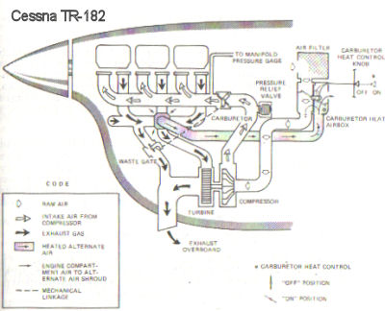
    - Carburetor ice
      - Can occur at temperatures between -7°C (20°F) and +21°C (70°F) when there is visible moisture or high humidity
      - Vaporization of fuel plus expansion of air flowing through carburetor causes sudden cooling to freezing temperatures in sometimes less than one second
      - Causes drop in RPM and/or manifold pressure (MP) with, usually, rough engine operation
      - Cessna TR-182
        - Monitor carburetor air temperature gauge: beware and pull carb heat knob out to ON for temperatures below or in yellow arc range, -15°C to +5°C
        - Suspect if unexplained or exaggerated drop in MP
        - To clear ice
- Advance throttle to 31 in. Hg. or full ON (<31 in. Hg.)
- Pull carburetor heat knob full out - ON
- Observe return to smooth engine operation
- When engine smooth, push carburetor heat off
- Readjust throttle
- Monitor carburetor temperature gauge
        - If continuous carburetor heat is necessary
- Use minimum carburetor heat needed to prevent ice formation (monitor carburetor temperature gauge)
- Lean mixture for smoothest engine operation
        - High altitude
- Application of carburetor heat may drop MP by up to 10 in. Hg.
- During carburetor heat application, advance throttle to lesser of full or desired power

  - Fuel system
    - Fuel system ice results from presence of dissolved or undissolved (e.g., entrained) water in the fuel system
    - Water suspended in fuel may freeze and form ice crystals big enough to block fuel screens, strainers or filters, or cause carburetor metering component icing
    - Use of anti-icing fuel additives has been approved for some piston engine aircraft to prevent fuel system icing
    - Cessna TR-182
      - Proper preflight draining eliminates any free water accumulations from the tank sumps
      - Small amounts of water in solution will normally be consumed unnoticed
      - Anti-ice fuel additives
        - Generally not needed
        - Permissible only when operating under the combined effects of
- Use of certain fuels
- High humidity on the ground
- Flight at high altitude and low temperature
        - Under above conditions, may add either
- Isopropyl alcohol
  - MIL-F-5566 or
  - Federal Specification TT-I-735a compliant
  - 1% by volume
- Ethylene glycol monomethyl ether (EGME)
  - MIL-I-27686 compliant or
  - Phillips PFA-55MB
  - Not to exceed 0.15% by volume

  - Pitot-static system
    - Pitot tube is particularly vulnerable to icing
      - Even light icing can block the entry hole (pressure inlet) where ram air enters the pitot-static system
        - Only instrument affected by this is ASI
        - If pitot tube has a water drain hole that is also blocked by ice (but aircraft static ports are open), then pressure is trapped in the pitot tube and the ASI may "act like an altimeter" with IAS increasing during a climb and decreasing during a descent
        - If water drain hole is present and open normally, then blocked pitot tube pressure may escape and IAS will decrease to zero
      - Most airplanes are equipped with a pitot heating system to keep ice away
        - Usually consists of coiled wire heating element wrapped around the air entry tube
        - Apply pitot heat before entering an area of suspected icing
        - Beware of potentially significant current drain of pitot heater
      - Cessna TR-182
        - Pitot heat system consists of heating element in pitot tube, rocker PITOT HEAT switch, 10-amp push-to-reset circuit breaker and wiring
        - Preflight check: Master ON, PITOT HEAT ON, feel pitot tube for heat
      - Static ports may become blocked by structural ice
        - If static ports blocked by ice
          - ASI becomes inaccurate in that IAS would be lower-than-actual at altitudes above that where ports became blocked and IAS would be higher-than-actual below that altitude
          - ALT would remain at altitude where blockage occurred
          - VSI would remain at zero
        - Many aircraft have static port heating systems
        - Some aircraft have an alternate static source vented inside the airplane cabin
          - Static pressure in cabin is usually lower than outside so
          - Use of alternate static source may result in erroneous instrument indications
- ALT reads higher than normal
- IAS reads greater than normal
- VSI momentarily shows a climb
- Ignore this initial false "climb up fast" indication
        - In absence of an alternate static source in an unpressurized aircraft, pilot could break the glass on the VSI to provide a source of static pressure to the ASI and ALT
          - This could cause additional instrument errors
- ASI and ALT will respond more sluggishly than normal (VSI capillary tube effect)
- VSI will indicate in reverse
          - So, it has been suggested instead (Kershner) to either
- Break the VSI by punching through to leave a good-sized hole in the VSI diaphragm (ASI and ALT would not then lag), or
- Carefully break the glass only of the ASI (then ASI, ALT, VSI should indicate essentially as accurately as expected using a cabin alternate static pressure)
        - Cessna TR-182
          - Static pressure alternate source valve installed adjacent to parking brake
          - Pull ALT STATIC valve out ON if external static source blockage suspected
          - See POH Section 5 for IAS corrections (no more than 3 knots if windows closed)

  - Radar/lightning detection system
    - Wx-500 Stormscope Series II Weather Mapping Sensor (Stormscope)
      - Description
        - Detects thunderstorm-associated electrical discharges within a 200 MN radius an sends information to a separate multifunction display (MFD) that depicts the location of these thunderstorms
        - Includes a combined crossed-loop and sense antenna mounted on the outside surface of the aircraft and a processor that converts discharge signals into range and bearing data and updates the MFD with this information every 2 seconds
        - Data types displayed
- Cell data most useful during periods of heavy electrical discharge activity
- Strike data most useful during light electrical activity; may show newly building thunderstorm before cell display
- Strike rate (approximate strikes per minute) helps pilot determine if cells are building or decaying
      - Compared to weather radar
        - Radar transmits UHF radio waves and receives echoes from water droplets while Stormscope receives atmospheric electrical discharges
        - Cumulus stage of thunderstorm
- Unlikely to appear on radar
- Generally will be detected by Stormscope by light but increasing cluster of discharge points
        - Radar, but not Stormscope, subject to attenuation, so may not see another thunderstorm behind a thunderstorm
      - Operation with Garmin GNS 530
        - Data displayed and unit operated via GNS 530 MFD
        - Runs self-test automatically on start up
        - Performs continuous self-test several times each minute
        - Storm data displayed on Map Page only if aircraft heading data is provided to the GNS 530 (e.g., via HSI)
        - Otherwise, storm data is available on third Nav Page, the Traffic/Weather Page
- Press MENU to select Weather? (or Traffic Screen)
- Press then rotate small right knob to select Cell or Strike mode
- Press MENU to select 120° or 360° viewing angle
- Press MENU and select Clear Storm Data?
  - After heading change (if heading information not available to GNS 530)
  - Periodically to help determine if storm is dissipating or building (discharge points will reappear faster and in larger numbers)
      - Interpretation of Stromscope data on the GNS 530 Weather Page
        - Clusters of two or more discharge points that reappear after clearing in the strike display mode indicate thunderstorm activity
        - In cell display mode even a single discharge point may represent a thunderstorm
        - In western United States a severe thunderstorm may have only a few discharge points
        - Pilots should "avoid by at least 20 miles any thunderstorm identified as severe or giving an intense radar echo." (Airman's Information Manual)
        - Radial spread artifact
- Triangular-shaped stream of discharge points between aircraft and cluster of discharge points in strike mode
- Reduce range and/or switch to cell mode to reduce radial spread
        - Randomly scattered discharge points
- More likely in strike mode, may indicate instability in cumulus clouds or developing or dissipating thunderstorm
- Watch for developing clusters (thunderstorms)
        - Cluster and splattering in 25 NM range
- Splattering due to discharge within 3 to 5 NM from aircraft too close to thunderstorm
- Fly away from main cluster
- Avoid any grouping of discharges within 25 NM
        - Discharge points off nose just inside 200 NM range
- May be strong thunderstorm just beyond 200 NM, or
- May be discharges arriving via atmospheric skip from distant thunderstorm well beyond 200 NM
        - Line of discharge points may be seen while taxiing
- Cable beneath taxiway or due to signals from nearby equipment (welders, subway rails)
- Clear screen after passing
    - Garmin GDL 49 Weather Datalink
      - Allows the GNS 530 MFD to display requested weather data received from satellites using the Echo Flight Message System
      - NEXRAD (NEXt generation RADar)
        - Description/limitations
- Network of Doppler stations (each with range of 124 NM) covers most of United States
- Display abnormalities
  - Ground clutter
  - Strobes and spurious radar data
  - Sun strobes
  - Metallic dust (military)
  - Shadows from buildings, mountains
- Limitations
  - Cannot determine cloud layers or precipitation types
  - Cannot detect storms directly overhead (or high and close by)
  - Resolution is 2-12 km (intensity displayed by each data square is the highest level sampled with the 2-12 km area)
- Echo intensity displayed by color
Color | dBZ | Rain | Snow
None | 0 | none | very light
Green | 5-25 | light | light-medium
Yellow | 30-50 | light-intense | mod-heavy
Red | 55-75 | extreme
        - Operation
- NEXRAD data may be requested from
  - Data Link Page (4th AUX page)
  - Map Page
- MSG flashes when date received
- Display/customize
  - NAV Weather Page (MENU, select View 120° or 360°)
  - Map Page (MENU, Setup Map, Weather, select NEXRAD SMBL range, ENT and/or NEXRAD DENSITY, ENT, CLR)
  - Default NAV Page
- Shortcuts
  - Select WPT Group, Airport Location Page, or
  - Highlight any airport ID with cursor, and
  - MENU, select Request NEXRAD, Request METAR or View Text Metar, and ENT
- Data Link Request Log Page logs requests
        - Graphical METARs
          - Request from
- Data Link Page
- Map Page
- Airport Page
          - Weather Legend Page displays relevant symbology
          - Display
- Nav Weather Page (CRSR, 'METAR', CRSR)
- Map Page for specific airport (highlight with cursor)
          - Textual METARs are displayed on METARS Text Page
          - Temperature/dewpoints and Wind data may be displayed on NAV Weather Page
          - Data Link Status Page
            - Provides indication of integrity of Data Link
            - Allows monitoring of system and helps find cause of failure

