AIRPLANE SYSTEMS RELATED TO IFR OPERATIONS

Objective:

To determine that the applicant exhibits adequate knowledge of the elements related to applicable aircraft anti-icing/deicing system(s) and their operating methods.

Content:
- Airframe
  - Deicing boots
  - Heated Wings
  - Weeping wings
- Propeller
- Intake
- Fuel System
- Wind Screen
- Pitot-Static System

Completion Standards:
The lesson is complete when the instructor determines that the student has an adequate understanding of the how anti-icing and de-icing systems available in aircraft work and their limitations, by giving an oral or written exam.

Instructor Notes:

Airfoil Anti-Ice and Deice
Inflatable deicing boots consist of a rubber sheet bonded to the leading edge of the airfoil. When ice builds up on the leading edge, an engine-driven pneumatic pump inflates the rubber boots. Many turboprop aircraft divert engine bleed air to the wing to inflate the rubber boots. Upon inflation, the ice is cracked and should fall off the leading edge of the wing. Deicing boots are controlled from the flight deck by a switch and can be operated in a single cycle or allowed to cycle at automatic, timed intervals.
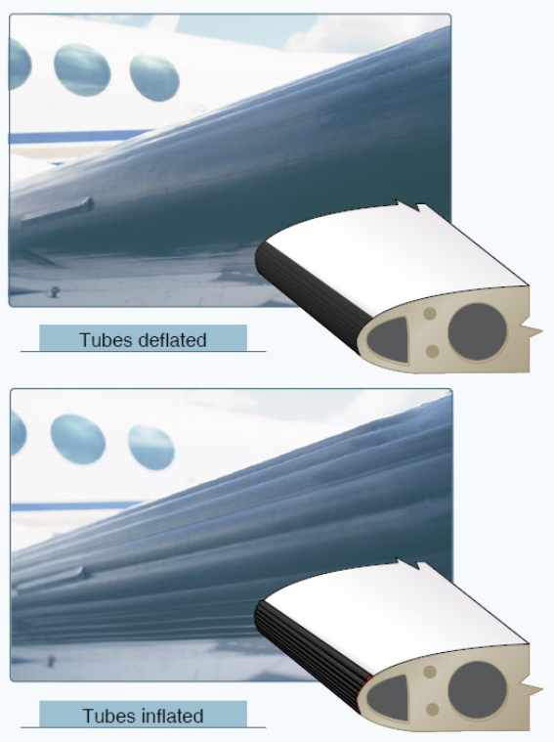
In the past, it was believed that if the boots were cycled too soon after encountering ice, the ice layer would expand instead of breaking off, resulting in a condition referred to as ice “bridging.” Consequently, subsequent deice boot cycles would be ineffective at removing the ice buildup. Although some residual ice may remain after a boot cycle, “bridging” does not occur with any modern boots. Pilots can cycle the boots as soon as an ice accumulation is observed. Consult the AFM/POH for information on the operation of deice boots on an aircraft.
Many deicing boot systems use the instrument system suction gauge and a pneumatic pressure gauge to indicate proper boot operation. These gauges have range markings that indicate the operating limits for boot operation. Some systems may also incorporate an annunciator light to indicate proper boot operation.
Proper maintenance and care of deicing boots are important for continued operation of this system. They need to be carefully inspected during preflight.
Another type of leading edge protection is the thermal anti-ice system. Heat provides one of the most effective methods for preventing ice accumulation on an airfoil. High performance turbine aircraft often direct hot air from the compressor section of the engine to the leading edge surfaces. The hot air heats the leading edge surfaces sufficiently to prevent the formation of ice. A newer type of thermal anti-ice system referred to as ThermaWing uses electrically heated graphite foil laminate applied to the leading edge of the wing and horizontal stabilizer. ThermaWing systems typically have two zones of heat application. One zone on the leading edge receives continuous heat; the second zone further aft receives heat in cycles to dislodge the ice allowing aerodynamic forces to remove it. Thermal anti-ice systems should be activated prior to entering icing conditions.

An alternate type of leading edge protection that is not as common as thermal anti-ice and deicing boots is known as a weeping wing. The weeping-wing design uses small holes located in the leading edge of the wing to prevent the formation and build-up of ice. An antifreeze solution is pumped to the leading edge and weeps out through the holes. Additionally, the weeping wing is capable of deicing an aircraft. When ice has accumulated on the leading edges, application of the antifreeze solution chemically breaks down the bond between the ice and airframe, allowing aerodynamic forces to remove the ice.

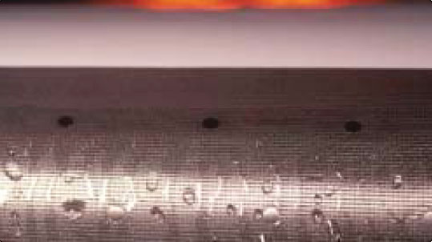

Windscreen Anti-Ice
There are two main types of windscreen anti-ice systems. The first system directs a flow of alcohol to the windscreen. If used early enough, the alcohol prevents ice from building up on the windscreen. The rate of alcohol flow can be controlled by a dial in the flight deck according to procedures recommended by the aircraft manufacturer.

Another effective method of anti-icing equipment is the electric heating method. Small wires or other conductive material is imbedded in the windscreen. The heater can be turned on by a switch in the flight deck, causing an electrical current to be passed across the shield through the wires to provide sufficient heat to prevent the formation of ice on the windscreen. The heated windscreen should only be used during flight. Do not leave it on during ground operations, as it can overheat and cause damage to the windscreen. Warning: the electrical current can cause compass deviation errors by as much as 40°.

Propeller Anti-Ice
Propellers are protected from icing by the use of alcohol or electrically heated elements. Some propellers are equipped with a discharge nozzle that is pointed toward the root of the blade. Alcohol is discharged from the nozzles, and centrifugal force drives the alcohol down the leading edge of the blade. The boots are also grooved to help direct the flow of alcohol. This prevents ice from forming on the leading edge of the propeller. Propellers can also be fitted with propeller anti-ice boots. The propeller boot is divided into two sections—the inboard and the outboard sections. The boots are imbedded with electrical wires that carry current for heating the propeller. The prop anti-ice system can be monitored for proper operation by monitoring the prop anti-ice ammeter. During the preflight inspection, check the propeller boots for proper operation. If a boot fails to heat one blade, an unequal blade loading can result and may cause severe propeller vibration.

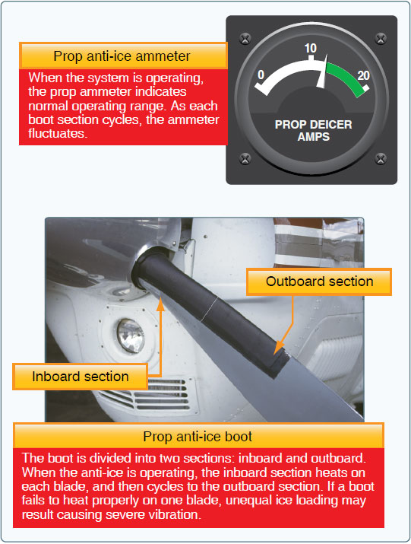

Other Anti-Ice and Deice Systems
Pitot and static ports, fuel vents, stall-warning sensors, and other optional equipment may be heated by electrical elements. Operational checks of the electrically heated systems are to be checked in accordance with the AFM /POH.

Operation of aircraft anti-icing and deicing systems should be checked prior to encountering icing conditions. Encounters with structural ice require immediate action. Anti-icing and deicing equipment are not intended to sustain long-term flight in icing conditions.

