AIRPORT/SEAPLANE BASE, RUNWAY AND TAXIWAY SIGNS, MARKINGS, AND LIGHTING (ASEL and ASES)

Objective:
To familiarize the student with the various markings and lights on an airport.

Content:
- Runway numbering conventions
  - VFR vs. IFR runways
  - Displaced threshold
  - Blast pad/stopway
- Taxiway Markings
  - Vehicle roadway markings
  - Solid white lines are boundaries
  - Dashed white lines separate lanes within roadway
  - VOR receiver checkpoint markings
  - Painted circle w/ arrow in the middle pointing in direction of checkpoint azimuth
  - Non-movement area boundary markings
  - Two yellow lines, one solid, one dashed
- Airport Signs – 6 Types (see PHAN Figures 12-3 & 12-4)
  - Mandatory Instruction Signs
  - White letters, red background
  - Entrance to runway, critical area, or prohibited area
- Location signs
  - Yellow letters, black background, yellow border
  - Taxiway/runway location, boundary of runway, or ILS critical area
- Direction Signs
  - Black letters, yellow background
- Destination Signs
- Information Signs
- Runway Distance Remaining Signs
- Airport Lighting
  - Airport Beacon
  - Approach Light Systems
    - Visual Glideslope Indicators
    - VASI
    - PAPI
  - Runway Lighting
    - REILs
    - Runway edge lights
    - In-Runway lighting
  - Taxiway Lights
  - Obstruction Lights
  - Control of Airport Lighting
- Wind direction Indicators

Things to Avoid (Common Errors):
- Failure to comply with airport, runway, taxiway sings and markings
- Failure to comply with airport, runway and taxiway lighting
- Failure to use proper runway incursion avoidance procedures

References:
AOPA Safety Advisor No. 2 “Operations at Towered Airports” in Appendix
AIM

Completion Standards:
The lesson is complete when the instructor determines that the student has adequate knowledge of airport and runway markings and lights by giving an oral or written exam.

Instructor Notes:
- Runway Incursion Avoidance
  - Be aware of the airplane’s position and be aware of other aircraft and vehicle operations on the airport
  - Read back all runway crossing and/or hold short instructions
  - Review the Taxi Diagrams as part of preflight planning, before landing, and while taxiing as needed
  - Know airport signage
  - Review NOTAMs for information regarding runway/taxiway closures and construction areas
  - Request progressive taxi instructions from ATC when unsure of the taxi route
  - Check for traffic before crossing any runway hold line and before entering a taxiway
  - Turn on aircraft lights and the rotating beacon or strobe lights when taxiing
  - When landing, clear the runway as soon as possible, and wait for taxi instructions before moving
  - Study and use proper phraseology in order to understand and respond to ground control instructions
  - Write down complex taxi instructions at unfamiliar airports
  - Failure to use proper runway incursion avoidance procedures
    - Do not cross hold short lines until you have been cleared for T/O or to taxi onto/across a runway
    - Without a control tower, look both ways and announce your intentions before proceeding
    - Never taxi onto the runway when there is a plane on final approach
- Runway Markings
  - General
    - There are three types of markings for runways:
      - Visual; Nonprecision Instrument; Precision Instrument
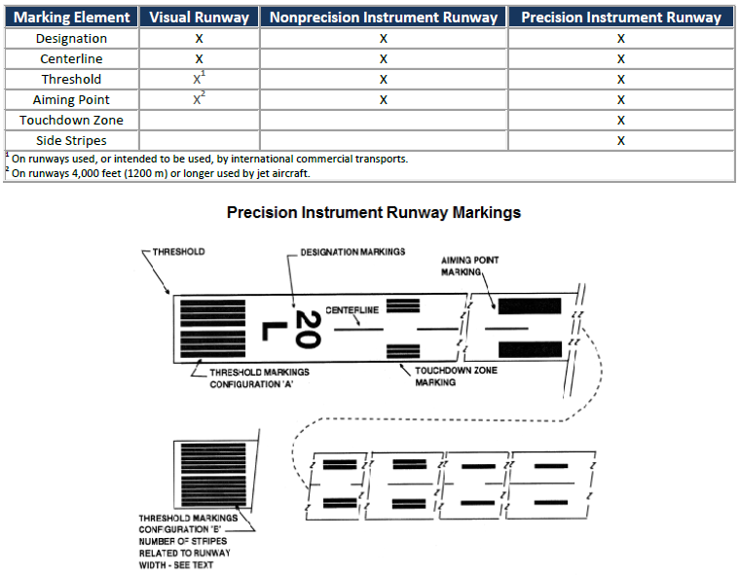

  - Runway Designators
    - Purpose - To identify/differentiate runways from the approach end
        - The whole number nearest one-tenth the magnetic azimuth of the runway (To Magnetic N)
        - Letters differentiate between left (L), right (R), and center (C) runways
    - Markings - Large white numbers
  - Runway Centerline Marking
    - Purpose - Identifies the center of the runway providing alignment guidance during T/O and LDG
    - Markings - A line of uniformly spaced stripes and gaps
  - Runway Aiming Point Markings
    - Purpose - Serves as a visual aiming point for a landing aircraft
    - Markings - Broad white stripe on each side of the centerline, approx 1,000’ from the threshold
  - Runway Touchdown Zone Markers
    - Purpose - Identifies the touchdown zone for LDG ops and provide distance info in 500’ increments
    - Markings - Groups of 1, 2, and 3 rectangular bars in pairs about the runway centerline
  - Runway Side Stripe Markings
    - Purpose - Delineate the edges of the runway providing a contrast between the runway and shoulder
    - Markings - Continuous white stripes located on each side of the runway
  - Runway Shoulder Markings
    - Purpose – May be used with side stripes to identify pavement areas not intended for aircraft use
    - Markings - Yellow stripes
  - Runway Threshold Markings
    - Purpose – Identifies the beginning of the runway available for landing
    - Markings - 8 longitudinal stripes of uniform dimensions placed about the centerline (A)
      - The number of stripes is related to runway width (B):
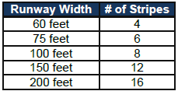
    - Threshold can be Displaced or Relocated
      - Displaced Threshold (DT)
        - Explanation
          - A threshold at a point on the runway other than the designated beginning of the runway
          - Reduces the amount of runway available for landings
          - The portion behind it is for T/Os either direction and LDGs from the opposite direction
            - Can be used for taxiing, takeoff, and landing rollout
        - Markings
          - A 10’ wide white threshold bar is located across the runway at the displaced threshold
          - White arrow heads are located across the runway just prior to the threshold bar
          - White arrows are down the centerline between the runway and displaced threshold
          - Demarcation Line
            - Purpose - Delineates the DT from a blast pad/stopway/ taxiway prior to the runway
            - Markings - 3 feet wide and yellow
          - Chevrons
            - Purpose - Show areas aligned with the runway that are unusable for taxi, T/O, LDG
            - Markings - Yellow arrows
      - Relocated Threshold
        - Explanation
          - Sometimes construction or other activities require the threshold to be relocated
          - A NOTAM should be issued identifying the portion of the runway is closed
            - EX. 10/28 W 900 CLSD
        - Markings – Identification can vary, as the duration of the relocation varies
          - Common practice is to use a 10’ wide white threshold bar across the runway
          - Runway lights between the old threshold and new threshold will not be illuminated
          - Runway markings in this area may or may not be showing
  - Blast pad/Stopway Area
    - The blast pad area is an area where a propeller or jet blast can dissipate without creating a hazard
    - Stopway is paved in to provide space to decelerate/stop in the event of an aborted T/O (Chevrons)
- Taxiway Markings
  - General
    - Taxiways should have centerline/runway holding position markings whenever intersecting a runway
    - Edge markings separate the taxiway from areas not for aircraft use or define taxiway edges
    - May have shoulder/hold position markings for ILS critical areas and taxiway/taxiway intersections
  - Taxiway Centerline Markings
    - Normal Centerline
      - Purpose - Provides a visual cue to permit taxiing along a designated path (aircraft kept over line)
        - Markings - A single continuous yellow line that is 6” – 12” wide
    - Enhanced Centerline
      - Purpose - Same as above but at larger commercial airports to warn that a runway hold position marking is being approached and unless cleared to cross the aircraft should prepare to stop
      - Markings - A parallel line of yellow dashes on either side of the normal taxiway centerline
        - Centerlines are enhanced for a max of 150’ prior to a runway holding position marking
  - Taxiway Edge Markings
    - Purpose - Defines the edge of the taxiway (usually when edge doesn’t match up with pavement)
    - 2 types of markings, depending on whether the aircraft is supposed to cross the taxiway edge
      - Continuous Markings
        - Purpose - Define the taxiway edge from the shoulder/paved surface not for use by aircraft
        - Markings - Continuous double yellow line with each line at least 6’ wide and 6’ apart
      - Dashed Markings
        - Purpose - Define the taxiway edge when adjoining pavement is intended for aircraft (Apron)
        - Markings - Broken double yellow line ( 6” wide/spaced 6” apart, 15’ long and 25’ apart)
  - Taxi Shoulder Markings
    - Purpose - Paved shoulders prevent erosion but they may not support aircraft
    - Markings - Taxiway edge markings will usually define this area
      - If confusion exists to the side of use, yellow shoulder markings are used
  - Surface Painted Taxiway Direction Signs
    - Purpose - When it isn’t possible to offer direction signs at intersections, or to supplement such signs
    - Markings – Surface painted location signs with a yellow background and black inscription
      - Adjacent to the centerline with signs indicating left turns on the left side of the centerline and vice versa
  - Surface Painted Location Signs
    - Purpose - Supplement location signs alongside the taxiway assisting in confirming the designation of the taxiway on
    - Markings - Black background with a yellow inscription, R of center
  - Geographic Position Markings
    - Purpose - Identifies aircraft location during low visibility operations
    - Markings - Left of the taxiway centerline in the direction of taxiing
      - A circle with an outer black ring, inner white ring and a pink circle
        - When on dark pavements the white/black ring are reversed
      - Designated with either a number or a number and a letter
        - Number corresponds with consecutive position on the route
- Holding Position Markings
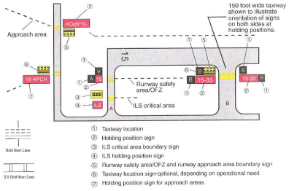
  - General
    - Show where an aircraft is supposed to stop when approaching a runway (Hold on the solid side)
    - 4 yellow lines (2 Solid/2 Dashed) spaced 6” or 12” apart across the width of the taxiway/runway
      - 3 locations where runway hold lines are encountered: 1Taxiways; 2Runways; 3Approach Areas
  - Runway Holding Position Markings on Taxiways
    - Purpose - Identify where to stop without a clearance onto the runway
      - Always stop so that no part extends beyond the hold markers
      - Don’t cross w/o clearance/ample separation at uncontrolled airports
  - Runway Holding Position Markings on Runways
    - Purpose - Only installed if normally used for LAHSO or taxiing operations
        - Must stop before markings/exit prior to reaching the position
    - Markings - Sign (white inscription/red background) next to hold markings
      - Markings are placed on the runway prior to the intersection
  - Taxiways Located in Runway Approach Area
    - Purpose - Hold aircraft on taxiway so it does not interfere with ops
    - Holding Position Markings for Instrument Landing System (ILS)
      - Purpose – Hold aircraft when the ILS critical area is being protected
      - Markings - 2 yellow solid lines 2’ apart joined by pairs of solid lines 10’ apart across the taxiway
    - Holding Position Markings for Taxiway/Taxiway Intersections
      - Purpose - Installed on taxiways where ATC normally holds aircraft short of a taxiway intersection
      - Markings - Single dashed line extending across the width of the taxiway
        - If requested to HS of a taxiway w/o marking, provide adequate clearance from the taxiway
    - Surface Painted Holding Position Signs
      - Purpose - Used to supplement the signs located at the holding position
        - Normally used when the width of the holding position on the taxiway is greater than 200’
      - Markings - Red background/white inscription, L of center, on the holding side, prior to hold lines
- Other Markings
  - Vehicle Roadway Markings
    - Purpose - Used to define a path for vehicle ops on or crossing areas also intended for aircraft
    - Markings - White solid line delineates each edge and a dashed line separates lanes
      - In lieu of the solid lines, zipper markings may be used to delineate edges
  - VOR Receiver Checkpoint Markings
    - Purpose - Allow the pilot to check aircraft instruments with navigational aid signals
    - Markings - A painted circle with an arrow in the middle (Arrow is aligned toward the facility)
      - Located, with a sign, on the apron/taxiway
      - Sign shows the VOR station ID letter, course for the check, and DME data (if necessary)
      - Black letters/numerals on a yellow background
  - Nonmovement Area Boundary Markings
    - Purpose - Delineates the movement area (The area under air traffic control)
    - Markings - 2 yellow lines (one solid and one dashed) 6” in width
      - Solid line is the nonmovement area side, the dashed line is the movement area side
  - Marking and Lighting of Permanently Closed Runways
    - Purpose - For runways and taxiways which are permanently closed
    - Markings - The lighting circuits will be disconnected
      - The runway threshold, designation, and touchdown markings are obliterated
      - Yellow crosses are placed at each end of the runway and at 1,000’ intervals
  - Temporarily Closed Runways and Taxiways
    - Purpose - To provide a visual indication to pilots that a runway is temporarily closed
    - Markings - Yellow crosses are placed on the runway at each end
      - A raised lighted yellow cross may be placed on each end of the runway instead
      - A visual indication may not be present depending on the reason for closure, duration of the closure, configuration and the existence and hours of operation of an airport control tower
        - Check NOTAMs and the ATIS for information
      - Closed taxiways are treated as hazardous areas and blockaded; no part of the aircraft may enter
        - As an alternative, a yellow cross may be installed at each entrance to the taxiway
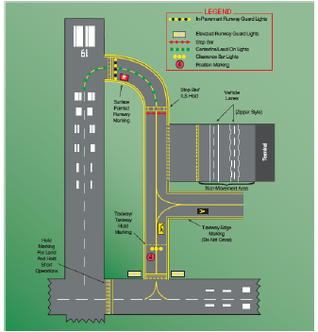
- Airport Signs
  - General
    - Six types of signs installed on airfields
      - Mandatory Instruction; Location; Direction; Destination; Info; Runway Distance Remaining
  - Mandatory Instruction Signs
    - Purpose - Denote entrance to runway or critical area/area where aircraft are prohibited
    - Markings - Red background with a white inscription
    - Typical Mandatory Signs and Applications
      - Runway Holding Position Sign
        - Located at the hold position on taxiways intersecting runways/runways intersecting runways
        - The sign states the designation of the intersecting runway
      - Runway Approach Area Holding Position Sign
        - Used when necessary to hold aircraft on a taxiway in a runway approach/departure area so it doesn’t interfere with runway ops
      - ILS Critical Area Holding Position Sign
        - ILS system is being used, and it’s necessary to hold at a location other than the Hold Markers
        - The sign will have the inscription “ILS” and will be located adjacent to the holding position marking on the taxiway
      - No Entry Sign
        - Prohibits an aircraft from entering an area
        - Typically on a taxiway intended to be used only in 1 direction or vehicle intersections of that may be mistaken as a taxiway/movement surface
  - Location Signs
    - Purpose - Identify either a taxiway or runway on which the aircraft is located
      - Other location signs provide a visual cue to assist in determining when an area has been exited
    - Taxiway Location Sign
      - Purpose - Along taxiways to indicate location
      - Markings - Black background with yellow inscription and border
    - Runway Location Sign
      - Purpose - Complement compass info; typically installed where the proximity of runways to one another could cause confusion as to which runway the pilot is on
      - Markings - Black background with a yellow inscription (Runway #)/ border
    - Runway Boundary Sign
      - Purpose - Provides a visual cue to use as a guide in deciding when “clear of the runway”
        - Adjacent to the hold markings on the pavement
        - Visible when exiting the runway
      - Markings - Yellow background/black inscription depicting the hold markings
    - ILS Critical Area Boundary Sign
      - Purpose - Provides a visual cue to use as a guide in deciding when clear of the ILS critical area
        - Adjacent to ILS hold markings and can be seen leaving the critical area
      - Markings - Yellow background/black inscription depicting ILS hold markings
  - Direction Signs
    - Purpose - Identify the designations of intersecting taxiways leading out of an intersection
        - Designations and their arrows are arranged clockwise from the 1st taxiway on the pilot’s left
    - Markings - Yellow background/black inscription with an arrow indicating the turn direction
  - Destination Signs
    - Purpose - Indicates a destination on the airport
      - Destinations commonly shown are
        - Runways
        - Aprons
        - Terminals
        - Military Areas
        - Civil Aviation Areas
        - Cargo Areas
        - International Areas
        - FBOs

    - Markings - Yellow background/black inscription indicating a destination on the airport
      - Always have an arrow showing the direction of the taxiing route to that destination sign
  - Information Signs
    - Purpose - Used to provide a pilot with information on such things as:
      - Areas the tower can’t see, radio frequencies, and noise abatement procedures
    - Markings - Yellow Background with a black inscription
  - Runway Distance Remaining Signs
    - Purpose - Used to inform the pilot the amount of distance remaining on the runway
      - The number on the sign indicates the thousands of feet of landing runway remaining
    - Markings - Black background/white numeral inscription one 1/both sides of the runway
  - CE - Failure to comply with airport, runway, taxiway sings and markings
    - Make sure you know the meaning and purpose of all the signs and markings
      - If unsure, stop and ask ATC for clarification
- Airport Lighting and Other Airport Visual Aids
  - Approach Light Systems (ALS)
    - Purpose - The basic means to transition from IFR to VFR for landing
    - Explanation - A configuration of signal lights staring at the landing threshold and extending into the approach area
  - Visual Glideslope Indicators
    - Visual Approach Slope Indicator (VASI)
      - Purpose - Provide visual decent guidance information during approach
      - Explanation - The lights are visible from 3-5 miles during day and up to 20 or more at night
        - Safe obstruction clearance within +/- 10o of the centerline and 4 NM from the threshold
      - Configurations
        - 2,4,6,12, or 16 light units arranged in bars
          - Arranged as near, middle, and far bars (Mid provide another glide path for high cockpits)
          - VASIs of 2,4, or 6 light units are located on one side of the runway (usually the left)
          - VASIs consisting of 12 or 16 light units are located on both sides of the runway
        - Most installations consist of 2 bars and may consist of 2,4, or 12 light units
      - Two Bar VASIs
        - Provide one visual glide path, normally set at 3o
      - Three Bar VASIs
        - Provide two visual glide paths
          - The lower glide path is provided by the near and middle bars and is normally set to 3o
            - Some locations may have up to 4.5o glide paths for proper obstacle clearance
          - The upper glide path is provided by the middle and far bars and is normally set ¼o higher
      - How it Works
        - Each unit projects light with an upper white segment and a lower red segment
        - The light units are arranged so that the pilot will see the combinations of lights below:
        - 2-bar VASI
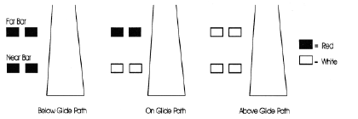
  - 3-bar VASI
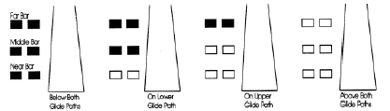
  - For other VASI configurations
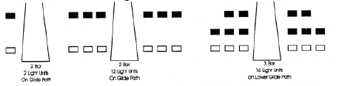
  - Precision Approach Path Indicator (PAPI)
    - General
      - Lights arranged to provide visual decent guidance information during the approach to a runway
      - Uses light units similar to the VASI but in a single row of either 2 or 4 light units
    - Configuration
      - Tri-Color Systems
        - Normally a single unit projecting a 3-color visual approach path into the final approach area
        - Glide Path Indications
          - Below - Red
          - Above- Amber
          - On - Green
        - Useful Range
          - Day – ½ to 1 mile
          - Night – Up to 5 miles (depending on the visibility)
      - Pulsating Systems
        - Normally a single unit projecting a 2-color visual approach path into the final approach area
        - Glide Path Indications
          - Slightly Below - Steady red
          - Below - Pulsating red
          - On - Steady white
          - Slightly Above - Pulsating white
          - Above - Faster pulsating white
            - Pulsating increases as the aircraft gets further above/below the glide slope
          - Useful Range
            - During the Day, 4 miles and at Night, up to 10 miles
  - Runway End Identifier Lights (REIL)
    - General - Installed to provide rapid/positive identification of the approach end of a runway
    - Configuration - A pair of synchronized flashing lights located on each side of the runway threshold
    - Effective for:
      - Identification of a runway surrounded by a preponderance of other lighting
      - Identification of a runway which lacks contrast with the surrounding terrain
      - Identification of a runway during reduced visibility
  - Runway Edge Light Systems (HIRL, MIRL, LIRL)
    - General - Outline the edges of runways during periods of darkness or restricted visibility conditions
      - Classified according to the intensity or brightness they are capable of producing
        - High Intensity (HIRL); Medium Intensity (MIRL); Low Intensity (LIRL) a HIRL and MIRL have variable intensity controls
    - Configuration
      - Runway edge lights – White
        - Instrument runways – Turn yellow the last 2,000,’ or half the runway, whichever is shorter
      - Lights marking the end of the runway – Red/Green
        - Red is emitted toward the runway to indicate the end of the runway to a departing aircraft
        - Green is emitted outward from the runway end to indicate the threshold to landing aircraft
  - In-runway Lighting
    - Runway Centerline Lighting System (RCLS)
      - General - Installed on some precision runways to facilitate landing under adverse conditions
      - Configuration
        - Located along the runway centerline and are spaced at 50’ intervals
        - From the landing threshold, the lights are white until the last 3,000’ of the runway a White lights begin to alternate with red for 2,000’, and the last 1,000’ all lights are red
    - Touchdown Zone Lights (TDZL)
      - General - On some precision runways, indicating the TD zone with adverse visibility conditions
      - Configuration
        - Two rows of transverse light bars disposed symmetrically about the runway centerline
        - Steady burning white lights starting 100’ beyond the landing threshold and extending to 3,000’ beyond the landing threshold or to the midpoint of the runway, whichever is less
    - Taxiway Centerline Lead-Off Lights
      - General
        - Provide visual guidance to persons exiting the runway
        - Color coded to warn: In runway environment/ILS critical area, whichever is more restrictive
      - Configuration
        - Alternate green/yellow lights are installed, beginning with green, from the runway centerline to 1 light position beyond the runway hold position/ILS critical area hold position
    - Taxiway Centerline Lead-on Lights
      - General
        - Provide visual guidance to persons entering the runway
        - Warn: In the runway environment/ILS critical area, whichever is more conservative
      - Configuration
        - Color coded with the same pattern as lead-off lights
        - Bidirectional (i.e., 1 side emits light for the lead-on function the other for the lead-off)
    - Land and Hold Short Lights
      - General
        - Used to indicate the hold short point on certain runways which are approved for LAHSO
          - Where installed, the lights will be on anytime LAHSO is in effect and off when not
      - Configuration - A row of pulsing white lights installed across the runway at the hold short point
  - Control of Lighting Systems
    - Operation of approach light systems and runway lighting is controlled by the control tower/FSS
    - Pilots may request the lights be turned on or off
  - Pilot Control of Airport Lighting
    - Radio control of lighting is available at some airports by keying the aircraft’s microphone
      - Often available w/o specified hours for lighting and with no tower/FSS or when they’re closed
    - All lighting systems which are radio controlled at an airport operate on the same frequency
      - The CTAF is used to activate the lights at most airports, but other frequencies may also be used
        - The frequency is in the AFD/the standard instrument approach procedures publications
        - It is not identified on the sectional charts
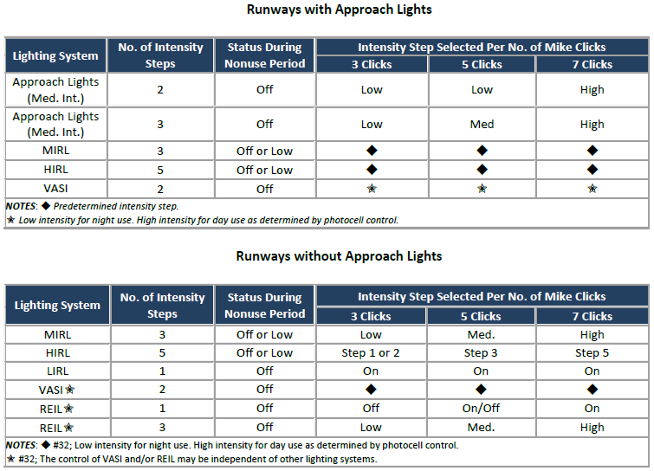

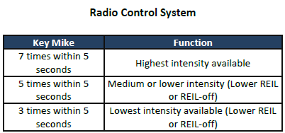
  - Airport Beacons
    - Vertical light distribution to make them more effective from 1o to 10o above the horizon
      - They can be seen well above and below this peak spread
    - Light Projection
      - Omnidirectional capacitor discharge device
      - Rotate at a constant speed
    - Flashes
      - 24-30 per min for airports/landmarks/points on federal airways; 30-45 per min for heliports
    - Colors and Combinations of Beacons
      - White and Green – Lighted land airport
      - *Green alone – Lighted land airport
      - White and Yellow – Lighted water airport
      - *Yellow alone – Lighted water airport
      - Green, Yellow, and White – Lighted heliport
          - Green/Yellow alone is used w/a white & green/white & yellow beacon display, respectively
    - Military Beacons
      - Two quick white followed by a green flash
    - Operation during the day
      - In Class B, C, D and E surface areas, operation of the airport beacon during the hours of daylight often indicates that the ground visibility is less than 3 miles and/or the ceiling is less than 1,000’
        - Don’t rely solely on the airport beacon to indicate if weather conditions are IFR or VFR
          - There is no regulatory requirement for daylight operation
  - Taxiway Lights
    - Taxiway Edge Lights
      - Purpose - Outline the edges of taxiways during periods of darkness or restricted visibility
      - Configuration - Emit blue light
    - Taxiway Centerline Lights
      - Purpose - Used to facilitate ground traffic under low visibility conditions
      - Configuration - Steady burning green lights along the centerline
    - Clearance Bar Lights
      - Purpose - Installed to increase the conspicuity of the holding position in low visibility conditions
        - May also be installed to indicate the location of an intersecting taxiway during darkness
      - Configuration - Three in pavement steady burning yellow lights
    - Runway Guard Lights
      - Purpose - Enhance the conspicuity of taxiway/runway intersections
      - Configuration - Either a pair of elevated flashing yellow lights on either side of the taxiway, or a row of in pavement yellow lights across the entire taxiway, at the runway hold marking
    - Stop Bar Lights
      - Purpose - Confirm ATC clearances to enter/cross the active runway in low visibility conditions
      - Configuration - Row of red, unidirectional, steady burning in pavement lights installed across the entire taxiway at the runway hold position, and elevated steady-burning red lights on each side
        - Following ATC clearance, the stop bar is turned off and the lead-on lights are turned on
      - Cautions
        - Never cross a red illuminated stop bar even if they have received ATC clearance
        - If after crossing, the lead-on lights extinguish, hold position and contact ATC for instruction
  - CE - Failure to comply with airport, runway and taxiway lighting
    - Due to reduced visibility, it can be hard to find your way on the ground at night at a new airport
      - Make sure you know the meaning of all the lights before proceeding

