TURNS TO HEADINGS (ASEL and ASES)

Objective:
To familiarize the pilot with turning the aircraft with reference to the instruments and any errors associated with these instruments.

Before Flight:
- For small heading changes, use a bank angle that doesn’t exceed degrees to be turned
- Lead desired heading and begin roll-out apprx. ½ the bank angle in degrees
- Perfect this technique to determine appropriate lead for current aircraft
- Timed Turns:
  - Calibrate turn coordinator to determine actual std. turn indication (establish std. rate turn and check headings at chosen time intervals)
  - Note correct deflection of turn coordinator required for std. rate and use that in all std. rate turns
  - 3* per second at standard rate
  - See IFH Figure 5-34 for primary and supporting instruments
- Compass Turns:
  - Compass Errors:
    - Variation
    - Isogonic and Agonic lines
    - Conversion from True to Magnetic North
    - Deviation
    - Magnetic Dip
    - Caused by vertical component of Earth’s flux lines
    - Acceleration/Deceleration Error (ANDS in the Northern Hemisphere)
    - Turning Error (UNOS in the Northern Hemisphere)
    - Magnitude is apprx. equal to current latitude for N or S

Maneuver Elements:
- Instructor will check heading indicator for accuracy of student’s turns
- Student will perform maneuver as covered before flight
- Student will perform maneuver with partial panel

Diagrams:
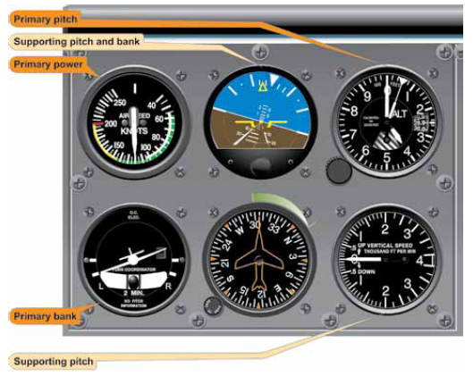

Aircraft Setup:
Flaps up, gear up
Normal climb: (C172RG: 23” Hg, 2300 RPM)

Things to Avoid (Common Errors):
- Failure to properly interpret instruments
- Failure to cross-reference instruments

References:
Instrument Flying Handbook – Chapter 5

Completion Standards:
The lesson is complete when the student demonstrates knowledge through a written or oral exam and is able to perform turns to headings with reference to the instruments to the satisfaction of the instructor and in accordance with the current Practical Test Standards for the student’s stage of training.

