CHANDELLES (ASEL and ASES)

Objective:
To develop the student’s coordination, orientation, planning, and accuracy of control during maximum performance flight.

Before Flight:
- Altitude gain will be dependent on weather conditions and so maximum gain for that day should be the goal
- Purpose is to demonstrate a maximum performance climbing turn
- Since airspeed is constantly decreasing, torque effects will become more prominent
- Rolling out of a left chandelle, adverse yaw will work in conjunction with torque to produce a strong left yawing force
- Rolling out of a right chandelle, these two forces will tend to cancel each other out

Maneuver Elements:
- Clear the area
- Choose forced landing area
- Configure aircraft for maneuvering: ≤ VA with propeller to full, gear up, flaps up, cowl flaps open, altitude ≥1500’ AGL
- Select outside references (off wingtip for 90º point)
- Establish a coordinated 30° bank turn
- Throttle to full (C172RG: 25” Hg, 2500 RPM)
- Apply pitch to arrive at 90° reference point with max desired pitch
- Anticipate need for rudder pressure
- Maintain pitch attitude once at 90º with increasing back elevator pressure while reducing bank to 180º point
  - As aircraft slows, greater back elevator is required to maintain pitch
- At 180° point, roll wings level, (90º point is now off opposite wing from the start), slightly above stall speed
  - Rolling out of a left chandelle requires more right rudder pressure
  - Rolling out of a right chandelle requires little rudder pressure, but will require right rudder pressure to maintain heading upon completion of rollout
- Gently reduce pitch to straight-and-level but maintain altitude and build airspeed
- Adjust throttle to maintain altitude
- Maintain ball centered
- Look for traffic

Aircraft Setup:
Flaps up, gear up
C172RG: 18” Hg, 2500 RPM, 106 KIAS at MGW
Max Bank: 30°
Max Pitch: Approx. 15°

Things to Avoid (Common Errors):
- Failure to adequately clear the area
- Too shallow an initial bank, resulting in a stall
- Too steep an initial bank, resulting in failure to gain maximum performance
- Allowing the actual bank to increase after establishing initial bank angle
- Failure to start the recovery at the 90° point in the turn
- Allowing the pitch attitude to increase as the bank is rolled out during the second 90° of turn
- Removing all of the bank before the 180° point is reached
- Nose low on recovery, resulting in too much airspeed
- Control roughness
- Poor coordination (slipping or skidding)
- Stalling at any point during the maneuver
- Execution of a steep turn instead of a climbing maneuver
- Failure to scan for other aircraft
- Attempting to perform the maneuver by instrument reference rather than visual reference

Diagrams:
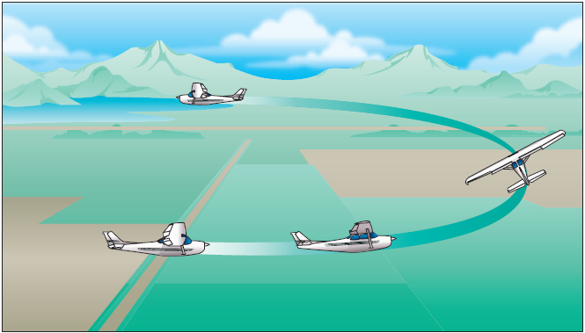

References:
Airplane Flying Handbook - Chapter 9

Completion Standards:
The lesson is complete when the student demonstrates knowledge through a written or oral exam and is able to perform chandelles to the satisfaction of the instructor and in accordance with the current Practical Test Standards for the student’s stage of training.

