CIRCLING APPROACH

Objective:
To teach the student the elements, proper procedures and technique for piloting an airplane on a circle to land approach.

Content:
- Elements of a circling approach procedure
  - Selection of the appropriate circling approach maneuver
  - Circling approach minimums
  - Compliance with advisories, clearances, instructions and/or restrictions
  - Importance of flying a circling approach pattern that does not exceed the published visibility criteria
  - Maintenance of an altitude no lower than the circling MDA until in a position from which a descent to a normal landing can be made
- Common Errors
  - Failure to have essential knowledge of the circling approach
  - Failure to adhere to the published MDA and visibility criteria
  - Inappropriate pilot technique during transition from the circling maneuver to the landing approach

References:
14 CFR Part 91, AIM, NACO TPPs
Aviation Instructor's Handbook, FAA-H-8083-9
Instrument Flying Handbook, FAA-H-8083-15, 1999
Instrument Rating ACS

Completion Standards:
The lesson is complete when the student can accurately perform the steps involved in flying a circle to land approach using the materials covered in this lesson to the satisfaction of the instructor.

Instructor Notes:
- Elements of a circling approach procedure
  - Selection of the appropriate circling approach maneuver considering maneuvering capabilities of the aircraft
    - Factors to consider
      - Maneuvering capability of aircraft (e.g. turn radius)
      - Altitude and airspeed (determines Category)
      - Ceiling and visibility
      - Airport design (traffic flow, pattern direction
      - Wind conditions
      - Turbulence, wind shear
      - Final approach course alignment
      - ATC instructions
      - Airport circling restrictions
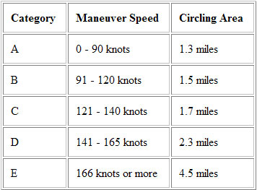
    - Patterns:
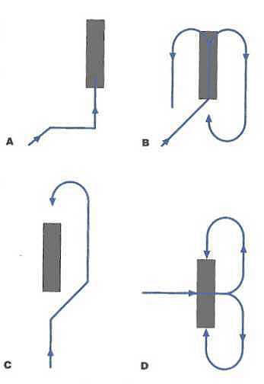

  - Circling approach minimums on the selected instrument approach procedure chart
    - Minimums section of IAP
    - Depends on aircraft category - safest: use actual circling airspeed (e.g., 100 KIAS use Cat B circling minimum)
    - Study IAP chart notes for factors effecting minimums (e.g., alternate altimeter setting)
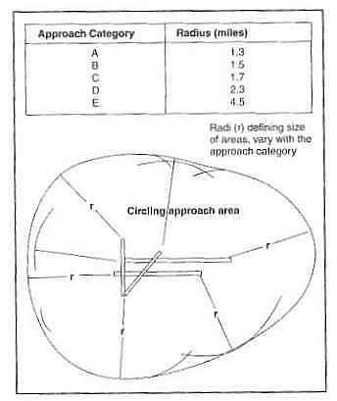
  - Compliance with advisories, clearances, instructions and/or restrictions
    - Comply with ATC clearances and instructions or request amendment
    - Study IAP chart notes for restrictions (e.g., Circling NA south of runway 9-27)
  - Importance of flying a circling approach pattern that does not exceed the published visibility criteria
If visual contact with an identifiable part of the airport is lost during circling approach (not due to banking of aircraft), then missed approach must be flown
  - Maintenance of an altitude no lower than the circling MDA until in a position from which a descent to a normal landing can be made
    - Obstacle clearance depends on remaining above MDA until in position to make normal landing
    - Maintain altitude at least MDA +100 feet, -0 feet
    - If below MDA and not in position to land normally, missed approach must be flown
    - If ceiling allows, fly higher, up to normal pattern altitude during circling approach
- Common Errors
  - Failure to have essential knowledge of the circling approach information on the instrument approach chart
    - Plan ahead
    - Know approach(es) to expect (ATC, ATIS)
    - Study, record, memorize key data in advance
How low? How long? How far? Which way?
    - Use PC or simulator to practice flying approaches, including circling, to destinations of upcoming flights
  - Failure to adhere to the published MDA and visibility criteria during the circling approach maneuver
    - Maintain altitude at least MDA +100 feet, -0 feet
    - If below MDA and not in position to land normally, missed approach must be flown
    - If ceiling allows, fly higher, up to normal pattern altitude during circling approach
    - If visibility drops below circling minimum, missed approach must be flown
  - Inappropriate pilot technic during transition from the circling maneuver to the landing approach
Precise, accurate, positive control essential in circling approach

