CONSTANT AIRSPEED CLIMBS AND DECENTS

Objective:
To enhance the student skills and comfort with performing straight, constant airspeed climbs and descents under instrument meteorological conditions.

Before Flight:
- Constant Airspeed Climbs
  - Under given power setting and load condition, only one attitude will give most efficient climbs
  - Entry:
    - From cruising airspeed, raise mini aircraft to approximate nose-high indication for predetermined climb speed
    - Power may be set to climb power simultaneously, or after pitch change
    - See IFH Figure 5-25 for Primary and Supporting Instruments
  - Stabilized Climb at Constant Airspeed:
    - See IFH Figure 5-26 for primary and supporting instruments
  - Leveling Off:
    - Level off before reaching desired altitude (lead by 10% VS)
    - To level off at climb airspeed, reduce power simultaneously with pitch change
    - See IFH Figure 5-29 for primary and supporting instruments
- Constant Airspeed Descents
  - Entry:
    - Reduce power first to descent speed and then pitch to maintain that speed
    - Any airspeed deviation calls for pitch adjustment
    - See IFH Figure 5-30 for primary and supporting instruments
  - Leveling Off:
    - Apprx. 100-150 feet above altitude, set cruise power (for level flight at higher than descent speed)
    - Begin to level-off 50 feet above altitude
    - To level-off at descent airspeed, level-off and set cruise power at 50 feet above altitude
    - See IFH Figures 5-31 and 5-32 for primary and supporting instruments

Maneuver Elements:
- Constant Airspeed Climbs
  - perform climbs using airspeed, vertical speed (rate) or both
    - Pitch
    - Power
    - Trim
  - Leveling out: for climbs: 10% of climb rate prior to altitude; for descents: 100-150’ prior to altitude
    - With turns, roll out on new heading at 50% of bank angle prior to heading
- Constant Airspeed Descents
  - Perform descents using airspeed, vertical speed (rate) or both
    - Power
    - Pitch
    - Trim
  - Leveling out: for climbs: 10% of climb rate prior to altitude; for descents: 100-150’ prior to altitude
    - With turns, roll out on new heading at 50% of bank angle prior to heading

Aircraft Setup:
Flaps up, gear up
Normal climb: (C172RG: 25” Hg, 2500 RPM)

Things to Avoid (Common Errors):
- Failure to properly interpret instruments
- Failure to cross-reference instruments

Diagrams:
Climbs
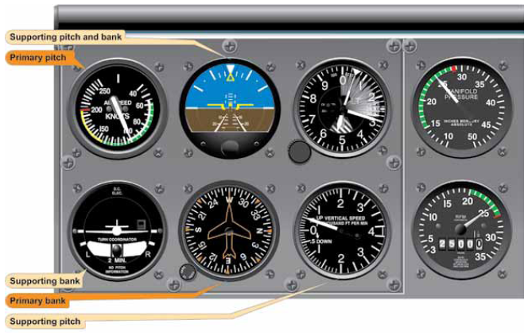

Descents
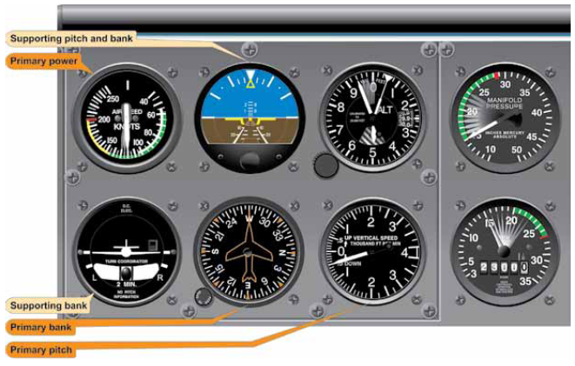
References:
Instrument Flying Handbook Chapter 5

Completion Standards:
The lesson is complete when the student demonstrates knowledge through a written or oral exam and is able to perform straight, constant airspeed climbs and descents with reference to the instruments to the satisfaction of the instructor and in accordance with the current Practical Test Standards for the student’s stage of training.

