EIGHTS ON PYLONS (ASEL and ASES)

Objective:
To develop the ability to control the airplane accurately while dividing attention between the flight path and the selected points on the ground.
Before Flight:
- Before introducing this maneuver, instructor should ensure that the student has the ability to make a coordinated turn without gain or loss of altitude, excellent feel of the airplane, stall recognition, relaxation with low altitude maneuvering, and an absence of the error of over concentration.
- Review pivotal altitude (TAS² / 11.3 = Pivotal Altitude)
- Student should not use rudder pressure to keep the pylon along line-of-sight

Maneuver Elements:
- Clear the area
- Choose forced landing area
- Configure aircraft: flaps and gear up, maneuvering power, adjust altitude to pivotal altitude, pitch and trim to maintain pivotal altitude
  - Pivotal altitude in AGL = (TAS in Knots)² / 11.3 or (TAS in MPH)² / 15
  - TAS = Groundspeed when wind is zero (pivotal altitude affected by groundspeed)
  - Pivotal altitude at 100 KIAS = 885’ AGL, if 10 knots of winds, lowest groundspeed is 90 KIAS = 717’ AGL, highest groundspeed is 110 KIAS = 1071’ AGL
- Select pylon – Fly with the winds at the 45º quartering tailwind position, maintaining pivotal altitude until an ideal pylon (point as a ground reference) is selected, which should be within the 45º off the left side of the flight path and close enough for a 30º to 40º bank
- Bank onto pylon (30º to 40º) – Maintain straight-and-level flight at pivotal altitude until abeam the first pylon (it should be off the left wingtip), then roll 30º to 40º angle of bank
- Adjust pivotal altitude – Gradually decrease pivotal altitude and slightly reduce bank angle as you turn about the pylon, turning directly into the wind
- Keep wingtip reference on pylon – Throughout, maintain ball centered and pivotal altitude necessary to hold wingtips (i.e. a row of rivets along the wingtip) on pylon, adjusting with pivotal altitude and bank changes only, not with power or rudder; no need for constant radius
- Wings level (3-5 seconds) – Begin the rollout to straight-and-level flight as the first turn is completed, then maintain straight-and-level flight and crab into the wind as necessary, flying straight-and-level for 3 to 5 seconds, climbing if necessary to return to pivotal altitude
- Select second pylon – Select a second pylon, within 45º off the right side of the flight path and close enough for a 30º to 40º bank
- Bank onto pylon (30º to 40º) – Maintain straight-and-level flight at pivotal altitude until abeam the first pylon (it should be off the right wingtip), then roll 30º to 40º angle of bank, noting that your line of reference may look different in the opposite turn
- Adjust pivotal altitude – Gradually decrease pivotal altitude and slightly reduce bank angle as you turn about the pylon, turning directly into the wind
- Keep wingtip reference on pylon – Throughout, maintain ball centered and pivotal altitude necessary to hold wingtips (i.e. a row of rivets along the wingtip) on pylons
- Avoid slips and skids
- Look for traffic throughout

Aircraft Setup:

Flaps and gear up, Power and speed at or below Va
Pivotal Altitude No Wind: (100*100)/11.3 = 885 ft.

C172RG: MP: 18” Hg
RPM: 2300 RPM
Speed: 100 KIAS

Things to Avoid (Common Errors)

- Failure to adequately clear the area
- Skidding or slipping in turns (whether trying to hold the pylon with rudder or not)
- Excessive gain or loss of altitude
- Over concentration on the pylon and failure to observe traffic
- Poor choice of pylons
- Not entering the pylon turns into the wind
- Failure to assume a heading when flying between pylons that will compensate sufficiently for drift
- Failure to time the bank so that the turn entry is completed with the pylon in position
- Abrupt control usage
- Inability to select pivotal altitude

Diagram:
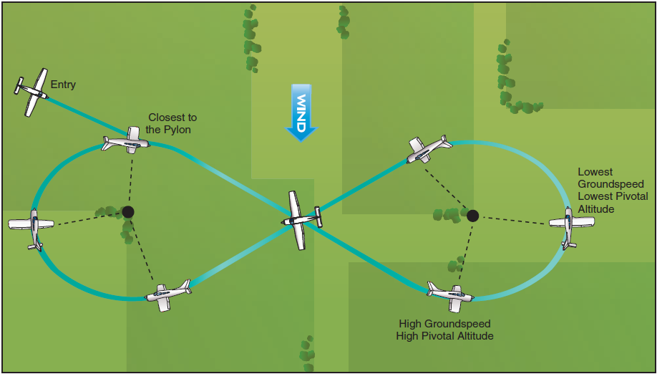

References:
Airplane Flying Handbook - Chapter 6
Completion Standards:
The lesson is complete when the student demonstrates knowledge through a written or oral exam and is able to perform eights-on-pylons to the satisfaction of the instructor and in accordance with the current Practical Test Standards for the student’s stage of training.

