GO-AROUND/REJECTED LANDING (ASEL and ASES)

Objective:
To teach the student the proper procedures and technique for executing an alternative to a landing that cannot be accomplished for any reason.

Before Flight:
- Review relevant aircraft aerodynamics and performance characteristics
- Go-around is not an emergency-only maneuver
- Power – number one concern
- Altitude
- Configuration – flaps first, then landing gear
- Full flaps usually create more drag than landing gear
- In case aircraft accidentally touches down during go-around initiation, gear down and locked will be advantageous
- Dangers of immediate full flap retraction
- Anticipation of aerodynamic forces

Maneuver Elements:
- Clear the area
- Choose forced landing area (runway)
- Configure aircraft: landing checklist, begin the final approach to land
- Select outside references (field)
- Commit to go-around (don’t change mind!)
- Smoothly apply throttle to full while simultaneously anticipating left-turning tendencies with right rudder pressure
- Adjust pitch for V_{X}
- Carburetor heat off (cold)
- Establish positive rate of climb
- Smoothly retract first notch of flaps; stabilize attitude
- Rough trim as needed
- Maneuver airplane to the traffic-pattern side of the runway and fly parallel to it
- Smoothly retract the remaining flaps incrementally (allow aircraft to stabilize)
- Adjust pitch for V_{Y}
- Open cowl flaps
- Retract landing gear upon passing useable runway and achieving a safe altitude and positive climb rate
- Maintain ball centered
- Look for traffic

Aircraft Setup:

Flaps as required, gear down, propeller Full
Final Approach: (C172RG: 15” Hg, 2700 RPM)
Vx: (C172RG: 55 KIAS)
Vy: (C172RG: 77 KIAS)

Things to Avoid (Common Errors)
- Failing to commit to a go-around when situation warrants
- Failing to anticipate and adjust for pitch to maintain safe airspeed
- Failing to anticipate and adjust for left turning tendencies
- Retracting landing gear before flaps, since flaps cause more drag and since an inadvertent touchdown (or second touchdown) can occur

Diagrams:
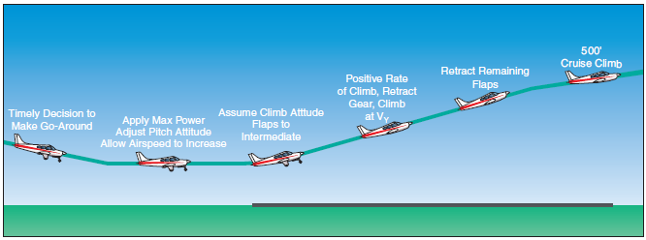

References:
Airplane Flying Handbook - Chapter 8
Aircraft Flight Manual / Pilot’s Operating Handbook

Completion Standards:
The lesson is complete when the instructor determines that the student can perform a proper go-around by making a timely decision to discontinue the landing, applying takeoff power immediately and pitching for Vy, performing other required elements of the go-around.

