LANDING FROM AN INSTRUMENT APPROACH

Objective:
To determine the applicant exhibits satisfactory knowledge, risk management, and skills
associated with performing the procedures for a landing from an instrument approach.

Content:
- Elements related to the pilot’s responsibilities, and the environmental, operational, and meteorological factors that affect landing from a straight-in or circling approach.
  - Effect of specific environmental, operational and meteorological factors
    - Environmental factors
    - Operational factors
    - Meteorological factors
  - Transition to, and maintenance of, a visual flight condition
  - Adherence to ATC advisories
    - NOTAMs
    - Wind shear
    - Wake turbulence
    - Braking conditions
  - Completion of appropriate checklist items
  - Maintenance of positive aircraft control
- Airport Signs, Lighting and Markings
- Approach Lighting Systems

- Common Errors
  - Attempting to land from an unstable approach.
  - Flying below the glidepath.
  - Errors transitioning from instrument to visual references for landing.
  - Failure to have essential knowledge of the information on the instrument approach chart
  - Incorrect communications procedures or noncompliance with ATC clearances or instructions
  - Failure to accomplish checklist items

References:
14 CFR Part 91, AIM, NACO TPPs
Aviation Instructor's Handbook, FAA-H-8083-9
Instrument Flying Handbook, FAA-H-8083-15, 1999
Instrument Rating ACS

Completion Standards:
The lesson is complete when the student can accurately perform the steps involved in landing an aircraft from a instrument approach using the materials covered in this lesson to the satisfaction of the instructor.

Instructor Notes:
- Elements related to landing from a straight-in and circling approaches
  - Effect of specific environmental, operational and meteorological factors
    - Environmental factors
      - Runway dimensions
After reaching MAP determined by timing, may safely land on long runway beyond threshold, but circle or fly missed approach if shorter runway
      - Runway condition
    - Operational factors
      - Increased minimums with inoperative approach components
      - Aircraft capabilities - need distance/time to slow +/- add flaps before normal landing
    - Meteorological factors
      - Visibility
        - Only pilot can determine if flight visiblity meets the landing requirement noted on the IAP chart
        - Flight visibility below minimums => go-around, fly missed approach
      - Wind condition
Normal crosswind landing technic
  - Transition to, and maintenance of, a visual flight condition
    - Approaching DA/DH, MAP or VDP, carefully divide attention between instrument and visual references on transition to visual for landing
    - Expect need to go right back to instruments for missed approach if runway visual reference lost
    - On ILS, stay on glide slope and localizer to over runway
    - On pitch changes, flap extensions, avoid inadvertent climb back into IMC (necessitating missed approach)
  - Adherence to ATC advisories, such as NOTAMs, wind shear, wake turbulence, runway surface and braking conditions
    - NOTAMs for inoperative approach components may require higher minimums
    - Wind shear
      - Aviodance best policy
      - Avoid approach near thunderstorm
      - Possible wind shear (pirep, ATC), consider:
        - More power, faster airspeed (+½ gust)
        - Stay higher longer
        - Mentally prepare for go-around, missed approach
    - Wake turbulence
      - Stay 4 miles behind large, 5 miles behind heavy airplanes
      - May "request additional separation" from ATC
    - Braking conditions
      - May request runway braking report from ATC
      - If "nil", don't land, request proceed to alternate airport
      - May land if braking action fair or poor if
        - Relatively longer runway
        - Touchdown on runway close to threshold
        - Minimum practicable airspeed
        - Controlled landing with longitudinal axis over runway centerline
        - Aerodynamic braking
  - Completion of appropriate checklist items
    - Complete before landing checklist by FAF
    - Re-check on final approach course
    - Complete after landing checklist clear of runway
  - Maintenance of positive aircraft control
First fly your airplane

- Common Errors
  - Inappropriate division of attention during the transition from instrument to visual conditions
    - Carefully divide attention between instrument and visual references on transition to visual for landing
    - Expect need to go right back to instruments for missed approach if runway visual reference lost
    - Stay on glide slope and localizer to over runway
  - Failure to complete required checklist items
    - Complete before landing checklist at FAF
    - Re-check on final approach course
    - Complete after landing checklist clear of runway
  - Failure to properly plan and complete the turn to final approach
Especially circling approach
- Remain within protected area and
- Allow enough distance for normal descent and landing
  - Improper technic for wind shear, wake turbulence and crosswind
    - Wind shear
      - Avoid
      - More power, airspeed
    - Wake turbulence - separation
    - Normal crosswind technic
  - Failure to maintain positive aircraft control throughout the complete landing maneuver
First fly your airplane

Airport Signs and Markings
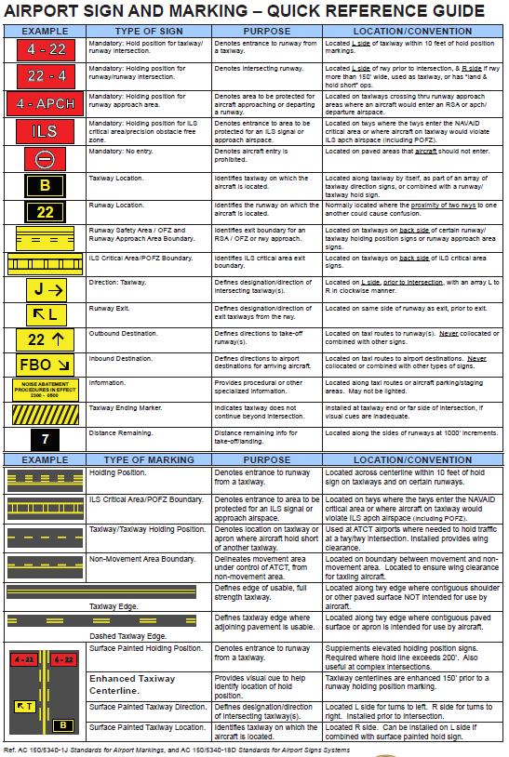

Approach Lighting Systems
There are a variety of approach light systems that few general aviation pilots take the time to study. In inclement weather it is critical that we brief the anticipated Approach Lighting System (ALS) because it is likely the first thing we will see approaching the runway. Below is a list of the various systems found at US airports with a brief description and graphic depicting their configuration:

- HIRL – High Intensity Runway Light system
- MALSR – Medium intensity Approach Light System with Runway alignment indicator lights
- TDZ/CL – runway Touchdown Zone and Centerline Lighting system
- ALSF 1 – high intensity Approach Light System with Sequenced Flashing lights, system length 2,400 to 3,000 feet
- ALSF 2 – high intensity Approach Light System with Sequenced Flashing lights and red side row lights the last 1,000 feet, system length 2,400 to 3,000 feet
- SALS/SALSF – Short Approach Lighting System, high intensity (same as inner 1,500 feet of ALSF 1)
- SSALF – Simplified Short Approach Lighting system with sequenced Flashing lights and runway alignment indicator lights, system length 2,400 to 3,000 feet
- MALD/MASLF – Medium intensity Approach Lighting, with and without Sequenced Flashing lights, system length 1,400 feet
- ODALS – OmniDirectional Approach Lighting System with sequenced flashing lights, system length 1,400 feet
- RAIL – Runway Alignment Indicator Lighted sequence flashing lights (which are only installed in combination with other light systems)
- REIL – Runway End Identifier Lights (threshold strobes)
- LDIN – sequenced flashing LeaD-IN lights
- VASI – Visual Approach Slope Indicator
- PAPI – Precision Approach Path Indicator

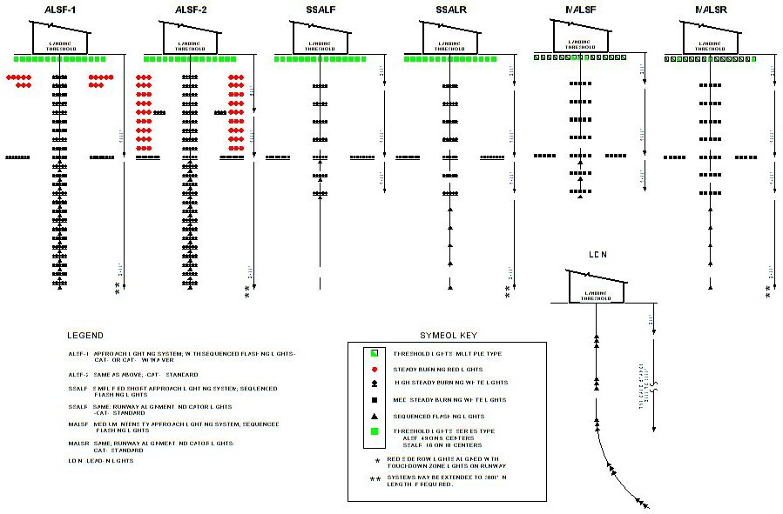
When flying in low visibility conditions it is important you recognize the appropriate light system. Lights are usually the first visible object but often street lights, parking lot lights or building lights are mistaken for the correct approach light system. Too many accidents result from a controlled descent below MDA or DA short of the runway. A little mental preparation will ensure you identify the correct lights and land safely.

ALSF 1 and ALSF 2 systems are typically used for runways with Category II and III approach minimums. MALSR systems are much more common at GA airports served by Category I ILS and non-precision approaches. However, at uncontrolled airports only accessed by non-precision approach procedures you may only have REILs to identify the runway threshold. In low visibility conditions these lights may be the only thing you see, especially at night. At an uncontrolled airport it is critical you activate the approach lighting system when handed off to CTAF. Initially, activate the lights to their highest setting. Once visually identified you can turn down the lights as necessary to avoid blinding and disorientation.

