LAZY EIGHTS (ASEL and ASES)

Objective:
To develop the perfect coordination of controls through a wide range of airspeeds and altitudes so that certain accuracy points are reached with planned altitude and airspeed.

Before Flight:
- Pitch-pitch-bank

Maneuver Elements:
- Clear the area
- Choose forced landing area
- Configure aircraft: straight-and-level, airspeed less than Va, altitude ≥1600’ AGL
- Select outside references (45º, 90º, 135º points)
- Gradual climbing turn toward 45º point, increasing pitch and bank so that at 45º point you are highest pitch and 15º of bank (tip: adjust pitch before bank, e.g. “pitch pitch pitch bank”)
- From 45º to 90º decrease pitch to horizon while increasing your bank and maintain coordinated flight so that at 90º you are level with maximum altitude, approx. 30º bank and 5-10 KIAS above stall, all the while gradually reducing elevator back pressure
- From 90º to 135º slowly roll out bank while gradually lowering the nose so that upon reaching 135º the nose is at the lowest pitch approx. equal but opposite of the highest pitch achieved earlier, with bank angle of 15º, all the while gradually relaxing rudder and aileron pressure
- Arrive at 180º point straight-and-level at the original heading, altitude and airspeed
- Maintain ball centered
- Look for traffic
- Continue the maneuver in the opposite direction

Aircraft Setup:
Flaps up, gear up
C172RG: 18” Hg, 2500 RPM, 106 KIAS at MGW

Things to Avoid (Common Errors):
- Failure to clear area
- Using the nose or engine cowling instead of the true longitudinal axis, resulting in unsymmetrical loops
- Watching the airplane instead of the reference points
- Inadequate planning, resulting in peaks of the loops both above and below the horizon not coming the proper place
- Control roughness, usually caused by attempts to counteract poor planning
- Persistent gain or loss of altitude with the completion of each eight
- Attempting to perform the maneuver rhythmically, resulting in poor pattern symmetry.
- Allowing the airplane to “fall” out of the tops of the loops rather than flying the airplane through the maneuver
- Slipping and/or skidding
- Failure to scan for traffic during the maneuver

Diagrams:
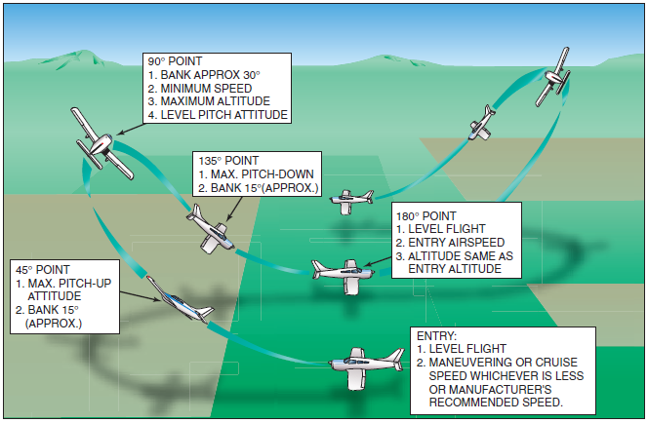

References:
Airplane Flying Handbook - Chapter 9

Completion Standards:
The lesson is complete when the student demonstrates knowledge through a written or oral exam and is able to perform lazy eights to the satisfaction of the instructor and in accordance with the current Practical Test Standards for the student’s stage of training.

