LEVEL TURNS (ASEL and ASES)

Objective:
To teach the student to detect small deviations from straight-and-level flight as soon as they occur, necessitating only small corrections.

Before Flight:
- Review general aircraft operation and speeds
- Review aerodynamics for level turns
  - Aileron actions
  - Adverse yaw
  - Use of rudder
  - Once established in medium turn, rudder is no longer needed (no adverse yaw because ailerons are neutral)
- Terms:
  - Shallow turns – lateral stability attempts to return wings level ( < 20?(
  - Extra lift developed by outside wing moving faster is not enough to overcome inherent lateral stability
  - Medium turns – airplane remains at constant bank (20? – 45?)
  - Increased lift developed by outside wing moving faster balances aircraft’s inherent lateral stability
  - Steep turns – airplane tends to overbank (> 45?)
- Increased lift developed by outside wing overpowers inherent lateral stability and causes tendency to increase bank angle
- As a result of increase lift, increased induced drag causes wing to lag slightly, inducing a slight slip in steep turns
- Parallax error in turns in aircraft with side-by-side seats
  - Left turns make nose appear to rise
  - Right turns make nose appear to descend
- Roll out of turns ½ bank angle before desired heading

Maneuver Elements:
- Clear the area
- Choose forced landing area (always be aware of options)
- Configure aircraft for cruise
- Select outside references (point on the horizon corresponding to desired heading)
- Periodically insure the nose is fixed below the horizon
- Gently bank the airplane to no more than 20º for shallow turns when learning turning (20º to 45º for medium turns when more proficient) and maintain this bank until approaching desired heading
- Apply rudder in the direction of the bank to keep the ball centered while applying elevator back-pressure to maintain level flight (constant altitude)
- Use wingtips as reference of banking angle
- Anticipate rollout to new heading by leading with half the bank angle (10º for a 20º bank)
- Trim as necessary to maintain altitude
- Look for traffic

Aircraft Setup:

Flaps and gear up
Power and speed as required

C172RG: MP: 23” Hg
RPM: 2300 RPM
Speed: As required

Things to Avoid (Common Errors)
- Failure to adequately clear the area before beginning the turn
- Attempting to execute the turn solely by instrument reference
- Attempting to sit up straight, in relation to the ground, during a turn, rather than riding with the airplane
- Insufficient feel for the airplane as evidenced by the inability to detect slips/skids without reference to flight instruments
- Attempting to maintain a constant bank angle by referencing the “cant” of the airplane’s nose
- Fixating on the nose reference while excluding wingtip reference
- “Ground shyness”—making “flat turns” (skidding) while operating at low altitudes in a conscious or subconscious effort to avoid banking close to the ground
- Holding rudder in the turn
- Gaining proficiency in turns in only one direction (usually the left)
- Failure to coordinate the use of throttle with other controls
- Altitude gain/loss during the turn

Diagrams:
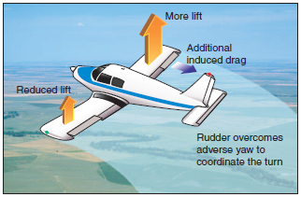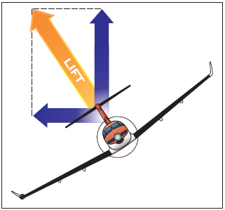

References:
Airplane Flying Handbook - Chapter 3

Completion Standards:
The lesson is complete when, to the satisfaction of the instructor, the student can select a specific angle of bank and apply control pressures to maintain the desired bank angle once it is established.

