LOGBOOK ENTRIES AND CERTIFICATE ENDORSEMENTS

Objective:
To familiarize the student with the rules for logbook entries and endorsements for the different types of students he may encounter as a flight instructor.

Content:
- 14 CFR Part 61.51 for Pilot Logbooks
- Student Pilot Endorsements
  - Solo Requirements for Student Pilots (FAR 61.87)
  - Solo cross-country flight requirements (FAR 61.93)
  - Operation in Class B airspace and airports within Class B airspace
- Preparation of a Practical Test Recommendation
- Flight Review Endorsements
- Flight Instructor Records (61.189)

References:
FAR 61.51 for Pilot Logbook requirements

Completion Standards:
The lesson is complete when the student can pass a written exam given by the instructor covering logbook entries and certificate endorsements.

Instructor Notes:
- Logbook Entries (61.189)
  - A flight instructor must sign the logbook of each person that instructor has given flight/ground training
  - Logbook entries must include:
Date
Aircraft Identification
Airplane Make and Model
Type of Experience (Solo, PIC, etc.)
Total Flight Time
Flight Conditions (Day, Night, Instrument, etc.)
Location of Departure and Arrival
    - Date; Airplane Make/Model; Total Flight time; Location of Departure and Arrival; Identification of the Aircraft; Type of Experience (Solo, PIC, etc); Conditions of the Flight (Day, Night, etc)
- Student Pilot Certificate Endorsements (Including appropriate logbook entries)
  - Student pilot certificates provide for CFI endorsements on the back for solo/solo XC flight
    - The certificate must be endorsed prior to the student’s 1st solo in each make and model of airplane
    - The certificate must also be endorsed prior to the student’s 1st solo XC flight
      - This endorsement, although, is for aircraft category (not make and model)
    - FAR 61.87: A student pilot may not operate an aircraft in solo flight unless he/she has received:
      - An endorsement from an authorized instructor on his or her student pilot certificate for the specific make and model aircraft to be flown
    - FAR 61.93: A student pilot must have a solo XC endorsement from the authorized instructor who conducted the training, and that endorsement must be placed on that person’s student pilot certificate for the specific category of aircraft to be flown
      - Logbook Endorsement: A student pilot must have a solo XC endorsement from an authorized instructor that is placed in the student pilot’s logbook for the specific make and model aircraft to be flown
  - Student Pilot Endorsements (Examples are shown in AC 61-65)
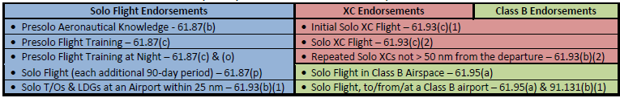
- Preparation of a Practical Test Recommendation
  - Each applicant must have received an endorsement from an authorized instructor who certified that the applicant received and logged the required flight time/training in preparation for the practical test within 60 days preceding the date of the test and has been found proficient to pass the practical test
  - All applicants must have the required endorsements specified in Part 61 for the aircraft category, class, rating, or privilege of certification sought
  - Instructor/student must complete/sign Form 8710-1 (Application Certificate and/or Rating Application
    - This is given to the examiner at the practical test
  - Except in certain instances, the applicant must hold at least a current 3rd class medical certificate
  - Reapplying
    - All applicants who reapply for a retest must present another endorsement stating the necessary training has been given and they are prepared for the practical test
      - A practical test, whether satisfactory or not, uses up the endorsement for that test
      - An instructor’s recommendation on Form 8710-1 is required for each retest conducted
  - Practical Test Endorsements
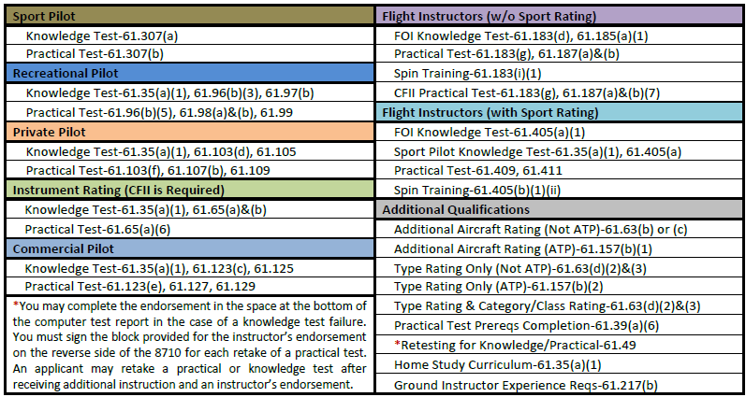
- Flight Review Endorsements
  - After a satisfactory completion of a flight review, the instructor must endorse the pilot’s logbook
    - Flight Review Endorsement- 61.56(a) & (c)
      - The endorsement is found in AC 61-65
  - Instrument Proficiency Checks
    - CFII is required to perform IPCs for instrument rated pilots
    - Upon satisfactory completion of an IPC, the pilot’s logbook must be endorsed
      - Instrument Proficiency Check Endorsement-61.57(d)
        - The endorsement is found in AC 61-65
  - No logbook entry reflecting unsatisfactory performance on either flight review is necessary
    - But, a logbook entry for the instruction given should be made
- Flight Instructor Records (FAR 61.189)
  - A flight instructor must maintain a record in a logbook or a separate document containing the following:
    - The name of each person whose logbook or student pilot certificate that instructor has endorsed for solo flight privileges, and the date of the endorsement
    - The name of each person that instructor has endorsed for a knowledge test or practical test, and the record shall also indicate the kind of test, the date, and the results
  - Each flight instructor must retain the records required for at least 3 years

