NORMAL AND CROSSWIND APPROACH AND LANDING (ASEL and ASES)

Objective:
To familiarize the student with the proper procedures and techniques for takeoff and climb under crosswind conditions.

Before Flight:
- Review aircraft V-speeds
- Terms:
  - Takeoff Roll (Ground Roll)
  - Lift-off (Rotation)
  - Ground Effect
  - Initial Climb
  - Torque/P-Factor
  - Propeller slipstream
- Headwind and Crosswind Components
- Pre-takeoff considerations
  - Aircraft crosswind limitations
  - Preflight check
  - CTAF or ATC
  - Wake turbulence
  - Maintaining runway centerline during takeoff roll and climbout
  - Max demonstrated crosswind component
- Crosswind correction during taxi and takeoff
  - Ailerons/Elevator
  - Crab
  - Aircraft as weathervane
  - Why takeoff into the wind?
- Noise abatement procedures

Maneuver Elements:
- Clear the area
- Choose forced landing area (should be runway)
- Configure aircraft for normal approach and begin descent as normal
- Select outside references (e.g. runway numbers)
- Clear area, then turn to final (≤30° bank)
- On final: remaining flaps when runway is assured, CCGUMPS check
- Select aim point (e.g. before runway numbers)
- Sideslip (maintain centerline): Lower upwind wing to correct for drift while simultaneously applying opposite rudder to maintain longitudinal axis with runway centerline
- Adjust pitch and power to maintain normal approach speed and descent angle
- Trim to relieve control pressures
- Make sure feet are not on brakes
- 10-20’ off ground: reduce throttle to idle
- Gradually apply back pressure to pitch for landing attitude, attempting to fly just above runway (fly in ground effect) straight-and-level until passing aim point, then continue adjusting pitch for climb attitude just above horizon
- Maintain crosswind control inputs to the surface, as airspeed decreases, greater crosswind control inputs are required
- Touchdown on upwind main gear first, just above stalling speed
- Maintain pitch attitude for aerodynamic braking
- Gradually relax back pressure to lower nose wheel while applying maximum aileron in upwind direction
- Gentle braking as required
- Crosswind control inputs for taxi

Aircraft Setup:

Flaps as required, gear down, propeller Full
Short final speed: (C172RG: 65 KIAS)

Things to Avoid (Common Errors)
- Attempting to land in crosswinds that exceed the airplane’s maximum demonstrated crosswind component
- Inadequate compensation for wind drift on the turn from base leg to final approach, resulting in undershooting or overshooting
- Inadequate compensation for wind drift on final approach
- Unstabilized approach
- Failure to compensate for increased drag during sideslip resulting in excessive sink rate and/or too low an airspeed
- Touchdown while drifting
- Excessive airspeed on touchdown
- Failure to apply appropriate flight control inputs during rollout
- Failure to maintain direction control on rollout
- Excessive braking

Diagrams:
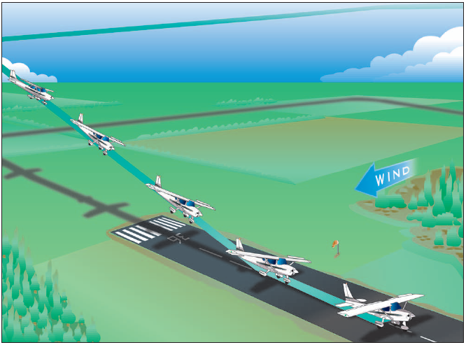

References:
Airplane Flying Handbook - Chapter 8
Aircraft Flight Manual / Pilot’s Operating Handbook

Completion Standards:
The lesson is complete when the student is able to perform normal and crosswind takeoffs and climbs to the satisfaction of the instructor and according to the current Practical Test Standards for the student’s stage of training.

