NORMAL AND CROSSWIND TAKEOFF AND CLIMB (ASEL and ASES)

Objective:
To familiarize the student with the proper procedures and techniques for takeoff and climb under crosswind conditions.

Before Flight:
- Review aircraft V-speeds
- Terms:
  - Takeoff Roll (Ground Roll)
  - Lift-off (Rotation)
  - Ground Effect
  - Initial Climb
  - Torque/P-Factor
  - Propeller slipstream
- Headwind and Crosswind Components
- Pre-takeoff considerations
  - Aircraft crosswind limitations
  - Preflight check
  - CTAF or ATC
  - Wake turbulence
  - Maintaining runway centerline during takeoff roll and climbout
- Crosswind correction during taxi and takeoff
  - Ailerons/Elevator
  - Crab
  - Aircraft as weathervane
  - Why takeoff into the wind?
- Noise abatement procedures

Maneuver Elements:
- Clear the area
- Choose forced landing area
- Configure aircraft: flaps up, cowl flaps open, propeller to full
- Select outside references: vanishing point on runway
- Taxi onto runway centerline, using wind correction during taxi
- Position full ailerons into the direction of the wind (turn into for headwinds, dive away from tailwinds)
- Smoothly apply full power
- Anticipate need for right rudder pressure and to maintain centerline
- Check engine instruments (in green)
- As controls become effective, gradually reduce aileron / rudder pressures
- At Vr, gradually apply back pressure to lift nose wheel
- Pitch for normal climb attitude, climb at Vy
- Gear up upon positive rate of climb, safe airspeed, no useable runway
- Crab into wind as necessary to maintain extended runway centerline
- Maintain ball centered
- Look for traffic

Aircraft Setup:
Flaps up, gear down, propeller Full
Vr (C172RG: 55 KIAS)
Vy (C172RG: 84 KIAS)

Things to Avoid (Common Errors)
- Failure to adequately clear the area prior to taxiing onto the active runway
- Using less than full aileron pressure into the wind initially on the takeoff roll
- Mechanical use of aileron control rather than sensing the need for varying aileron control input through feel for the airplane
- Premature lift-off resulting in side-skipping
- Excessive aileron input in the latter stage of the takeoff roll resulting in a steep bank into the wind at lift-off
- Inadequate drift correction after lift-off

Diagrams:
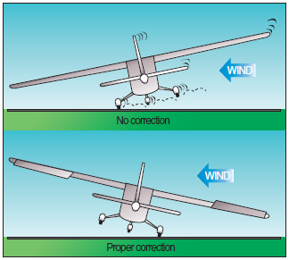

References:
Airplane Flying Handbook - Chapter 5
Aircraft Flight Manual / Pilot’s Operating Handbook

Completion Standards:
The lesson is complete when the student is able to perform normal and crosswind takeoffs and climbs to the satisfaction of the instructor and according to the current Practical Test Standards for the student’s stage of training.

