ONE ENGINE INOPERATIVE (SIMULATED) DURING STRAIGHT-AND-LEVEL FLIGHT AND TURNS (AMEL, AMES)

Objective:
To determine the applicant exhibits satisfactory knowledge, risk management and skills associated with flight solely by reference to instruments with one engine inoperative.

Before Flight:
- Attitude indicator as Direct Indication of pitch attitude in level flight
- Must be adjusted according to other direct indications of level flight
- Altimeter as Indirect Indication of pitch attitude in level flight
- Rate of change indicates magnitude of deviation from level attitude

Maneuver Elements:
- Procedures used if engine failure occurs during straight-and-level flight and turns while on instruments.

- Promptly recognize an engine failure and maintain positive airplane control.
- Set the engine controls, reduce drag, identify and verify the inoperative engine, and simulate feathering of the propeller on the inoperative engine. (Evaluator should then establish zero thrust on the inoperative engine.)
- Establish the best engine-inoperative airspeed and trim the airplane.
- Use flight controls in the proper combination as recommended by the manufacturer, or as required to maintain best performance, and trim as required.
- Verify the prescribed checklist procedures normally used for securing the inoperative engine.
- Attempt to determine and resolve the reason for the engine failure.
- Monitor engine functions and make necessary adjustments.
- Maintain the specified altitude ±100 feet or minimum sink rate if applicable, airspeed ±10 knots, and the specified heading ±10°.
- Assess the airplane’s performance capability and decide an appropriate action to ensure a safe landing.
- Avoid loss of airplane control or attempted flight contrary to the engine-inoperative operating limitations of the airplane.
- Demonstrate SRM.

Aircraft Setup:
Flaps up, gear up
Normal cruise

Things to Avoid (Common Errors):
- Failure to identify the inoperative engine.
- Inability to climb or maintain altitude with an inoperative engine.
- Low altitude maneuvering including stall, spin, or CFIT.
- Distractions, loss of situational awareness, or improper task management.
- Fuel management during single-engine operation.
- Slow or improper cross-check during straight-and-level flight
ALT needle tip 0, AI scale pointer (bank index) 0, ASI needle tip on speed,
TC level & centered ball, HI needle tip center of bug, VSI needle tip 0
- Improper power control
Learn/use MP that you know will result in approximate desired airspeed in SLF
If airspeed changes, cross-check VSI, ALT before any power change
- Failure to make smooth, precise corrections as required
Aim for precision: heading +/- 2°, airspeed +/- 2 knots, altitude +/- 20 feet
Beware overcontrolling
Use two step corrections
Just enough control pressure to stop needle movement
A bit more to start smooth correction
- Uncoordinated use of controls
Keep the ball centered
- Improper trim control
Trim to relieve control pressures
Small, frequent adjustments
Diagrams:
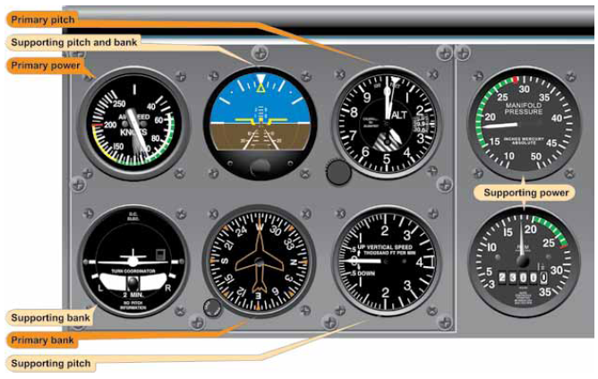

References:
Instrument Flying Handbook – Chapter 5

Completion Standards:
The lesson is complete when the student the ability to perform straight-and-level flight and level turns with reference to the instruments after a simulated engine failure to the satisfaction of the instructor and in accordance with the current Practical Test Standards for the student’s stage of training.

Instructor Notes:

Fundamentals
Attitude instrument flying means control of the aircraft's spatial position by using instrument's rather than outside visual references
Two basic methods:
- Control and performance
attitude + power = performance
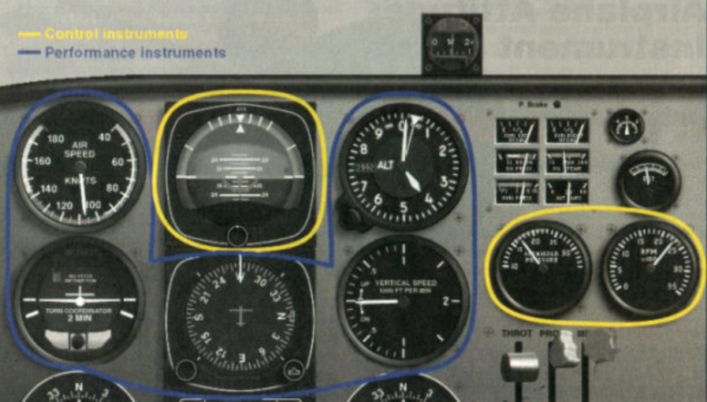

- Primary and Supporting Instruments
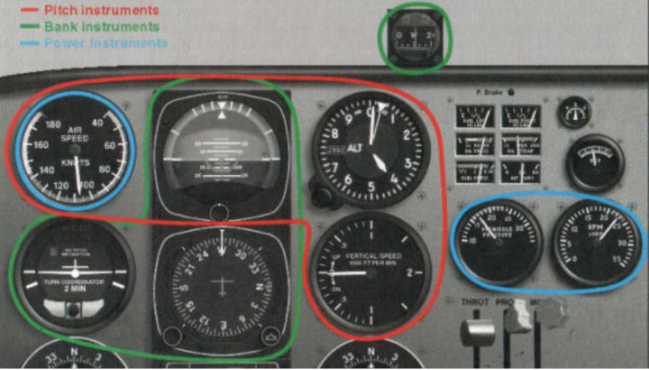

Pitch instruments
attitude indicator (AI)
altimeter (ALT)
airspeed indicator (ASI)
vertical speed indicator (VSI)
Bank instruments
attitude indicator (AI)
heading indicator (HI)
magnetic compass (MC)
turn coordinator (TC)
Power instruments
airspeed indicator (ASI)
engine instruments
manifold pressure gauge (MP)
tachometer (RPM)
For any maneuver or flight condition
Primary instruments
One in each group (pitch, bank, power)
Provide most pertinent and essential information
Indication stable with correct flight (shows greatest change with improper aircraft control)
Secondary instruments
Back up and supplement primary instruments
Advantages
Emphasized by FAA (Instrument Flying Handbook)
Requires specific knowledge and interpretation of each individual instrument during training
Helps avoid over-dependence on attitude indicator, facilitating partial panel flight

Fundamental skills
- Cross-check
Continuous, logical observation of instruments for attitude and performance information
Proficient pilot adjusts scan rate and sequence to specific flight situation
Common errors
Fixation
Omission
Emphasis
- Interpretation
Appled knowledge of
instrument construction and operating principles
aircraft performance capabilities (POH)
Learn what performance to expect and combination of instruments to interpret for each flight condition
- Control
Four components
Pitch
Bank
Power
Trim
Common error - Tension - use relaxed touch

Straight-and-Level Flight
- The relationship of pitch, bank and power in straight-and-level flight
Pitch varies with airspeed and load
At constant airspeed, there is only one specific pitch attitude for level flight
Uncorrected bank leads to decreasing pitch with increasing airspeed
- Procedure using full panel and partial panel
Full panel
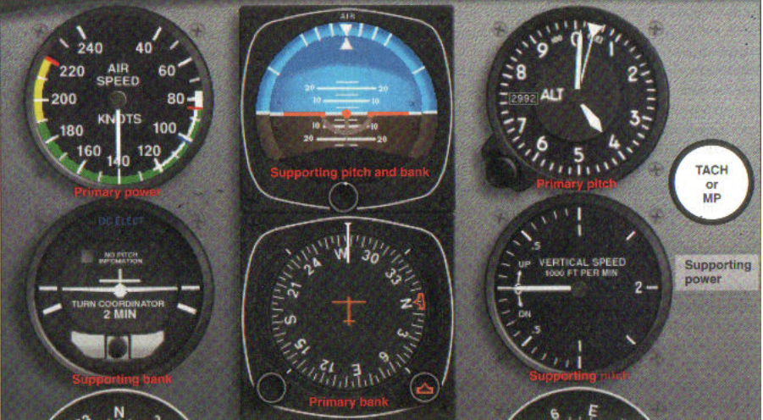

Maintain constant altitude (+/- 100 ft) and heading (+/- 10°) at a given contstant airpseed (+/- 10 kt)
Constant altitude
- Adjust pitch to maintain assigned ALT with VSI = 0
- Trim to relieve control pressures
- Correct small deviations (< 100 feet) with pitch only
  - ½ bar width on AI
  - VSI < 200 fpm
- Larger deviations may require use of pitch and power
  - Initial 1 bar width on AI
  - VSI = 2 x error in alt
- VSI is primary pitch instrument during altitude corrections
Constant heading
- Adjust aileron and rudder pressures to keep HI constant, wings level on AI and TC with ball centered
- Corrections of heading deviations
Coordinated aileron and rudder
Bank angle < number of degrees off and < standard rate (3°/sec)
Constant airspeed - adjust power (MP, RPM) to maintain airspeed
Prompt, smooth, small corrections

Straight and Level Flight
 | Pitch | Bank | Power
Primary | ALT | HI | ASI
Secondary | AI, VSI | AI, TC | MP, RPM

Partial Panel (AI and HI inoperative)
Maintain altitude with ALT, VSI, ASI
Hold heading with TC level, centered ball, and MC

Straight and Level Flight - Partial Panel
 | Pitch | Bank | Power
Primary | ALT | TC | ASI
Secondary | VSI | MC | MP, RPM

- Coordination of controls and trim
Keep ball centered
Trim to relieve control pressures

