POWER-OFF STALLS (PROFICIENCY) (ASEL and ASES)

Objective:
To familiarize the student with the conditions that produce stalls. To assist in recognizing an approaching stall. To develop a habit in the student of taking prompt, preventive or corrective action. To better prepare the student to deal with stalls during approach to landing.

Before Flight:
- Review:
  - What is a stall?
  - When can a stall occur?
  - What do power-on/power-off/turning stalls simulate?
  - Wing washout
  - Warnings before a stall occurs:
  - Visual
  - Aural
  - Feel
  - Stall warning devices
- Steps to stall recovery:
  - Release back elevator pressure or apply forward pressure
  - Advance throttle
  - Regain straight and level flight using all controls
  - Aileron/rudder control should be used with care
  - Recovery should be completed no lower than 1,500 feet AGL during practice

Maneuver Elements:
- Setup
  - Clear the area
  - Choose forced landing area
  - Configure aircraft: gear down, full flaps, carburetor heat on, power set for final approach to land, altitude so recovery is ≥1500’ AGL
  - Select outside references
  - Start a descent (as if on final approach) using power and pitch
  - Power to idle
  - Smoothly raise nose until a stall is induced, maintaining constant pitch with the elevator
  - Maintain coordination (ball centered) and neutral ailerons
- Recovery
  - Reduce the angle of attack by releasing back-elevator pressure
  - Advancing the throttle to maximum power
  - Carburetor heat off, retract first notch of flaps immediately
  - Anticipate left-turning tendencies with right rudder pressure
  - Continue to lower nose to regain flying speed, slowly returning to level flight
  - Upon positive rate of climb, retract flaps and gear are as necessary
  - When in level flight, reduce power to a setting for cruise flight or climb as necessary
  - Maintain ball centered
  - Look for traffic

Aircraft Setup:
Flaps down, gear down
Approach power: (C172RG: 18” Hg, 2700 RPM)
Approach Speed: (C172RG: 65 KIAS)

Things to Avoid (Common Errors):
- Failure to adequately clear the area
- Inability to recognize an approaching stall condition through feel for the airplane
- Premature recovery
- Over-reliance on the airspeed indicator while excluding other cues
- Inadequate scanning resulting in an unintentional wing-low condition during entry
- Excessive back-elevator pressure resulting in an exaggerated nose-up attitude during entry
- Inadequate rudder control
- Inadvertent secondary stall during recovery
- Failure to maintain a constant bank angle during turning stalls
- Excessive forward-elevator pressure during recovery resulting in negative load on the wings
- Excessive airspeed buildup during recovery
- Failure to take timely action to prevent a full stall during the conduct of imminent stalls

Diagrams:
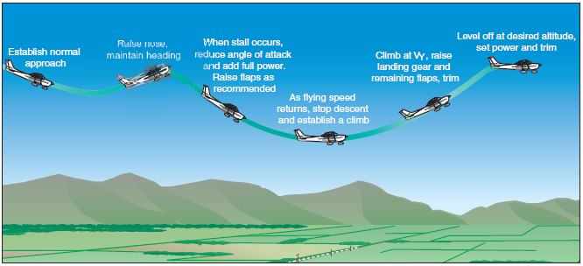

References:
Airplane Flying Handbook - Chapter 4

Completion Standards:
The lesson is complete when the student is able to perform power-off stalls to the satisfaction of the instructor and in accordance with the current Practical Test Standards for the student’s stage of training.

