POWER-ON STALLS (PROFICIENCY) (ASEL and ASES)

Objective:
To familiarize the student with the conditions that produce stalls. To assist in recognizing an approaching stall. To develop a habit in the student of taking prompt, preventive or corrective action. To better prepare the student to deal with stalls during takeoff and climb out.

Before Flight:
- What is a stall?
- When can a stall occur? (High Density Altitude)
- What do power-on/power-off/turning stalls simulate?
- Wing washout
- Warnings before a stall occurs:
- Visual
- Aural
- Feel
- Stall warning devices
- Steps to stall recovery:
- Release back elevator pressure or apply forward pressure
- Advance throttle
- Regain straight and level flight using all controls
- Aileron/rudder control should be used with care
- Recovery should be completed no lower than 1,500 feet AGL during practice

Maneuver Elements:
- Setup
  - Clear the area
  - Choose forced landing area
  - Configure aircraft for just before take-off: gear down, no flaps, carburetor heat on, slow to normal take-off speed with max propeller RPM, altitude so recovery is ≥1500’ AGL
  - Select outside references
  - Throttle to full (carburetor heat off) while simultaneously applying back-elevator pressure to smoothly raise nose to a high pitch attitude
  - Maintain back-elevator pressure at its full limit until airspeed, bleeding airspeed until it falls beyond Vs1 and stalls
  - Maintain coordination (ball centered) and neutral ailerons
- Recovery
  - Reduce the angle of attack by releasing back-elevator pressure
  - Simultaneously increasing throttle to full (if not already)
  - Anticipate left-turning tendencies with right rudder pressure
  - Return nose to straight-and-level coordinated flight
  - Maintain ball centered
  - Upon positive rate of climb, retract flaps and gear as necessary
  - Look for traffic

Aircraft Setup:
Flaps up, gear down
Normal take-off speed: (C172RG: 15” Hg, 2700 RPM, 65 KIAS)
Vs1: (C172RG: 50 KIAS)
Things to Avoid (Common Errors):
- Failure to adequately clear the area
- Inability to recognize an approaching stall condition through feel for the airplane
- Premature recovery
- Over-reliance on the airspeed indicator while excluding other cues
- Inadequate scanning resulting in an unintentional wing-low condition during entry
- Excessive back-elevator pressure resulting in an exaggerated nose-up attitude during entry
- Inadequate rudder control
- Inadvertent secondary stall during recovery
- Failure to maintain a constant bank angle during turning stalls
- Excessive forward-elevator pressure during recovery resulting in negative load on the wings
- Excessive airspeed buildup during recovery
- Failure to take timely action to prevent a full stall during the conduct of imminent stalls

Diagrams:
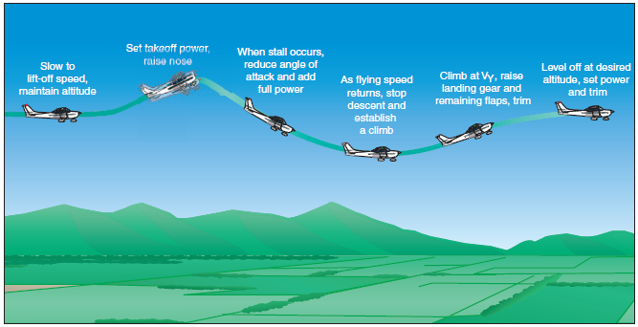

References:
Airplane Flying Handbook - Chapter 4

Completion Standards:
The lesson is complete when the student is able to perform power-on stalls to the satisfaction of the instructor and in accordance with the current Practical Test Standards for the student’s stage of training.

