RECTANGULAR COURSE (ASEL and ASES)

Objective:
To develop division of attention between the flight path and ground references, while controlling the airplane and watching for other aircraft in the vicinity. To develop recognition of drift toward or away from a line parallel to the intended ground track.

Before Flight:
- Review applicable aircraft performance information
- Airspeed and altitude should be held constant during maneuver
- Bank should normally not exceed 45° during maneuver
- All turns should be started when aircraft is abeam the corner of the field boundaries
- Anticipate turns based on groundspeed and turning radius

Maneuver Elements:
- Clear the area
- Choose forced landing area (ideally within rectangular pattern)
- Configure aircraft for maneuvering: flaps and gear up, traffic pattern power and speed, approx. traffic pattern altitude of 600 – 1000’ AGL
- Select outside references (ideally a large rectangular field or parking lot), deciding on either a left or right turns course
- Enter the pattern on the downwind, usually at 45º to the direction of the downwind, maintaining airspeed and ball centered (It can be entered on any leg of the course, but ideally enter on downwind)
- At the first corner, turn to base leg, which is more than 90º due to a necessary crab angle on the base leg; the bank will be steeper than normal due to the tailwind at start of the turn
- Crab as necessary to maintain a straight base leg
- At the second corner, turn to upwind leg, which is less than 90º due to the crab or wind correction on base; the bank will be shallower than normal due to headwind at end of turn
- Fly the upwind, which should require no wind correction
- At the third corner, turn to crosswind leg, which is less than 90º due to a necessary crab angle on the crosswind leg; the bank will be shallower than normal due to the headwind at start of the turn
- Crab as necessary to maintain a straight crosswind leg
- At the fourth corner, turn to downwind leg, which is more than 90º due to the crab or wind correction on crosswind; the bank will be steeper than normal due to tailwind at end of turn
- Complete additional circuits or exit from downwind by turning 45º from the downwind leg
- Maintain ball centered
- Look for traffic

Aircraft Setup:

Flaps and gear up
Traffic pattern power and speed
Traffic pattern altitude of 600 – 1000’ AGL
C172RG: MP: 18” Hg
RPM: 2500 RPM
Speed: 90 KIAS

Things to Avoid (Common Errors)

- Failure

- to clear the area
- Failure to establish proper altitude prior to entry
- Failure to establish appropriate wind correction angle resulting in drift
- Gaining or losing altitude
- Poor coordination
- Inability to adequately divide attention between airplane control and maintaining ground track
- Improper timing in beginning and recovering from turns
- Inadequate visual lookout for other aircraft

Diagram:
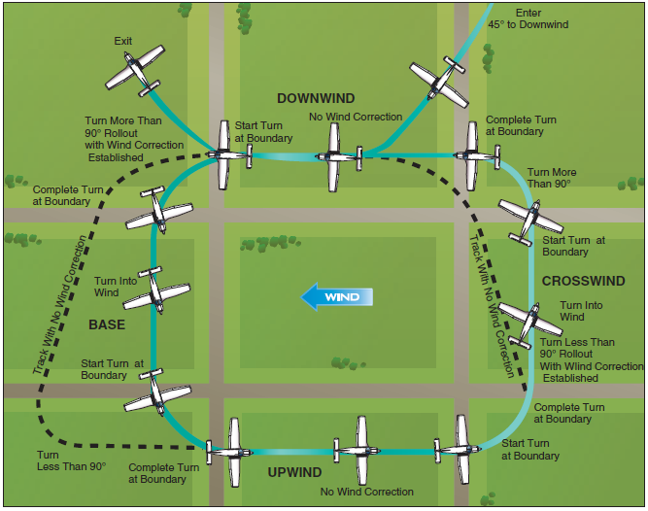

References:
Airplane Flying Handbook - Chapter 6

Completion Standards:
The lesson is complete when the student demonstrates knowledge through a written or oral exam and is able to perform a rectangular course to the satisfaction of the instructor and in accordance with the current Practical Test Standards for the student’s stage of training.

