REGULATIONS AND PUBLICATIONS RELATED TO IFR OPERATIONS

Objective:
To familiarize the student with the FAR’s and their application and applicability to the student and IFR operations as a pilot and to familiarize the student with the various aviation-related publications that he will use to gather information for flight.

Content:
- 14 CFR parts 61, 91, 95 and 97
- FAA-H-8083-15, Instrument Flying Handbook
- Aeronautical Information Manual
- Practical Test Standards
- Airport Facility Directory
- Standard Departures/Terminal Arrivals
- En Route Charts
- Standard Instrument Approach Procedure Charts

References:
14 CFR parts 61, 91, 95 and 97
FAA-H-8083-15, Instrument Flying Handbook
Aeronautical Information Manual
ACS
Airport Facility Directory
NACO Charts

Completion Standards:
This lesson continues throughout the student’s training and is, therefore, never complete.
The lesson is complete when the instructor determines that the student has adequate knowledge of the appropriate publications used for flight, and understands how to research the Federal Aviation Regulations pertinent to the activity being performed.

Instructor Notes

- 14 CFR parts 61, 91, 95 and 97
  - Part 61: Certification of Pilots, Flight Instructors, and Ground Instructors
    - Prescribes the requirements for issuing pilot, flight instructor, and ground instructor certificates, ratings and authorizations; the conditions under which these are necessary; and the associated privileges and limitations
  - Part 91: General Operating and Flight Rules
    - Prescribes rules governing the operation of aircraft (other than moored balloons, kites, unmanned rockets, and unmanned free balloons, which are governed by part 101 of this chapter, and ultralight vehicles operated in accordance with part 103 of this chapter) within the United States, including the waters within 3 nautical miles of the U.S. coast
  - Part 95: IFR Altitudes
    - Prescribes altitudes governing the operation of aircraft under IFR on Federal airways, jet routes, area navigation low or high routes, or other direct routes for which a MEA is designated in this part. In addition, it designates mountainous areas and changeover points
  - Part 97: Standard Instrument Approach Procedures
    - Prescribes standard instrument approach procedures for instrument letdown to airports in the United States and the weather minimums that apply to takeoffs and landings under IFR at those airports
- FAA-H-8083-15, Instrument Flying Handbook
  - Combined FAA and industry effort that conforms to pilot training and certification concepts established by the FAA and serves as a valuable training aid for instrument flight instructors and pilots training for instrument rating tests (supersedes AC 61-27C)
  - Contents: all aeronautical knowledge and skills required to operate in IMC
      - Human factors
      - Aerodynamic factors
      - Flight instruments
      - Airplane attitude instrument flying
      - Basic flight maneuvers
      - Navigation systems
      - National airspace system (NAS)
      - ATC system
      - IFR flight procedures
      - IFR emergencies
      - Instrument training lesson guide
- Aeronautical Information Manual
  - Provides pilots with current (updated every August and February) basic flight information and ATC prodecures for use in the National Air Space of the United States (the Aeronautical Information Publication is the international version)
  - Content
      - Navigational aids
      - Aeronautical lighting and other airport visual aids
      - Airspace
      - ATC
      - Air traffic procedures
      - Emergency procedures
      - Safety of flight
      - Medical facts
      - Aeronautical charts and related publications

- Airport Facility Directory (AFD)
  - FAA Airport/Facility Directory is a pilot's manual that contains data on public use and joint use airports, seaplane bases heliports, VFR airport sketches, NAVAIDs, communications data, weather data sources, airspace, special notices, and operational procedures. The seven volumes cover the conterminous United States, Puerto Rico, and the Virgin Islands. The AFD includes data that cannot be readily depicted in graphic form: e.g., airport hours of operation, types of fuel available, runway data, lighting codes, etc. The AFD also provides a means for pilots to update visual navigation charts between editions dates; i.e., the AFD is published every 56 days while the VFR Sectional and Terminal Area Charts are generally revised every six months.
  - Content also includes FSS and NWS telephone numbers, ARTCCs, GADOs and FSDOs, preferred IFR routes, VOR checkpoints, PAJAs, aeronautical chart bulletin
- Standard Departures/Terminal Arrivals
  - Instrument departure procedures (DPs)
    - Obstacle departure procedures (ODPs)
      - Designed specifically to provide obstacle clearance during climb from the terminal area to the en route structure
        - Provide obstacle clearance if aircraft
- Crosses end of runway above 35 feet AGL
- Climbs to 400 feet above airport elevation before turning
- Climbs at least 200 feet per nautical mile (FPNM) (that's 300 fpm at ground speed = 90 knots) or higher gradient specified in DP to assigned altitude
        - Pilots are strongly encouraged to fly published DPs at night, in marginal VMC and in IMC to ensure obstacle clearance
      - Some ODPs may also be depicted graphically in the TPP (these will have the name "Obstacle" in the title
      - TPPs are published every 56 days (8 weeks); and mid-cycle revisions are published every 4 weeks later by the NACO of the FAA
    - Standard Instrument Departures (SIDs)
      - Designed by ATC to standardize traffic flow, ensure aircraft separation and enhance capacity (also provide obstacle clearance)
      - ATC clearance is required to fly a SID
  - Standard terminal arrival routes (STARs)
    - Prescribed routes from the en route structure to a fix in the terminal area from which an instrument approach may be flown
    - STARs are graphically depicted and textually described in alphabetical order in Section P of the TPPs; and available online at the NACO site
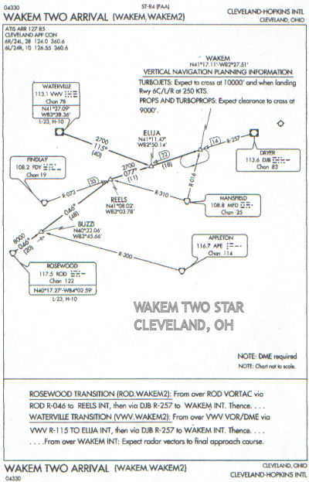
    - RNAV STARs
      - For use by GPS equipped aircraft
      - Type A - require track accuracy of +/- 2 NM
      - Type B - require track accuracy of +/- 1 NM
- En Route Charts
  - En route high altitude charts provide aeronautical information for en route instrument navigation at or above 18,000 feet MSL
    - Established routes 18,000 feet MSL to FL 450 use NAVAIDs not more than 260 miles apart
    - Scale varies: 1 inch = 18 to 45 NM
    - Revised (NACO) every 8 weeks
  - IFR en route low altitude charts
- Provide the aeronautical information needed to effectively navigate en route from one airport to another under IFR (the IFR equivalent of the VFR sectional chart)
- For a specific area, contain information about and depict the geographic relationships among airports, NAVAIDs, communication facilities, navigation routes, reporting points, airspace and ARTCC areas
      - Scale varies: 1 inch = 5 to 20 NM
      - A more detailed area chart (A-1,2) is available for 12 major US traffic hubs
      - Detailed legend defines all symbols
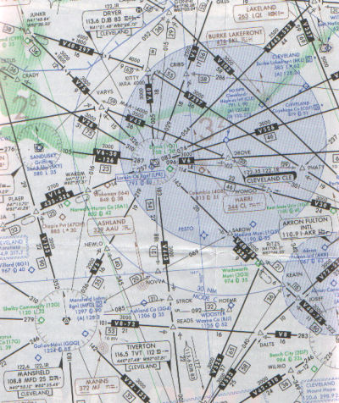
Available from NACO, Distribution Division, which publishes revised editions every 56 days (8 weeks)

- Standard Instrument Approach Procedure Charts (IAPs)
  - IAPs satisfy US Standard for Terminal Instrument Approach Procedures (TERPs) cri
  - IAP chart elements
    - Margin identification (top and bottom margins)
      - Chart reference number and approval authority
      - Amendment status, effective date (00123 = 123rd day of 2000)
      - Name of city, airport
      - Approach name
        - Derived from type(s) of NAVAID(s) providing guidance for (and thus needed to fly) the final approach course
"/" => both required (VOR/DME RWY 6)
"or" => either OK (VOR or GPS RWY 24)
        - Includes runway number if final approach course within 30° of that runway, e.g. VOR RWY 23 (otherwise name includes a letter starting with A, as in VOR A)
        - Parallel runways distinguished by R, L, or C as in ILS 24R and ILS 24L
        - Multiple same-type approaches to one runway distinguished by letter starting with Z (ILS Z RWY 4 and ILS Y RWY 4)
    - Plan view
      - Graphic overhead depiction
      - Elements defined in legend in section G in front part of TPP booklets
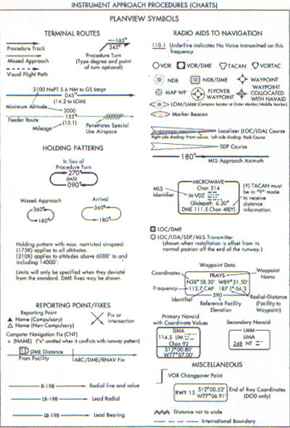
    - Profile view
      - Side view depicting altitudes, headings, distances, fixes
      - Elements defined in legend in section H in front part of TPP booklets
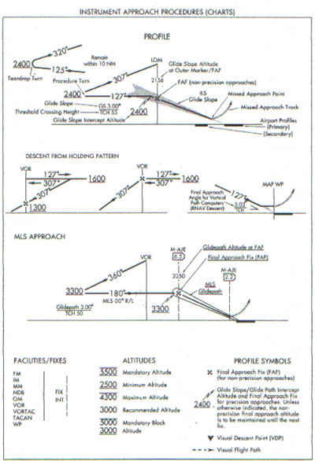
    - Minimum and notes section
      - Lowest altitude and visibility requirements
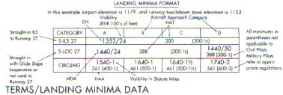
      - Procedural notes
    - Airport diagram
      - Sketch of airport
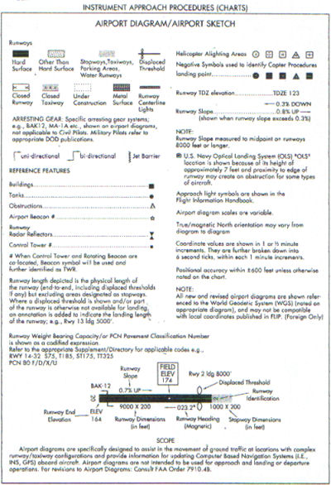
      - Approach lighting
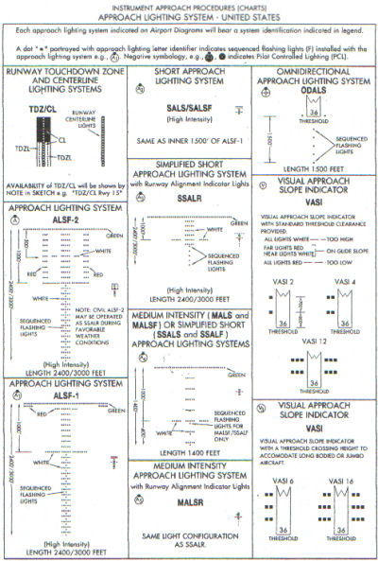
      - RNAV IAP charts
        - IAP charts are being converted to RNAV IAP chart format
        - Key information, including communication frequencies and MAP, in boxes near top of IAP
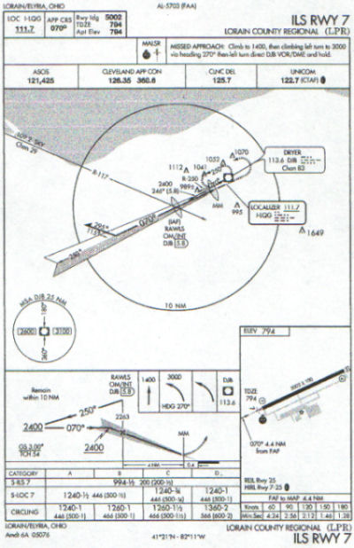
      - RNAV minima
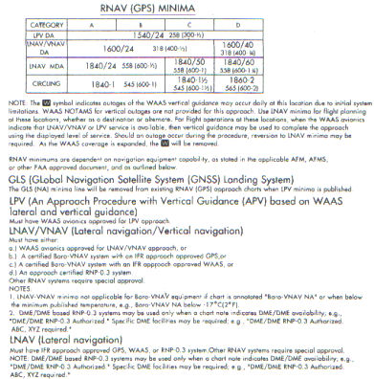
      - Terminology
        - DA (decision altitude) replaces DH (decision height)
        - MDA (minimum descent altitude) for LNAV only and circling
        - TCH (threshold crossing height) applies to height of "descent angle" or glidepath at runway threshold
  - IAPs are published in the US Terminal Procedures publication booklets (TPPs) every 56 days (8 weeks) with mid-cycle revisions ("Change Notices") by the NACO of the FAA; and are available online on the NACO website
  - US military IAPs are published by the DOD
  - Special IAPs may be approved by the FAA for use by specific individual operators

