S-TURNS ACROSS A ROAD (ASEL and ASES)

Objective:
To develop in the student the ability to compensate for drift during turns, orient the flight path with ground references, follow an assigned ground track, arrive at specified points on assigned headings, and divide the pilot’s attention.

Before Flight:
- Review principles learned during Rectangular course
- Review applicable aircraft performance information
- Bank will be steepest downwind, and shallowest upwind during turns
- Constant altitude should be maintained throughout maneuver
- Aircraft should trace a perfect S over the ground if done correctly
- It helps to pick ground points at the 90° point in both turns that are the same distance from the straight-line reference as aiming points to fly over

Maneuver Elements:
- Clear the area
- Choose forced landing area
- Configure aircraft: flaps and gear up, speed at or below Va, straight-and-level at altitude between 600-1000’ AGL, trim to maintain altitude
- Select a straight ground reference perpendicular to the wind
- Approach from upwind side (have a tailwind)
- Start first turn to the left (steepest bank) upon crossing the ground reference
- When aircraft is parallel to ground reference the aircraft should have a moderate bank and groundspeed is decreasing
- Approaching the reference point again the aircraft should have its shallowest bank
- Wings level and parallel at the ground reference line.
- Start second turn to the right (shallowest bank) upon crossing the ground reference
- When aircraft is parallel to ground reference the aircraft should have a moderate bank with groundspeed increasing
- Approaching the reference point again the aircraft should have its steepest bank
- On completion, wings should be level and parallel to the reference upon crossing
- Maintain ball centered
- Look for traffic

Aircraft Setup:

Flaps and gear up
Power and speed at or below Va
Traffic pattern altitude of 600 – 1000’ AGL
C172RG: MP: 18” Hg
RPM: 2300 RPM
Speed: 100 KIAS

Things to Avoid (Common Errors)

- Failure to adequately clear the area
- Poor coordination
- Gaining of losing altitude
- Inability to visualize the half circle ground track
- Poor timing in beginning and recovering from turns
- Faulty correction for drift
- Inadequate

- visual lookout for other aircraft

Diagram:
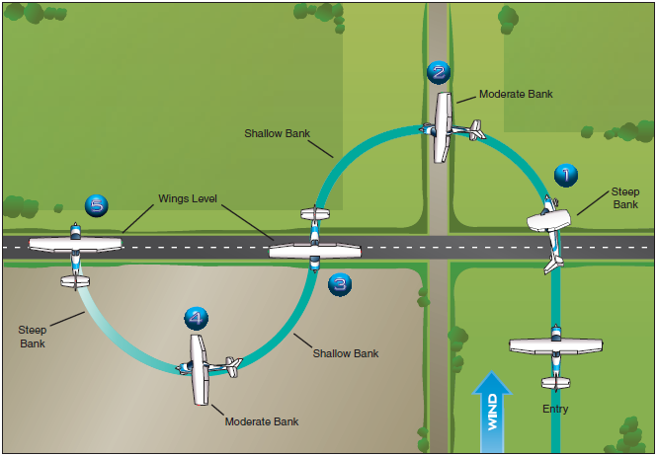

References:
Airplane Flying Handbook - Chapter 6
Completion Standards:
The lesson is complete when the student demonstrates knowledge through a written or oral exam and is able to perform s-turns to the satisfaction of the instructor and in accordance with the current Practical Test Standards for the student’s stage of training.

