SHORT-FIELD (CONFINED AREA—ASES) TAKEOFF AND MAXIMUM PERFORMANCE CLIMB (ASEL and ASES)

Objective:
To familiarize the student with the proper procedures and techniques for short-field takeoff and climb.

Before Flight:
- Review aircraft V-speeds
- Terms:
  - Takeoff Roll (Ground Roll)
  - Lift-off (Rotation)
  - Ground Effect
  - Initial Climb
  - Torque/P-Factor
  - Propeller slipstream
- Pre-takeoff considerations
  - Preflight check
  - CTAF or ATC
  - Wake turbulence
  - Maintaining runway centerline during takeoff roll and climbout
  - Why takeoff into the wind?
- Noise abatement procedures
- Obstacles or short runway

Maneuver Elements:
- Clear the area
- Choose forced landing area
- Configure aircraft: flaps as specified, cowl flaps open, propeller to full
- Select outside references: vanishing point on runway
- Taxi onto runway centerline
- Apply full brakes
- Smoothly apply full power, upon engine peak, release brakes
- Anticipate need for right rudder pressure
- Check engine instruments (in green)
- Attitude slightly tail-low
- Do NOT rotate at V_{R} for short field take-off
- At V_{X} (gear out), apply back pressure to lift nose wheel
- Adjust pitch to maintain steep climb out at V_{X}
- Clear the real or simulated obstacle (if applicable)
- Adjust to normal climb V_{Y} (gear out)
- Gear up upon positive rate of climb, safe airspeed, no useable runway and clear of obstacle
- After 500’ AGL, flaps up
- Maintain ball centered
- Look for traffic

Aircraft Setup:

Flaps (C172RG: 10º), gear down, propeller Full
Vx (C172RG: 63 KIAS)
Vy (C172RG: 84 KIAS)

Things to Avoid (Common Errors)
- Failure to adequately clear the area
- Failure to utilize all available runway/takeoff area
- Failure to have the airplane properly trimmed prior to takeoff
- Premature lift-off resulting in high drag
- Holding the airplane on the ground unnecessarily with excessive forward-elevator pressure
- Inadequate rotation resulting in excessive speed after lift-off
- Inability to attain/maintain best angle-of-climb airspeed
- Fixation on the airspeed indicator during initial climb
- Premature retraction of landing gear and/or wing flaps

Diagrams:
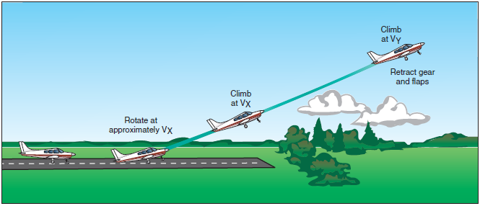

References:
Airplane Flying Handbook - Chapter 5
Aircraft Flight Manual / Pilot’s Operating Handbook

Completion Standards:
The lesson is complete when the student is able to perform short-field takeoffs and climbs to the satisfaction of the instructor and in accordance with the current Practical Test Standards for the student’s stage of training.

