SLIP TO A LANDING (ASEL and ASES)

Objective:
To teach the pilot proper procedures and technique for performing a forward slip to a landing in order to lose excess altitude quickly.

Before Flight:
- What is a slip?
  - Occurs when bank angle too great for current rate of turn
  - Forward slip is one in which the airplane’s direction of motion continues the same as before the slip was begun
  - Useful in situations where obstacles must be cleared during approaches to confined areas
  - Can be used to rapidly reduce airspeed in situations where flaps cannot be used or are not installed
- Slips cause large increases in drag. Why?
- Practical slip limit
  - Point at which maximum rudder is used, slip cannot increase
- Recovering form a slip
  - Slips may improve stall characteristics in some airplanes, however, normal instrument indications may be incorrect because of position error
- Student should learn to recognize proper slip by attitude, sound of airflow, and feel of controls
- What does the AFM/POH say about slips? (i.e. With flaps extended, etc)

Maneuver Elements:
- Clear the area
- Choose forced landing area (runway)
- Configure aircraft: landing checklist (no flaps), extend gear, final approach.
- Select outside references (touchdown point)
- Throttle to idle, bank in the direction of any crosswind with sufficient bank to give a steep descent based on the altitude necessary to lose while simultaneously applying sufficient opposite rudder to maintain the original flightpath
- Maintain attitude (IAS not accurate)
- Recover when a normal landing can be made: level the wings while releasing rudder
- Pitch to normal glide attitude
- Land at touchdown point (without use of flaps) beyond and within 400’ at approximate stalling speed with no side drift

Aircraft Setup:

Flaps up, gear down, propeller Full
Final approach speed: (C172RG: 15” Hg, 2700 RPM, 70 KIAS)

Things to Avoid (Common Errors)
- Recovering by abruptly releasing rudder pressure, causing the nose to swing to quickly and causing excessive airspeed
- Failing to control pitch resulting in excessive or insufficient airspeed
- Side slipping, resulting in drifting away from the ground track to the centerline of the runway

Diagrams:
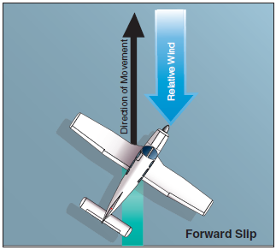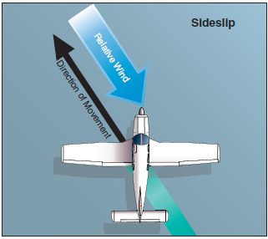

References:
Airplane Flying Handbook - Chapter 8
Aircraft Flight Manual / Pilot’s Operating Handbook
Note aircraft placards relating to slip limitations

Completion Standards:
The lesson is complete when the instructor determines that the student understands the forward slip maneuver and its uses and can execute the procedure by giving an oral or written exam and by having the student perform the maneuver properly in flight.

