SOFT-FIELD APPROACH AND LANDING (ASEL)

Objective:
To teach the pilot proper procedures and technique for making landings on soft surfaces.

Before Flight:
- When is this used?
- Lower than normal airspeed requires vigilance
- Used to minimize nose-over force from touchdown on soft fields
- Wider than normal pattern should be flown to allow time for proper setup
- Touchdown should be made at lowest possible speed
- See aircraft AFM/POH for specific procedures
- Region of reversed command and its applicability to soft-field approaches
- Considerations after touchdown

Maneuver Elements:
- Clear the area
- Choose forced landing area (should be runway)
- Configure aircraft for normal approach and begin descent as normal
- Select outside references (e.g. runway numbers)
- Clear area, then turn to final (≤30° bank)
- On final: remaining flaps when runway is assured, CCGUMPS check
- Select aim point (e.g. before runway numbers)
- Adjust pitch and power to maintain normal approach speed and descent angle
- Trim to relieve control pressures
- Make sure feet are not on brakes
- 10-20’ off ground: power to maintain minimum descent rate (e.g. throttle to idle then re-add some power to slow descent rate)
- Gradually apply back pressure to pitch for straight-and-level attitude, attempting to fly just above runway (fly in ground effect) straight-and-level until passing aim point, then continue adjusting pitch for climb attitude just above horizon
- Hold aircraft in ground effect, 1-2’ above surface, as long as possible
- Upon touchdown on main gear, smoothly apply elevator pressure to hold nose wheel off surface as long as possible
- Gently lower the nose wheel to the surface
- Slight addition of throttle upon touchdown can assist softly lowering the nose wheel
- Do not use brakes and maintain elevator back pressure for taxiing

Aircraft Setup:

Flaps as required, gear down, propeller Full
Final approach speed: (C172RG: 65 KIAS)

Things to Avoid (Common Errors)
- Excessive descent rate on final approach
- Excessive airspeed on final approach
- Unstabilized approach
- Roundout too high above the runway surface
- Poor power management during roundout and touchdown
- Hard touchdown
- Inadequate control of the airplane weight transfer from wings to wheels after touchdown
- Allowing the nose wheel to “fall” to the runway after touchdown rather than controlling its descent

Diagrams:
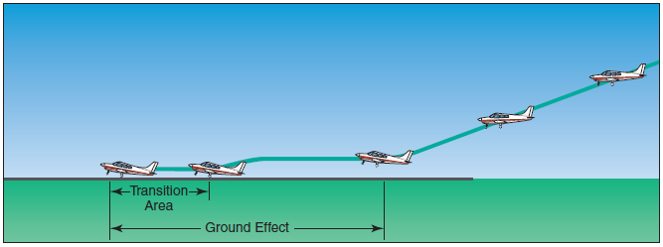

References:
Airplane Flying Handbook - Chapter 8-17
Aircraft Flight Manual / Pilot’s Operating Handbook

Completion Standards:
The lesson is complete when the student can fly a stabilized soft-field approach and landing at 1.3VSO +- 5 knots and can touch down as required by a soft-field landing. The instructor must also determine that the student has the appropriate knowledge required for soft-field landings by giving an oral or written exam.

