SOFT-FIELD TAKEOFF AND CLIMB (ASEL)

Objective:
To familiarize the student with the proper procedures and techniques for soft-field takeoff and climb.

Content:
- Before Flight:
  - Review aircraft V-speeds
  - Terms:
    - Takeoff Roll (Ground Roll)
    - Lift-off (Rotation)
    - Ground Effect
    - Initial Climb
    - Torque/P-Factor
    - Propeller slipstream
  - Pre-takeoff considerations
    - Preflight check
    - CTAF or ATC
    - Wake turbulence
    - Maintaining runway centerline during takeoff roll and climbout
    - Why takeoff into the wind?
  - Noise abatement procedures
  - Runway condition

Maneuver Elements:
- Clear the area
- Choose forced landing area
- Configure aircraft: flaps as specified, cowl flaps open, propeller to full
- Select outside references: vanishing point on runway
- Taxi onto runway centerline with full elevator back pressure: do not stop once taxiing
- Smoothly apply full power
- Anticipate need for right rudder pressure
- Check engine instruments (in green)
- As aircraft accelerates, apply enough back pressure to establish positive angle of attack
- After lift-off, lower the nose gently with the wheels clear of the runway, attempting to fly in straight-and-level flight within a half-wingspan above the ground
- Accelerate in ground effect to V_{Y}
- Gear up upon positive rate of climb, safe airspeed, no useable runway
- After 500’ AGL, flaps up
- Maintain ball centered
- Look for traffic

Aircraft Setup:

Flaps (C172RG: 10º), gear down, propeller Full
Vy (C172RG: 84 KIAS)

Things to Avoid (Common Errors)
- Failure to adequately clear the area
- Insufficient back-elevator pressure during initial takeoff roll resulting in inadequate angle of attack
- Failure to cross-check engine instruments for indications of proper operation after applying power
- Poor directional control
- Climbing too steeply after lift-off
- Abrupt and/or excessive elevator control while attempting to level off and accelerate after lift-off
- Allowing the airplane to “mush” or settle resulting in an inadvertent touchdown
- Attempting to climb out of ground effect area before attaining sufficient climb speed
- Failure to anticipate an increase in pitch attitude as the airplane climbs out of ground effect

Diagrams:
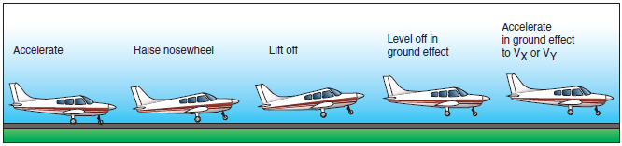

References:
Airplane Flying Handbook - Chapter 5
Aircraft Flight Manual / Pilot’s Operating Handbook

Completion Standards:
The lesson is complete when the student is able to perform soft-field takeoffs and climbs to the satisfaction of the instructor and in accordance with the current Practical Test Standards for the student’s stage of training.

