SPINS (ASEL)

Objective:
To teach the pilot to recognize impending stall and spin conditions. To teach the pilot to apply immediate corrective action any time it is apparent that the airplane is nearing spin conditions.

Before Flight:
- Determine if aircraft is approved for spins
- Determine weight and balance limitations
- Cover entry and recovery procedures
- Secure loose items in aircraft
- Four Spin phases:
  - Entry
  - Incipient
    - From time airplane stalls and rotation starts until spin has fully developed (may be up to two rotations)
    - Aerodynamic and inertial forces have yet to achieve balance
  - Developed
    - Aerodynamic and inertial forces balanced
    - Rotation rate, airspeed, vertical speed stabilized
    - Flight path nearly vertical
  - Recovery
    - Follow manufacturers recommendations, otherwise:
    - Idle throttle
    - Ailerons neutral
    - Full opposite rudder
    - Forward elevator pressure
    - Neutralize rudder after rotation stops
    - Apply back elevator pressure
- In aircraft placarded against spins, there is no assurance that recovery from a fully developed spin is possible
- “PARE” is the recovery technique. Spins are an aerobatic maneuver. 14 CFR 91.303 governs where aerobatic maneuvers may be done: Uncongested area, not in class B, C, D, or E airspace near an airport or airway. 3+ statute mile visibility is required. A parachute is ordinarily required, but not for spins that are done when required for a rating (14 CFR 91.307(d)). The airplane must be in the utility category or aerobatic category to withstand the loads imposed during a spin. (Load factors for aircraft categories: Utility +4.4, -1.76; Normal +3.8, -1.52; Aerobatic +6.0, -3.0.)

Maneuver Elements:
- Setup
  - Pre-flight: weight and balance of the aircraft must be calculated before the maneuver to confirm that the airplane is within the utility category
  - Clear the area
  - Choose forced landing area (should be runway)
  - Configure aircraft for landing (except gear up): altitude sufficient for recovery not below 1500’ AGL (ideally 5000’ AGL to start), flaps full, carburetor heat on
  - Select outside references for orientation
  - Power-off stall: reduce power to idle, simultaneously raise the nose
  - Add full rudder in direction of desired spin as airplane stalls
  - Apply full back pressure on elevator to the limit of travel
  - Ailerons in the neutral position
  - Take flaps out immediately
  - Allow spin to develop into a steady-state (developed) spin
- Recovery
  - Power – reduce to idle
  - Ailerons – position to neutral
  - Rudder – full opposite against the rotation
  - Elevator – brisk elevator control full forward to brake stall
  - After spin rotation stops, neutralize the rudder
  - Smoothly apply back-elevator pressure to raise the nose to level flight

Aircraft Setup:
Flaps down, gear up
Landing Power: Low MP, High RPM

Things to Avoid (Common Errors):
- Failure to establish proper configuration prior to spin entry
- Failure to achieve and maintain a full stall during spin entry
- Failure to close throttle when a spin entry is achieved
- Failure to recognize the indications of an imminent, unintentional spin
- Improper use of flight controls during spin entry, rotation, or recovery
- Disorientation during a spin
- Failure to distinguish between a high-speed spiral and a spin
- Excessive speed or accelerated stall during recovery
- Failure to recover with minimum loss of altitude
- Attempting to spin an airplane not approved for spins

Diagrams:
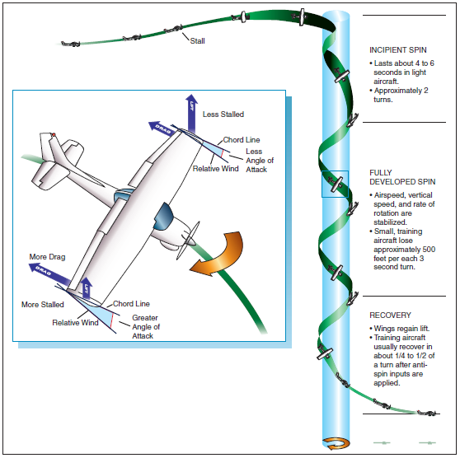

References:
Airplane Flying Handbook - Chapter 4

Completion Standards:
The lesson is complete when the student demonstrates knowledge through a written or oral exam and is able to perform spins (if required) to the satisfaction of the instructor and in accordance with the current Practical Test Standards for the student’s stage of training.

