STEEP SPIRALS (ASEL and ASES)

Objective:
To improve pilot techniques for airspeed control, wind drift control, planning, orientation, and division of attention.

Before Flight:
- This maneuver is also valuable for remaining over selected spot in preparation for landing, especially emergencies
- Review appropriate aircraft performance information
- Steepest bank will be no more that 60°
- Altitude must be such that will allow three 360° turns
- Maneuver should not continue below 1000′ AGL
- Throttle should be advanced occasionally to prevent excessive engine cooling or spark plug fouling
- Constant airspeed should be held throughout the maneuver

Maneuver Elements:
- Clear the area
- Choose forced landing area (ideally adjacent to encircling point)
- Configure aircraft: straight-and-level, altitude sufficient to allow three complete turns and still be ≥1000’ AGL, CCGUMPS (propeller to full), flaps 0º
- Select outside references (point to encircle, ideally adjacent to a forced landing area)
- Throttle to idle, propeller to full
- Establish best glide speed
- Establish a constant radius circle allowing a bank of ≤60º about ground reference point
  - Close enough to allow no more than 60º of bank at the steepest point
- Maintaining a constant airspeed by adjusting pitch and bank as necessary to correct for wind
- Trim as necessary
- Clear the engine when into the wind (advance throttle to normal cruise momentarily)
- Complete at least three complete 360º turns, but do not descend below 1000’ AGL unless the maneuver is to be followed by an emergency landing
- Maintain ball centered
- Look for traffic

Aircraft Setup:
Flaps up, gear up
Altitude: (C172RG: 5000’ AGL minimum)
Best glide: (C172RG: 75 KIAS 0º Flaps)

Things to Avoid (Common Errors):
- Failure to clear area
- Failure to maintain constant airspeed
- Poor coordination, resulting in skidding and/or slipping
- Inadequate wind drift correction
- Failure to coordinate the controls so that no increase/decrease in speed result when straight glide is resumed
- Failure to scan for other traffic
- Failure to maintain orientation

Diagrams:
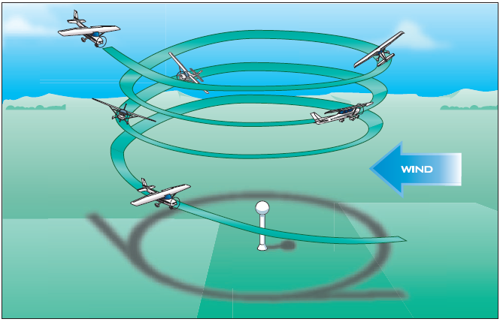

References:
Airplane Flying Handbook - Chapter 9

Completion Standards:
The lesson is complete when the student demonstrates knowledge through a written or oral exam and is able to perform steep spiral descents to the satisfaction of the instructor and in accordance with the current Practical Test Standards for the student’s stage of training.

