STRAIGHT CLIMBS AND CLIMBING TURNS (ASEL and ASES)

Objective:
To familiarize the student with the procedures and aerodynamics involved in climbs and climbing turns.

Before Flight:
- Ability to climb limited by thrust available
- What power/pitch settings lead to following climbs:
  - Normal climb
  - Better engine cooling
  - Easier control
  - Better visibility over the nose
- Best rate of climb, Vy
  - Airspeed at which most excess power is available
- Best angle of climb, Vx
  - Airspeed at which most excess thrust is available
- As altitude increases, Vx increases and Vy decreases. The point at which they meet is the absolute ceiling of the airplane
- Higher angle of attack and slower airspeed will cause torque and asymmetrical propeller loading to cause airplane to roll and yaw left
- Initiate level-off at 10% of climb rate above/below desired altitude
- Loss of vertical lift due to turning
- Adverse yaw more pronounced in climbing turns because of lower speed

Maneuver Elements:
- Clear the area
- Choose forced landing area (always be aware of options)
- Select outside references
- Configure aircraft: pitch 5-10º above horizon then power as necessary to maintain achieve either a normal or cruise climb, best angle of climb (V_{X}) or best rate of climb (V_{Y}).
  - For turning climbs, bank at approx. 30º for new heading
- Anticipate left-turning tendencies with sufficient rudder pressure
- Use outside references to maintain climb
- Trim to maintain climb
- Anticipate altitude (approx. 10% of climb rate), pitch for level flight, adjust power and trim as necessary
  - For turning climbs, anticipate heading (approx. 50% of bank angle)
- Maintain ball centered
- Look for traffic

Aircraft Setup:

Flaps and gear up, Power and speed as required
Normal or cruise climb: C172RG: 25” Hg, 2500 RPM, 90 KIAS
Best angle of climb (V_{X}): C172RG: 25” Hg, 2700 RPM, 67 KIAS
Best rate of climb (V_{Y}): C172RG: 25” Hg, 2500 RPM, 84 KIAS

Things to Avoid (Common Errors)
- Attempting to establish climb pitch attitude by referencing the airspeed indicator, resulting in “chasing” the airspeed
- Applying elevator pressure too aggressively, resulting in an excessive climb angle
- Applying elevator pressure too aggressively during level-off resulting in negative “G” forces
- Inadequate or inappropriate rudder pressure during climbing turns
- Allowing the airplane to yaw in straight climbs, usually due to inadequate right rudder pressure
- Fixation on the nose during straight climbs, resulting in climbing with one wing low
- Failure to initiate a climbing turn properly with use of rudder and elevators, resulting in little turn, but rather a climb with one wing low
- Improper coordination resulting in a slip which counteracts the effect of the climb, resulting in little or no altitude gain
- Inability to keep pitch and bank attitude constant during climbing turns
- Attempting to exceed the airplane’s climb capability

Diagrams:
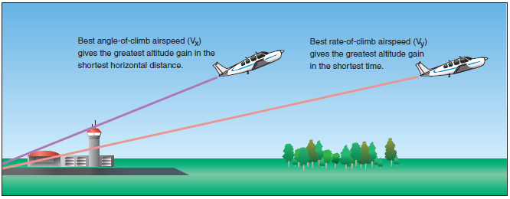

References:
Airplane Flying Handbook - Chapter 3

Completion Standards:
The lesson is complete when the student is able to perform straight climbs and climbing turns to the satisfaction of the instructor and in accordance with the current Practical Test Standards for the student’s stage of training.

