STRAIGHT DESCENTS AND DESCENDING TURNS (ASEL and ASES)

Objective:
To familiarize the student with the procedures and aerodynamics involved in descents and descending turns.

Before Flight:
- What power/pitch settings lead to following descents:
- Partial power descent
- aka. Cruise or En route descent
- 400 – 500 fpm
- Airspeed/pitch should be constant at predetermined levels
- Descent at minimum safe airspeed
- Nose-high, power assisted
- Principally used for clearing obstacles during short-field landing
- Airspeed recommended by manufacturer (usually no more than 1.3 VSO
- Steeper than normal descent angle
- Excessive power required to “recover” from low airspeed
- Glides
- Glide ratio
- L/D ratio determines distance aircraft can glides
- Weight will not affect glide angle
- Best glide speed corresponds to angle of attack giving L/Dmax
- Lessened propeller slipstream causes immediate nose down tendency when power is reduced

Maneuver Elements:
- Clear the area
- Choose forced landing area (always be aware of options)
- Select outside references
- Configure aircraft: reduce throttle then adjust pitch based on the type of descent:
  - Normal descent: reduce throttle to normal descent power, allow the nose to approx. pitch 5º below horizon then adjust as necessary to maintain either a standard rate (i.e. 500fpm) or constant airspeed (i.e. 90 KIAS).
  - Descent at minimum safe airspeed: reduce throttle to normal descent power, adjust pitch to achieve and maintain 1.3 V_{SO} or the short field approach speed
  - Glide: flaps and gear retracted, reduce throttle to idle and pitch for and maintain best glide speed
  - For turning climbs, bank at approx. 30º for new heading
- Maintain ball centered
- Trim to maintain descent rate or airspeed desired
- Use outside references for descent
- Upon reaching new altitude, anticipate altitude (approx. 100-150’), pitch for level flight, adjust power and trim as necessary
  - For turning descents, anticipate heading (approx. 50% of bank angle)
- Look for traffic

Aircraft Setup:

Flaps and gear up, Power and speed as required
Normal descent: C172RG: 17” Hg, 2500 RPM, descent rate 500 fpm or constant airspeed (i.e. 90 KIAS).
Descent at minimum safe airspeed: C172RG: 17” Hg, 2500 RPM, 63 KIAS
Best Glide: C172RG: Propeller 2700 RPM, 73 KIAS at MGW

Things to Avoid (Common Errors)
- Failure to adequately clear the area
- Inadequate back-elevator control during glide entry resulting in too steep a glide
- Failure to slow the airplane to approximate glide speed prior to lowering pitch attitude
- Attempting to establish/maintain a normal glide solely by reference to flight instruments
- Inability to sense changes in airspeed through sound and feel
- Inability to stabilize the glide (chasing the airspeed indicator)
- Attempting to “stretch” the glide by applying back-elevator pressure
- Skidding or slipping during gliding turns due to inadequate appreciation of the difference in rudder action as opposed to turns with power
- Failure to lower pitch attitude during gliding turn entry resulting in a decrease in airspeed
- Excessive rudder pressure during recovery from gliding turns
- Inadequate pitch control during recovery from straight glides
- “Ground shyness”—resulting in cross-controlling during gliding turns near the ground
- Failure to maintain constant bank angle during gliding turns

Diagrams:
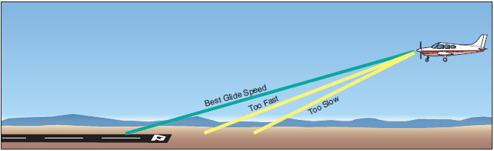

References:
Airplane Flying Handbook - Chapter 3

Completion Standards:
The lesson is complete when the student is able to perform straight descents and descending turns to the satisfaction of the instructor and in accordance with the current Practical Test Standards for the student’s stage of training.

