TRAFFIC PATTERNS (ASEL and ASES)

Objective:
To familiarize the student with operation in an airport traffic pattern. To familiarize the student with standard and right traffic patterns.

Content:
- Altitude
- Entry
- Traffic pattern indicators
- Turn to crosswind within 300′ of pattern altitude
- Pattern legs

Things to Avoid (Common Errors):
- Failure to comply with traffic pattern instructions, procedures, and rules
- Improper correction for wind drift
- Inadequate spacing from other traffic
- Poor altitude or airspeed control

Diagrams:

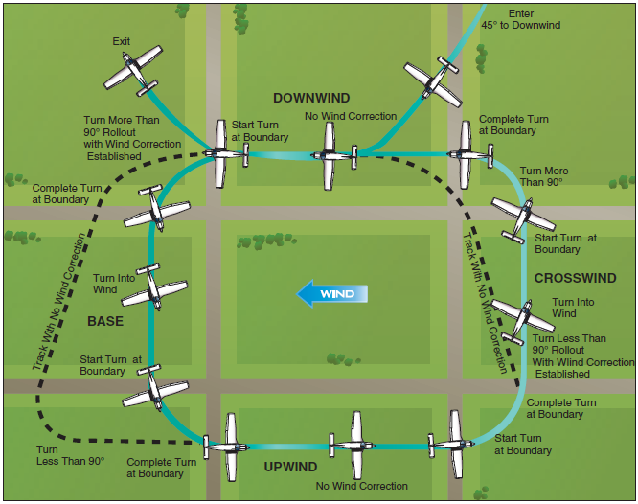

References:
Airplane Flying Handbook - Chapter 7

Completion Standards:

The lesson is complete when the instructor determines that the student has adequate knowledge of and is able to fly proper traffic patterns by giving an oral or written exam and observing the student during each flight.

Instructor Notes:
- The Pattern
  - Controlled - The pilot receives a clearance to approach/depart and pertinent pattern info
  - Uncontrolled - It’s up to the pilot to determine traffic direction, and comply with the appropriate rules
  - If familiar with the basic rectangular pattern, it approaches/departures will be easy at most airports
  - Standard Traffic Pattern
    - Usually 1,000’ AGL (Common Alt is the key factor in minimizing collisions at uncontrolled airports)
    - CE - Poor altitude or airspeed control
      - Know the AS required at certain points in the pattern (max is 200 knots in Class D)
      - Constantly checking the instruments to ensure AS and Alt and make fine, controlled adjustments
    - All turns are made to the left unless otherwise noted (AFD, Controller, Markings, etc)
      - Turns should not be banked more than 30o (Do Not use rudder to help the turn along)
    - Downwind - Parallel to the runway of intended landing (opposite landing direction)
      - Approximately ½ to 1 mile from the runway
      - At pattern altitude until abeam the approach end of the runway
      - Continues to a point 45o from the intended landing point
    - Base - Perpendicular to the runway and transitions between downwind and final
      - The ground track of the airplane should be perpendicular to the extended centerline
    - Final - The descending approach to the runway
    - Upwind - Flown parallel to the landing runway, but in the same direction to the landing direction
      - Continues past a point abeam the departure end of the runway
      - Transitional part of the pattern when a go-around is initiated
    - Crosswind - horizontally perp. to the runway centerline and transitions from up to downwind
    - Departure - The straight course aligned with, and leading from, the T/O runway
      - Continue climbing straight out and if remaining in the pattern, turn to the crosswind leg beyond the departure end of the runway within 300’ of pattern altitude
      - If departing, continue straight out or exit with a 45o turn to the left (or right in a right pattern)
  - Maintaining the Desired Ground Track
    - The airplane will have to be crabbed into the wind in order to maintain a straight ground track
    - The airplane can be kept at a specific position in relation to the runway with visual references
      - Place the runway centerline on a point on the leading edge of the wing/
      - Use landmarks to establish proper legs of the pattern
    - CE - Improper correction for wind drift
      - Keep the pattern a rectangle, always crabbing into the wind as necessary
- Controlled Field
  - The pilot receives, by radio, a clearance to approach/depart as well as pertinent info about the pattern
  - ATC will specify pattern entry and departure procedures (Where/how to enter and leave)
  - During the pattern the controller may adjust your pattern (Speed, Legs, 360o turn, S turn)
  - CE - Failure to comply with traffic pattern instructions, procedures, and rules
    - Know the rules and ensure you understand radio communications and instructions
    - Learn to divide attention in the pattern between flying, collision avoidance, checklists, and comms
- Uncontrolled Field
  - Communication
    - There are 2 ways to communicate intentions and obtain airport/traffic info at an uncontrolled field
      - Communicating with an FSS providing advisories
        - The FSS provides wind info, runway in use, altimeter setting, known traffic, NOTAMs, etc.
        - Inbound aircraft should initiate contact approx 10 miles out with Alt, AC Type, and Location
        - Departing should contact as practicable with Tail #, Type flight, destination, services desired
        - Or by making a self-announced broadcast on the CTAF (found in the AFD and on sectionals)
  - Arriving
    - Observe other aircraft already in the pattern and conform to the traffic pattern in use
      - If other aircraft are not in the pattern, use traffic indicators and wind to determine runway info
        - L shaped indicators displayed with a segmented circle (short part of L shows turn direction)
        - Check these indicators well above pattern altitude
        - Pattern direction can also be determined in the AFD and on sectional charts
    - Once pattern direction is determined, proceed to a point well clear of the pattern before descending
    - Enter in level flight, at altitude, at a 45o angle to the downwind, abeam the runway midpoint
      - Entry while descending creates collision hazards and should be avoided
    - Maintain pattern altitude until abeam the approach end of the landing runway or downwind leg
  - Departing - As discussed above
  - CE - Failure to comply with traffic pattern instructions, procedures, and rules
    - Know the rules and ensure you understand radio communications and instructions
    - Learn to divide attention in the pattern between flying, collision avoidance, checklists, and comms
- Orientation to the Runway
  - Know which runway is in use and remain oriented with the active runway
    - Plan to enter properly visualizing your position in relation to the runway on the HI
    - Confirm the runway number with the HI during all pattern legs
      - Downwind - Reciprocal; Base - 90o off (in the direction of the pattern); Final - Runway Number
- Checklists
  - Prior to entering/upon entering the pattern complete the Before-Landing Checklist
  - Run through the checklist again on final to ensure everything is complete
- Establishing Final Approach
  - The base leg will be adjusted depending on wind conditions
    - The stronger the wind, the closer the base leg because the decreased GS will shorten the approach
  - The turn to final should be no closer than ¼ mile at an altitude appropriate for the glide slope selected
  - 3o glide slope, means we should be 300’ AGL for every mile from the runway
- Maintaining Proper Spacing
  - In the pattern, you must observe other traffic and maintain separation (Know where other aircraft are)
  - When turning base and another plane is on final, turn once abeam/past the other aircraft
  - At a controlled field, the controller may request/advise certain maneuvers to provide spacing
  - YOU are responsible for seeing and avoiding whether at a controlled or uncontrolled field
  - CE - Inadequate spacing from other traffic
    - Don’t fly faster than an airplane in-front of you or turn too early following another plane
- Wind Shear and Wake Turbulence
  - Wind Shear
    - Best method in dealing with wind shear is to avoid it (Don’t fly in or near thunderstorms)
    - If there is a possibility of WS, during the approach, use more power, a higher AS, stay as high as feasible until necessary to land, and go-around at the first sign of an unexpected AS/pitch change
  - Wake Turbulence
    - Landing: Land prior to a jet’s T/O point or stay above and land beyond another jet’s landing point
    - T/O: T/O prior to and stay above another jet’s T/O point and T/O after another jet’s landing point

