TURNS AROUND A POINT (ASEL and ASES)

Objective:
To teach turning technique, subconscious control of the airplane, division of attention, effects of bank angle to radius of a turn, perception of altitude and correction of wind drift.
Before Flight:
- Review S-Turn principles
- Review applicable aircraft performance information
- Maximum bank during the maneuver should not exceed 45°

Maneuver Elements:
- Clear the area
- Choose forced landing area
- Configure aircraft: flaps and gear up, speed at or below Va, straight-and-level at altitude between 600-1000’ AGL, trim to maintain altitude
- Select outside reference (a distinguished point to encircle)
- Enter the circle, ideally on downwind and close enough to allow for a 30º to 45º bank at steepest point (this lesson assumes downwind entry)
- Turn to the steepest bank at the start of the circle (on downwind)
- Upon rounding the turn, the bank will become progressively shallower until on upwind, at which point it will be shallowest, then start to become steeper again until again on downwind
- Maintain radius of circle by adjusting bank as necessary to compensate for wind
- Maintain ball centered
- Look for traffic throughout

Aircraft Setup:

Flaps and gear up
Power and speed at or below Va
Traffic pattern altitude of 600 – 1000’ AGL
C172RG: MP: 18” Hg
RPM: 2300 RPM
Speed: 100 KIAS

Things to Avoid (Common Errors)

- Failure to adequately clear the area
- Failure to establish appropriate bank on entry
- Failure to recognize wind drift
- Excessive bank and/or inadequate wind correction angle on the downwind side of the circle resulting in drift towards the reference point
- Inadequate bank angle and/or excessive wind correction angle on the upwind side of the circle resulting in drift away from the reference point
- Skidding turns when turning from downwind to crosswind
- Slipping turns when turning from upwind to crosswind
- Gaining or losing altitude
- Inadequate visual lookout for other aircraft
- Inability to direct attention outside the airplane while maintaining precise airplane control

Diagram:
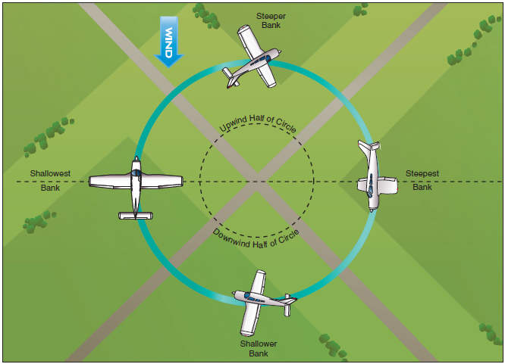

References:
Airplane Flying Handbook – Chapter 6
Completion Standards:
The lesson is complete when the student demonstrates knowledge through a written or oral exam and is able to perform turns around a point to the satisfaction of the instructor and in accordance with the current Practical Test Standards for the student’s stage of training.

