
AOPA Title Service Center
(Provided by AIC Title Services, LLC)
Phone: 1-800-711-0087
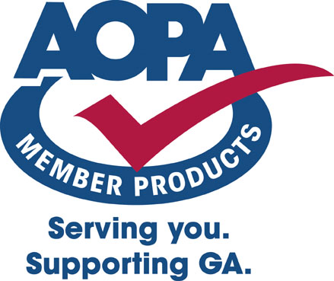

FAA AD REPORT

Prepared For: CHARLES MOUNT Date: March 23, 2006
Order #: 152018
N-Number: 3212T

Report includes AD’s current through February 21, 2006
(AD’s issued after the above date are available within a 60-day period on line at www.atp.com/ad)
Order Specifications:
(Please confirm that the airframe, engine and propeller described below and throughout the pages of this report apply to the specific aircraft in question. The airframe type certificate data sheet or most recent airworthiness certificate appearing in the FAA aircraft record may have been consulted for specific engine and prop descriptions.)

Airframe Make: CESSNA
Airframe Model: 177
Please note this report is not N-Number specific
Engine Make: LYCOMING
Engine Model: O-320-E2D
When an engine model series is indicated, the search was made on all models in that series. Carburetors and magnetos are considered appliances. AD’s for these units will not appear on the engine report.
Propeller Make: MCCAULEY 1C172

General Information:
The AD Compliance Record provides you with the AD number and a brief description of each AD that may apply to the equipment described above. The format makes it easy to record compliance of each AD. AD compliance is mandatory for aircraft appliances as well. A complete listing of all appliance ADs is included. The appliance listing is not specific to a particular aircraft as each aircraft is uniquely equipped.

This report is intended for preliminary research purposes only. A FAA certified aircraft maintenance technician with inspection authority (IA) should be consulted for final determination of AD applicability and compliance. The applicability of the AD’s listed herein should be verified by an IA through careful review of the text of each AD. The text of all AD’s is available to AOPA members online, free of charge, at www.aopa.org/members/files/airdirect. Some Airworthiness Directives require recurring action (noted in the attached report). This report does not reflect the airworthiness of any airframe, engine, propeller or appliance.

Only the data pertaining to the above listed airframe, engine(s) and propeller(s) have been searched. While every care has been exercised in the preparation of this report and in the selection of the source of the information contained herein, AOPA Aircraft Title Services, Inc., AOPA Service Corp., and AOPA cannot and do not guarantee the accuracy or timeliness of the information provided by that source.

