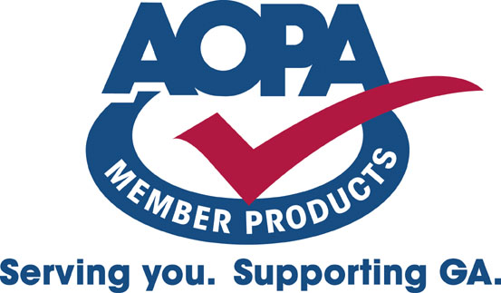

AOPA Aircraft Accident/Incident Report

(Provided by AIC Title Services, LLC)
Phone: 1-800-711-0087

General Information

The Aircraft Accident/Incident Report attached includes reported accidents (which occurred after 1961) and incidents (which occurred after 1978) that were investigated by the FAA or NTSB. Only those accidents and incidents meeting the criterion outlined by the rules of NTSB 830, which were current at the time, must be reported. Therefore, absence of data on this report should not be interpreted to mean the aircraft has no damage history. The aircraft may have sustained major damage in a non-reportable occurrence or in an occurrence that was hidden from the FAA or NTSB.

In addition to the Aircraft Accident/Incident Report, AOPA recommends a review of the FAA 337 Forms (Major Repair and Alteration) on file with the FAA Aircraft Registry. These are provided with your Title Search report. Any damage reflected by these sources and not properly explained in the aircraft maintenance logs should be investigated further.

Questions regarding the information contained in this report should be directed to AIC Title Services, LLC at 1-800-711-0087.

****

Aircraft registration numbers are often changed or reassigned. All prior registration numbers noted in the FAA aircraft record have been included in this search. Accidents and incidents involving aircraft not registered with the FAA Aircraft Registry at the time of the occurrence will not appear on this report. In addition, recent accidents and incidents (those occurring within the previous 6 to 8 months) may be excluded from this report due to FAA or NTSB backlog of data entry.

While every care has been exercised in the preparation of this report, AIC Title Services, LLC, AOPA Service Corp. and AOPA cannot and do not guarantee the accuracy or timeliness of the information obtained from the FAA and NTSB.

