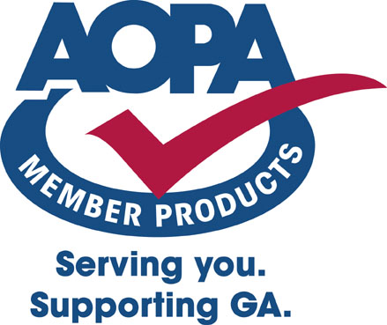
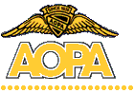

AOPA Title Services Center
(Provided by AIC Title Services, LLC)

Service Difficulty Report

Prepared For: CHARLES MOUNT Date: March 23, 2006
Order #: 152018
N-Number: 3212T

Order Specifications:

Airframe Make: CESSNA
Airframe Model: 177 AND 177 SERIES
(Please note this report is not N-Number specific)

General Information:
This report contains a summary of up to 1,000 Service Difficulty Reports received by the Federal Aviation Administration from 1/1/95 to the present, and includes malfunctions, defects and failures submitted to the FAA by pilots, mechanics, inspectors, and repair facilities. If the records pertaining to the specific aircraft model requested are limited, a supplemental report of the aircraft model series has been included at no additional charge. Data dating back to 1974 is available upon request. The Service Difficulty Program was designed to assist aircraft owners, operators, maintenance organizations, manufacturers and the FAA in detecting trends in aircraft problems encountered during service. The FAA requests the cooperation of all aircraft owners, operators, mechanics, pilots, and others in reporting service difficulties experienced with aircraft. Such reports contribute to the correction of conditions or situations which otherwise will continue to prove costly and/or adversely affect the airworthiness of aircraft. When a system, component or part of an aircraft functions badly or fails to operate in the normal or usual manner, it has malfunctioned and should be reported. Also, if a system, component, or part has a flaw or imperfection which impairs function or which may impair future function, it is defective and should be reported. For questions regarding this report, please call 1-800-872-2672.

The FAA does not verify the accuracy of the data reported herein. Therefore, this report should be used for preliminary research purposes only. This report does not reflect the airworthiness of any aircraft.

Only the data pertaining to the above listed aircraft make and model, or model series, has been researched. While every care has been exercised in the preparation of this report, AOPA Aircraft Title Services, Inc., AOPA Service Corp., and AOPA cannot and do not guarantee the accuracy or timeliness of the information obtained from the FAA and reported herein.

